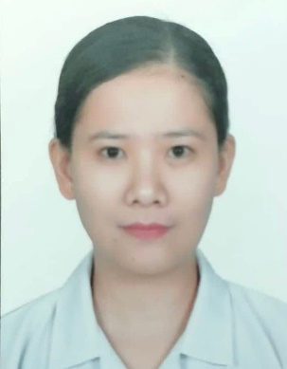
MARY HOPE ALCABEDOS VILLALUZ
Pussuac, STo. Domingo, Ilocos Sur
Mobile No.: 0921-6881435
Email Address: invencionmaryhope@gmail.com

OBJECTIVE:
To be able to contribute my knowledge and skills in my chosen field of work, by working with a great sense of responsibility, dedication and hard work such that whatever training and skills I had gained will be great help for personal and professional growth and performance of duty that will contribute to the development of the institution.

PERSONAL INFORMATION:
Permanent Address : Pussuac, STo. Domingo, Ilocos Sur
Birth Date : September 24, 1985
Birth Place : Batac, Ilocos Norte
Height : 5’1”
Weight : 60 kgs.
Gender : Female
Religion : Roman Catholic
Citizenship : Filipino
Civil Status : Married

EDUCATIONAL BACKGROUND:
Tertiary : University of Northern Philippines
Tamag, Vigan City, Ilocos Sur
Course: Bachelor of Science in Nursing
2003-2007

Secondary : MAGSINGAL NATIONAL HIGH SCHOOL
San Clemente, Magsingal, Ilocos Sur
1998-2002

Primary : MAGNUANG ELEMENTARY SCHOOL
Batac, Ilocos Norte
1992-1998

ELIGIBILITY:
- Registered Nurse
License No.: 0534758
Issued by: Professional Regulation Commission

- Registered Midwife
License No.: 0138386
Issued by: Professional Regulation Commission
PROFESSIONAL STRENGTHS:
- Pleasant personality and ability to communicate effectively
- Good sense of hygiene
- Affective organization and time management skills
- Ability to perform task in professional manner.

WORK EXPERIENCES:
- Ilocos Sur District Hospital – Magsingal
Magsingal, Ilocos Sur
Designation: Nurse
Duration: August 2019 – December 2020

- Tolentino Clinic and Hospital
Sto. Domingo, Ilocos Sur
Designation: Nurse
Duration: April 2018- January 2019

- Al Ajaji National Clinic
Riyadh, KSA
Designation: Dental Nurse
Duration: 2012-2018

- Rabara Clinic and Hospital
Vigan City, Ilocos Sur
Designation: Nurse

CHARACTER REFERENCE:
Janice T. Fernandez
Nurse 1
Ilocos Sur District Hospital – Magsingal

Mary Jane Pando
Head Nurse
Tolentino Clinic and Hospital

I hereby certify that the above information has been accomplished in good faith, verified by me to the best of my knowledge and belief and a true accurate statement.

MARY HOPE VILLALUZ
Applicant Signature

