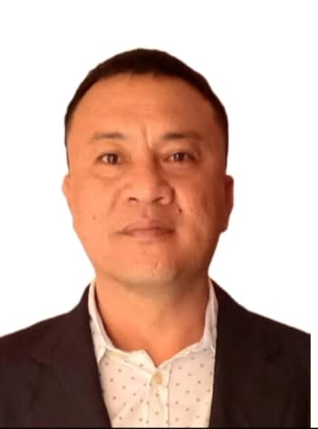
MARVIN P. DEL MAR
Don Andres Soriano, Toledo City
marvindelmar3@gmail.com
messenger/skype id: Marvin Del Mar

CAREER OBJECTIVE
Looking for an opportunity to secure a Position where I can employ all my skills to maximize my experiences with my training abilities and strong dedication towards development.

POSITION DESIRED ELECTRICIAN

- Personal Details:
Date of Birth: May 28, 1975
Father’s Name: Restituto P. Del Mar Sr.
Passport Number: P8065821A
Passport Validity: July 23, 2028
Years of Experience (CCC): 3 years
Years of Experience( Gulf): 9 years
Years of Experience: (Local): 5 years
Last Area in CCC: Tengriz, Kazakstan
Last Badge Number: 85023

Covid Vaccine Details:
1st Doze: July 29, 2021
Booster Doze: January 7, 2022

- Trainings and Seminars:

- August 11, 2003 to October 11, 2003
On- the- Job Training in Electrical Works
Mirant Toledo Power Station
Sangi & Carmen Plant Maintenance

- Safety Trainings on the following:

* Qualified Fire Watch

* CTJV (Chiuda Technip Joint Venture)
Confined Space Entry Safety
* Basic Permit to Training and Qualified
* RO 1125 B.A Familiarization Course
Hydrogen Sulphide & B. A Training
CTJV RASLAFFAN, QATAR

- Work Experiences:

Duration: February 4, 2022- Present
Position: Industrial Electrician
Company: CONSOLIDATED CONTRACTOR ENGINEERING & PROCUREMENT
Address: Tengiz, Kazakhstan

Duties and Responsibilities:
* Installation of Instrument such as:
* Flow Transmitter
* Pressure Transmitter
* Flame Detector
* Gas Detector
* Loop Checking
* Glanding Termination of Instruments

Duration: January, 2021- January, 2022
Position: Residential Electrician (On- Call)

Duration: July, 2018 – March, 2020
Position: Team Leader Electrician
Project: Construction Department
Company: CARMEN COPPER CORPORATION
Address: DAS, Toledo City, Cebu

Duties and Responsibilities:
* Work as a Team Leader Electrician
* Prepare the tools and materials needed for an on-going work
* Make a Galvanized Piping for expose area
* Make a Conduiting of EMT Pipe and PVC Pipe
* Make a Lay-Out as per drawing given by the superior
* Make a Cable Tray Installation such as Ladder- Type Cable Tray
and Perforated Cable Tray and Fittings

- Duration: July 4, 2017- May 8, 2018
Position: Team Leader Electrician
Project: High Rise Building
Company: PETROSERVE LIMITED
Address: Doha Qatar

Duties and Responsibilities:
* Work as a Team Leader Electrician
* Prepare the tools and materials needed for an on-going work
* Make a Lay-Out as per drawing given by the superior
* Make a Cable Tray Installation such as Ladder- Type Cable Tray
and Perforated Cable Tray and Fittings
* Make a Galvanized Piping for expose area
* Make a Conduiting of EMT Pipe and PVC Pipe

- Duration: July 3, 2016- December 31, 2016
Position: Electrician
Project: Oil Refinery
Company: DAEMYUNG ENGINEERING & CONSTRUCTION, LLC
Address: Sohar, Sultanate of Oman

Duties and Responsibilities:
* Work as a Team Leader Electrician
* Prepare the tools and materials needed for an on-going work
* Make a Lay-Out as per drawing given by the superior
* Make a Conduiting of EMT Pipe and PVC Pipe
* Make a Galvanized Piping for expose area
* Make a Cable Tray Installation such as Ladder- Type Cable Tray
and Perforated Cable Tray and Fittings

- Duration: December 20, 2010- December 23, 2015
Position: Electrical Group Leader
Project: Substation and Building
Company: SAUDI OGER LTD.
Address: Riyadh, KSA

Duties and Responsibilities:
* Work as a Group Leader Electrician
* Prepare the tools and materials needed for an on-going work
* Work in Cable Pulling of Power Cables
* Work in Glanding Termination of Power Cable, make meagering and Continuity Test of Wires and Cables from
MCB (Main Circuit Breaker) to Distribution Panels
* Make a Lay-Out as per drawing given by the superior
* Made a Galvanized Piping for expose area
* Made a Cable Tray Installation such as Ladder- Type Cable Tray
and Perforated Cable Tray and Fittings

- Duration: October 19, 2009- March 20, 2010
Position: Industrial Electrician
Project: Power Plant
Company: DASOL E & C Company, Seoul, Korea
Address: Khartoum, Sudan Africa

Duties and Responsibilities:
* Work as an Electrician
* Prepare the tools and materials needed for an on-going work
* Make a Lay-Out as per drawing given by the superior
* Make a Conduiting of EMT Pipe and PVC Pipe
* Make a Galvanized Piping for expose area
* Make a Cable Tray Installation such as Ladder- Type Cable Tray
and Perforated Cable Tray and Fittings

- Duration: July 10, 2008- July 11, 2009
Position: Industrial Electrician
Project: Gas Plant
Company: CONSOLIDATED CONTRACTORS COMPANY W.L.L
Address: Raslaffan, Qatar

Duties and Responsibilities:
* Work as an Electrician
* Prepare the tools and materials needed for an on-going work
* Work in Cable Pulling of Power Cables
* Work in Glanding Termination of Power Cable, make meagering and Continuity Test of Wires and Cables from
MCB (Main Circuit Breaker) to Distribution Panel
* Make a Lay-Out as per drawing given by the superior
* Make a Conduiting of EMT Pipe and PVC Pipe
* Make a Galvanized Piping for expose area
* Make a Cable Tray Installation such as Ladder- Type Cable Tray
and Perforated Cable Tray and Fittings

- Duration: June 8, 2007- July 9, 2008
Position: Industrial Electrician
Project: Power Plant
Company: CONSOLIDATED CONTRACTORS COMPANY W.L.L
Address: Rabigh, Kingdom of Saudi Arabia (K.S.A.)

Duties and Responsibilities:
* Work as a Team Leader Electrician
* Prepare the tools and materials needed for an on-going work
* Make a Lay-Out as per drawing given by the superior
* Make a Conduiting of EMT Pipe and PVC Pipe
* Make a Galvanized Piping for expose area
* Make a Cable Tray Installation such as Ladder- Type Cable Tray
and Perforated Cable Tray and Fittings

- Duration: January 17, 2006- March 15, 2007
Position: Electrician
Project: High Rise Building
Company: NILE ASTER QATAR W.L.L
Address: DOHA QATAR

Duties and Responsibilities:
* Work as an Electrician
* Prepare the tools and materials needed for an on-going work
* Make a Lay-Out as per drawing given by the superior
* Make a Cable Tray Installation such as Ladder- Type Cable Tray
and Perforated Cable Tray and Fittings
* Make a Conduiting of EMT Pipe and PVC Pipe
* Make a Galvanized Piping for expose area

- Duration: November 2004 -June 2005
Position: Industrial Electrician and Automation
Project: Keppel Cebu Shipyard
Company: AIS ENGINEERING AND CONSULTANCY
Address: BANAWA, CEBU CITY

Duties and Responsibilities:
* Work in Cable Pulling
* Work in Installation of Radar
* Work in Installation of Instrument Panel
* Work in Termination and Automation

- Duration: March 03, 2004 -September 15, 2004
Position: Electrical Technician
Project: Building and Warehouse Project
Company: SUMISETSU PHILIPPINES INC.
Address: MEPZ II, LAPU- LAPU CITY, CEBU

Duties and Responsibilities:
* Make a Conduiting of EMT Pipe and Rigid Pipe
* Work in Wiring of Lightings
* Work in Installation of Lightings
* Work in the Installation of Power Outlet
* Work in the Installation of Panel Board
* Make a Galvanized Piping for expose area

- Duration: February 2002 -August 2003
Position: Lineman I Electrician
Project: VECO Installation and Maintenance
Company: MAYFLOWER TECHNICAL RESOURCES CORPORATION
Address: WEST GORORDO AVENUE, CEBU CITY

Duties and Responsibilities:
* Work as a Lineman
* Work in the Installation of Pole
* Work in the Installation of High Tension Cable
* Work in the Installation of Transformer

- Duration: October 10, 2000 – January 7, 2002
Position: Electrician
Project: Electrical Installation of Diesel Power Plant
Company: JBR ELECTRO-MECHANICAL SERVICES, INC.
Address: VECO COMPOUND, CEBU CITY

Duties and Responsibilities:
* Pulling Cable
* Assist in the Medium Voltage Terminator and Electrical Works

- Educational Attainment:

Vocational: Technical Education and Skills Development Authority Region VII (TESDA)
May 15, 2000- July 25, 2000

Secondary: Don Andres Soriano Barangay High School
1988-1992

Elementary: Don Andres Soriano Elementary School
1987-1988

- Reference:
LUZ CHAVEZ
Purok Sto. Nino, Don Andres Soriano, Toledo City
09176235808

I certify that information above is true and correct to the best of my knowledge and belief.

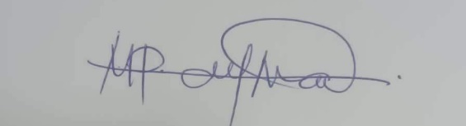
MARVIN P. DEL MAR
Passport No. P80665821A
Expiry: 23 July 2028

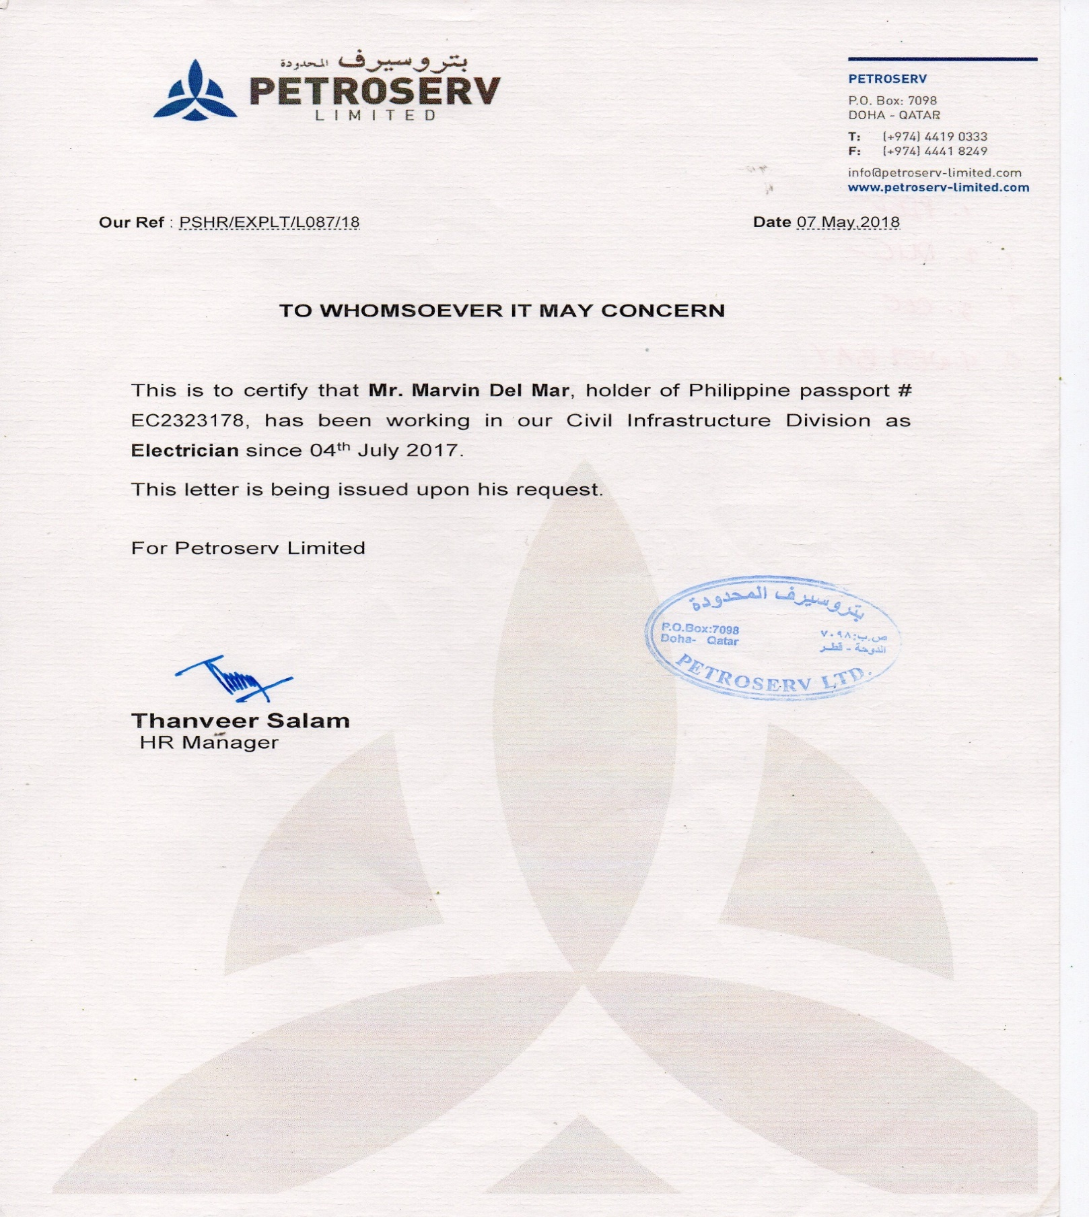

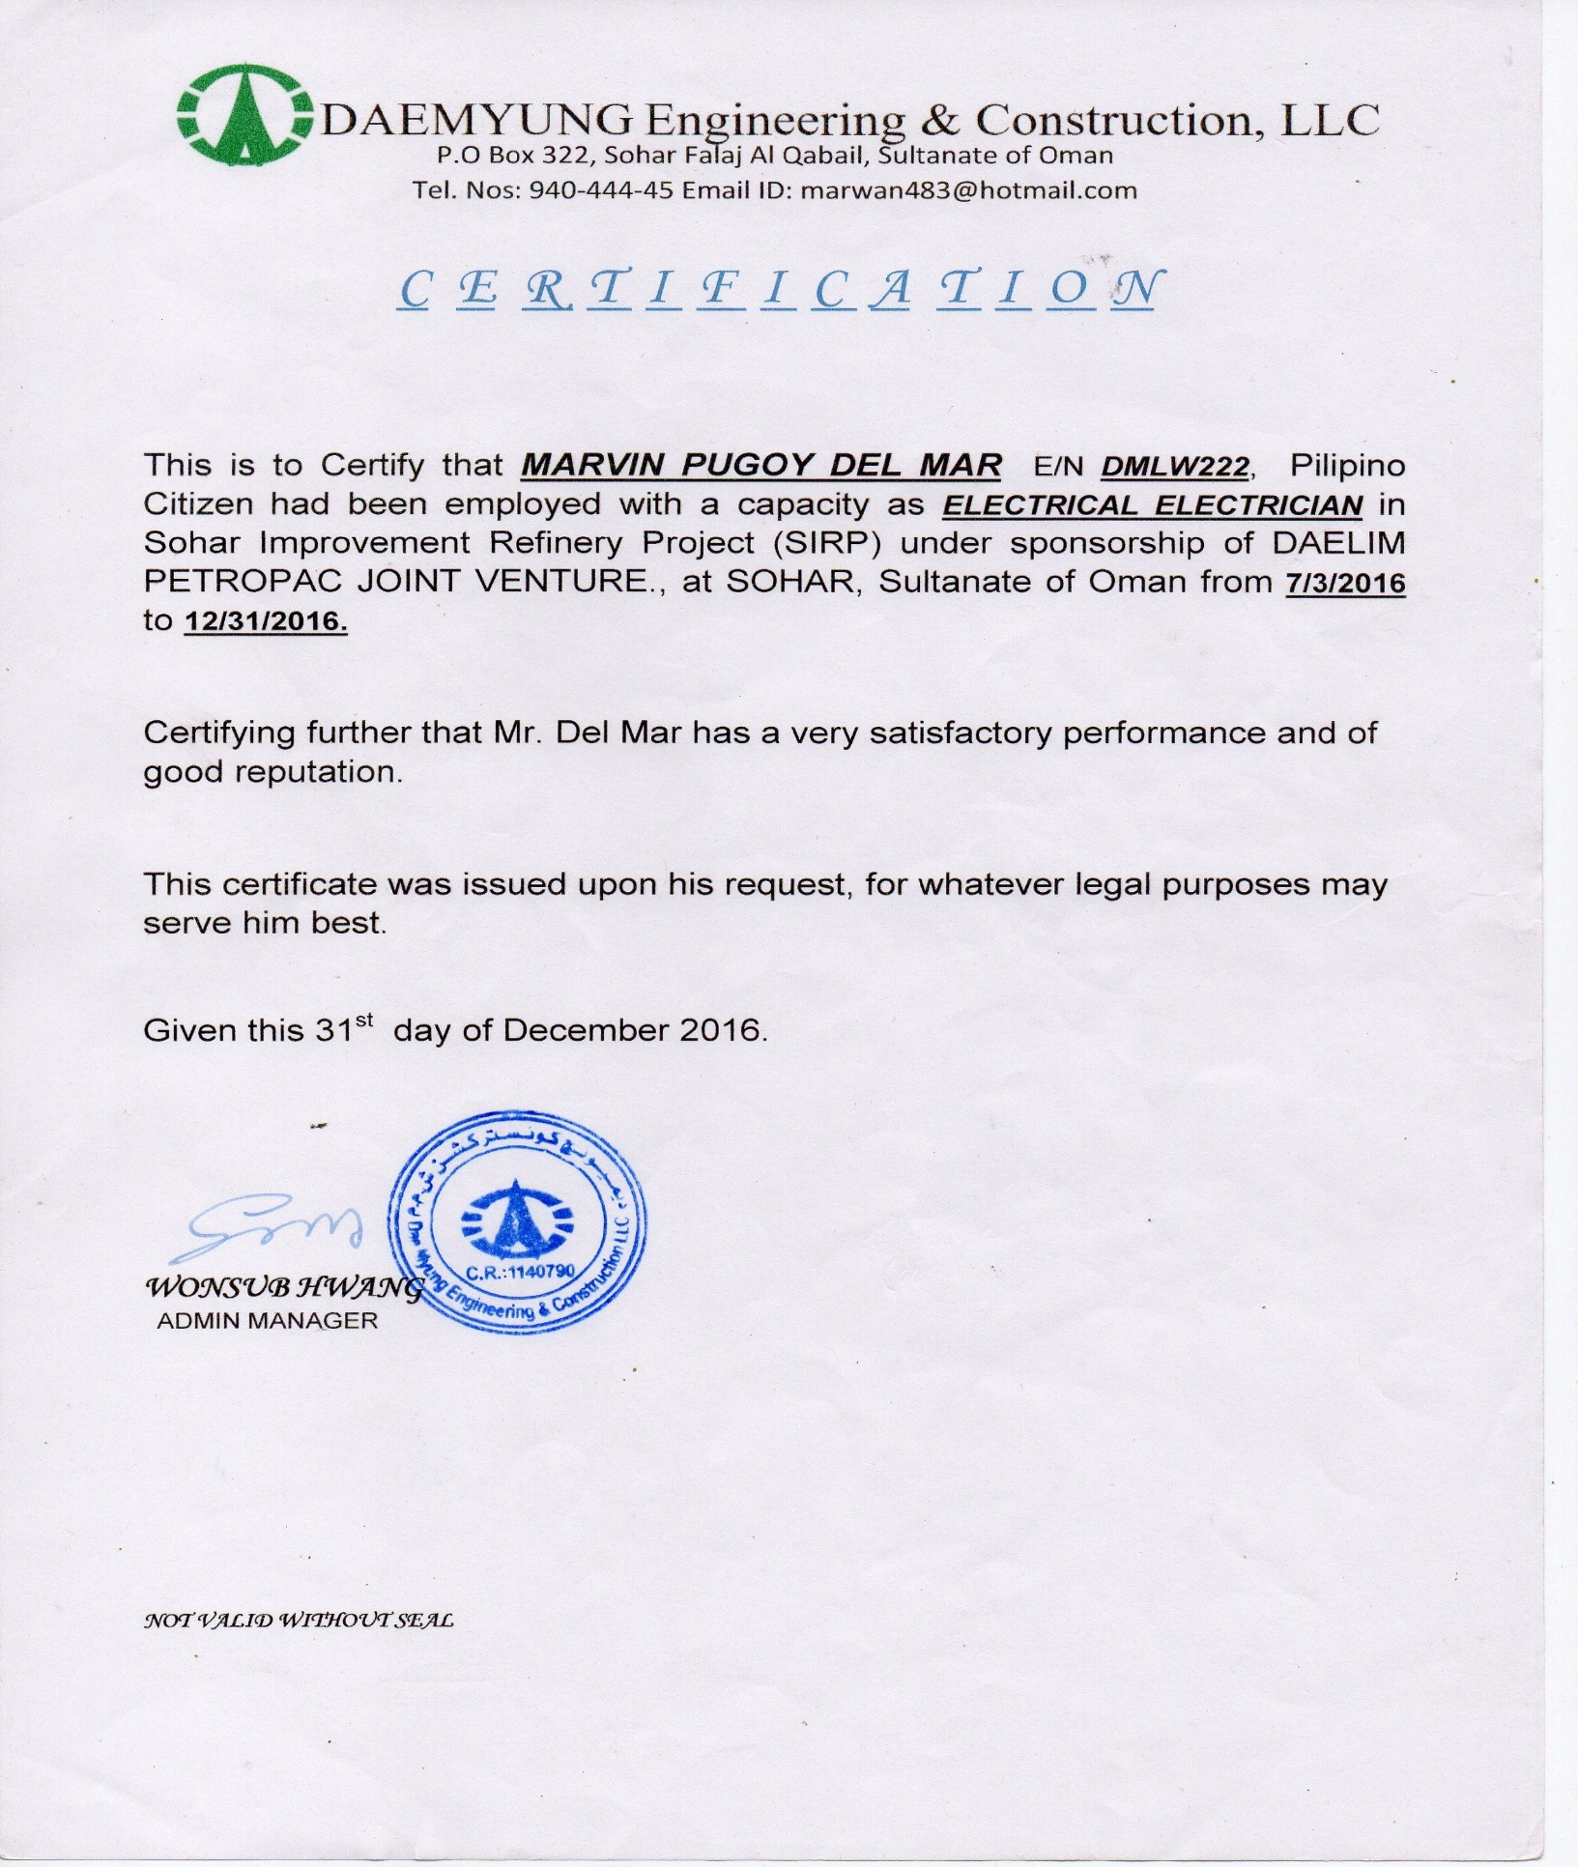

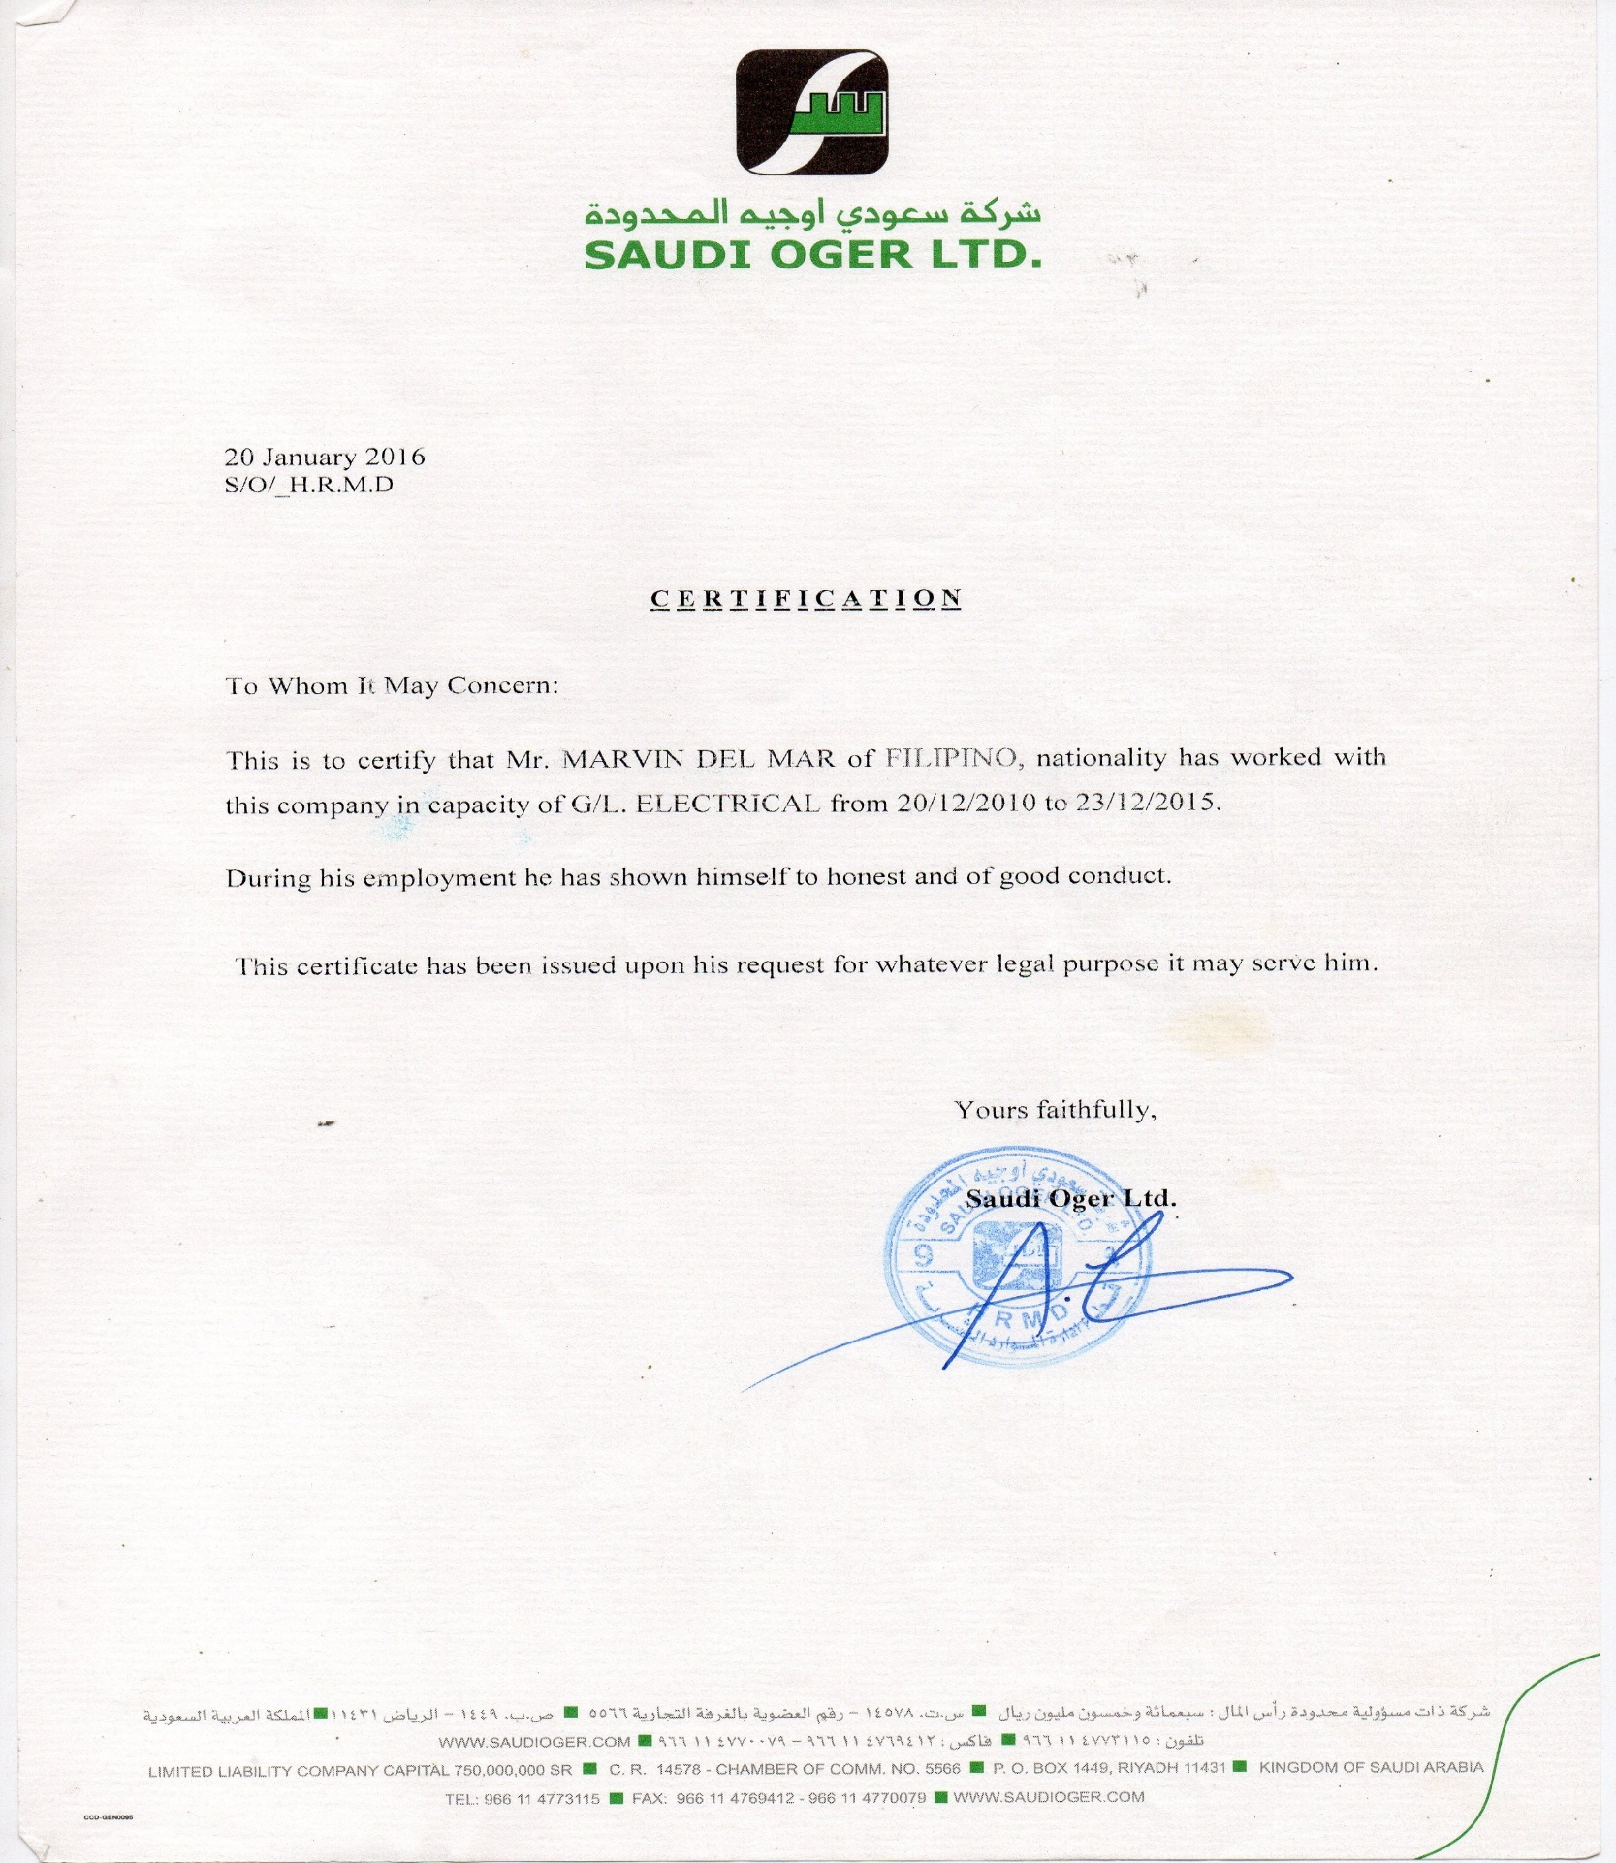

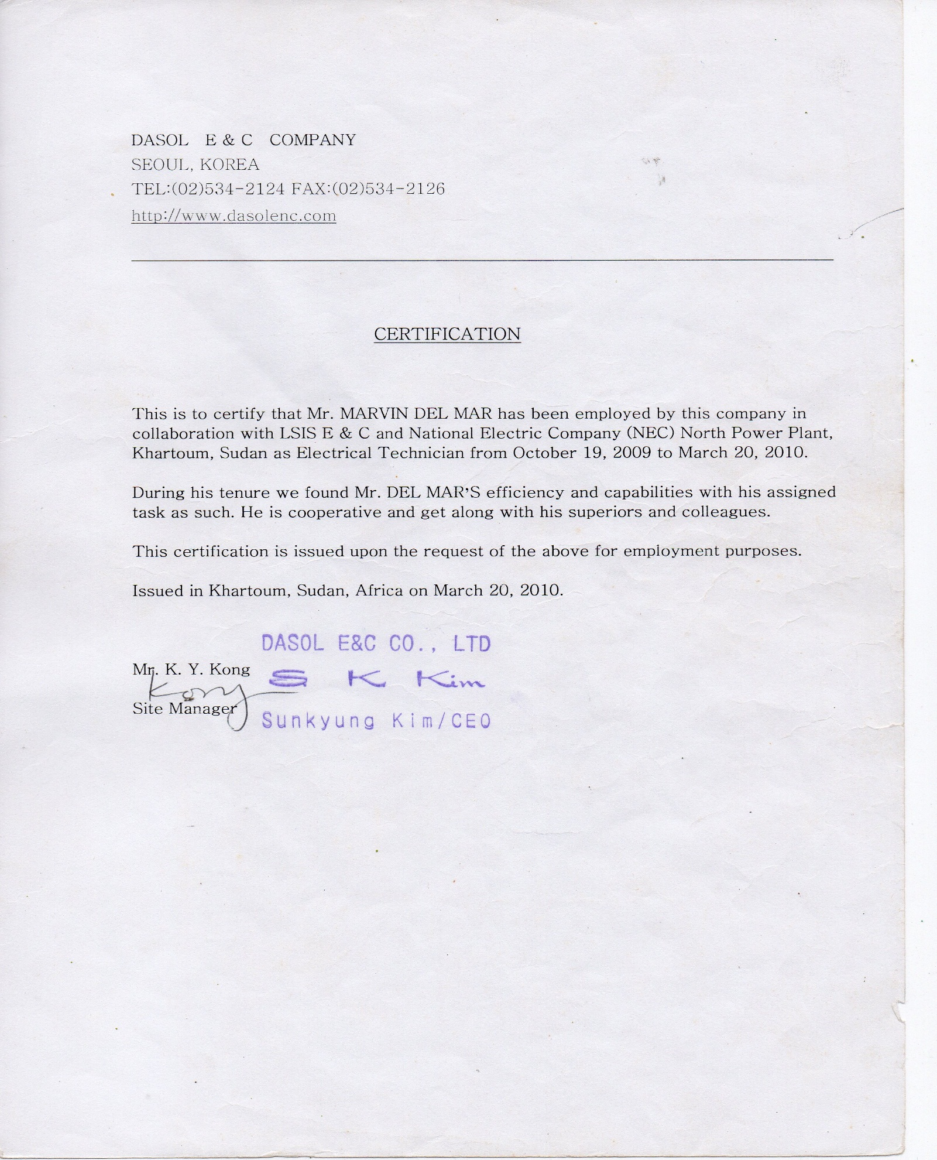

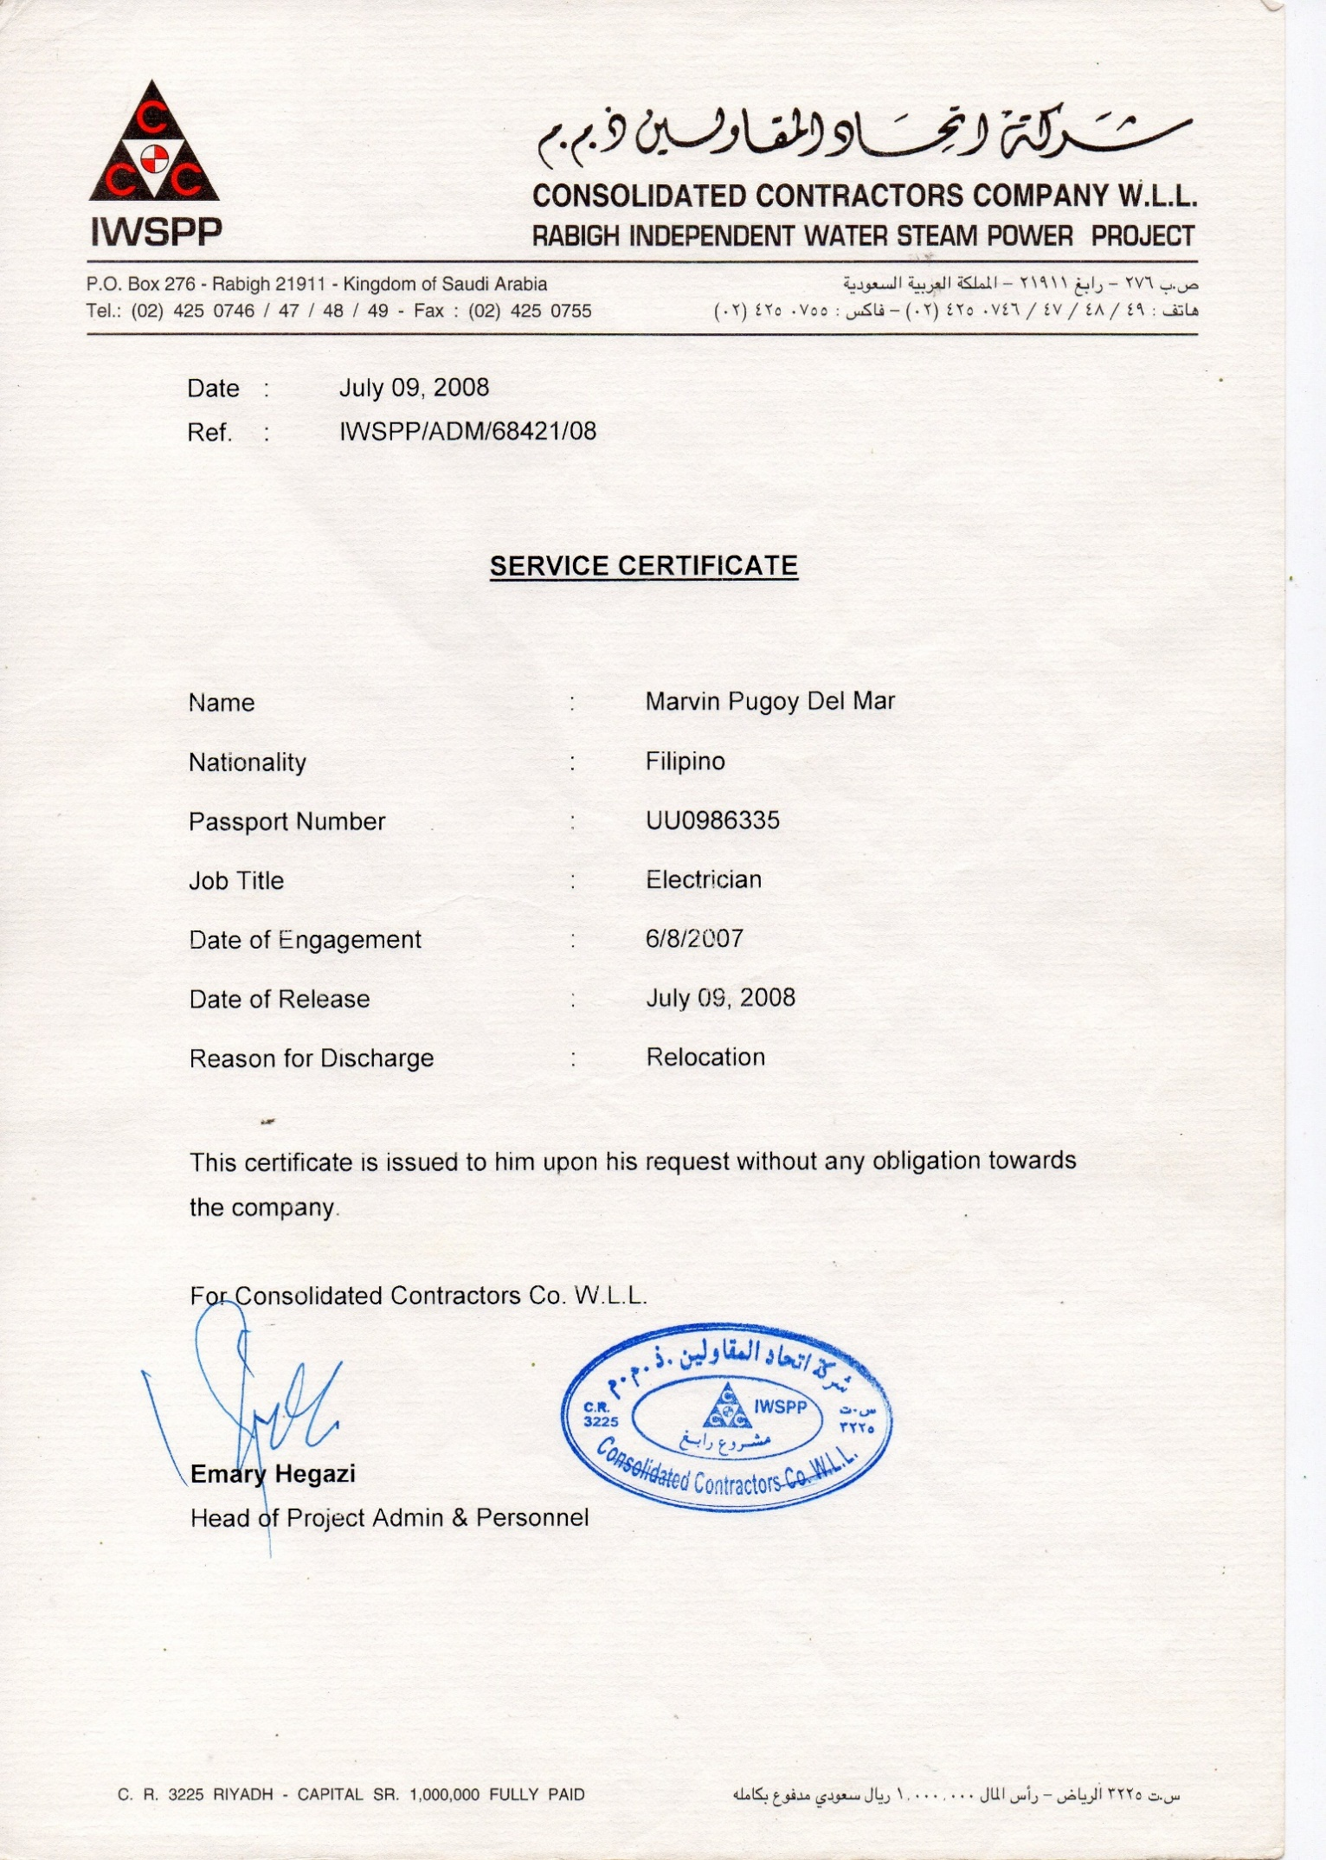

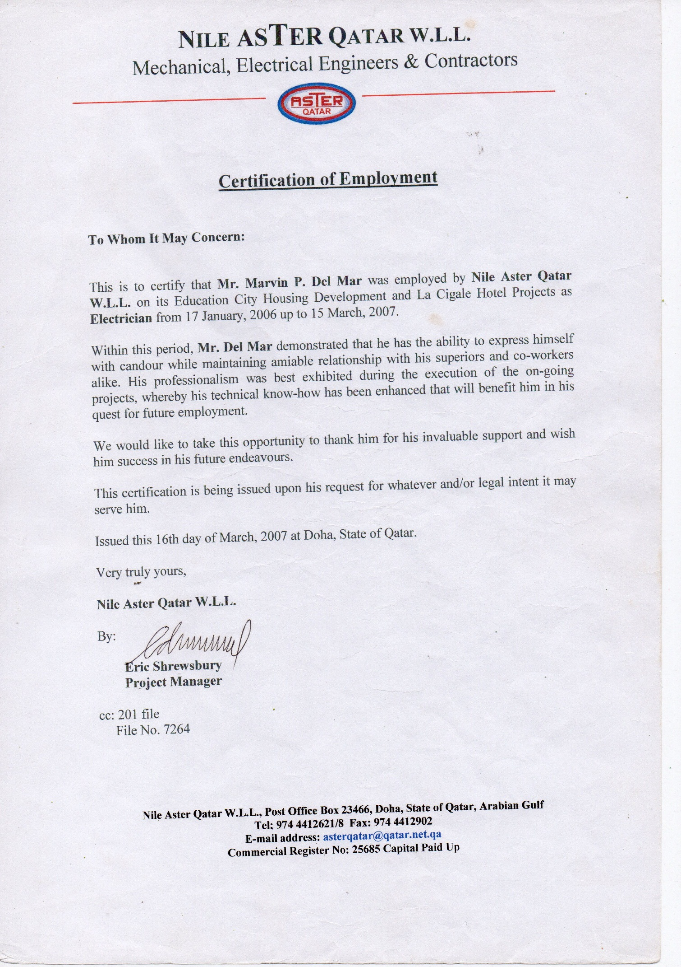

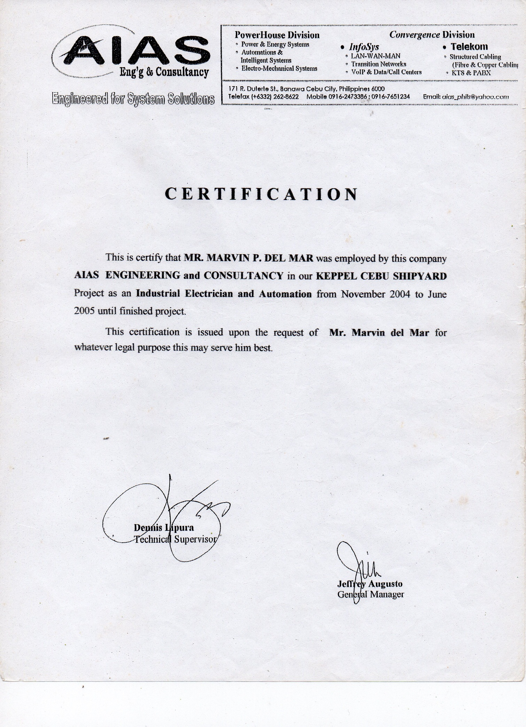

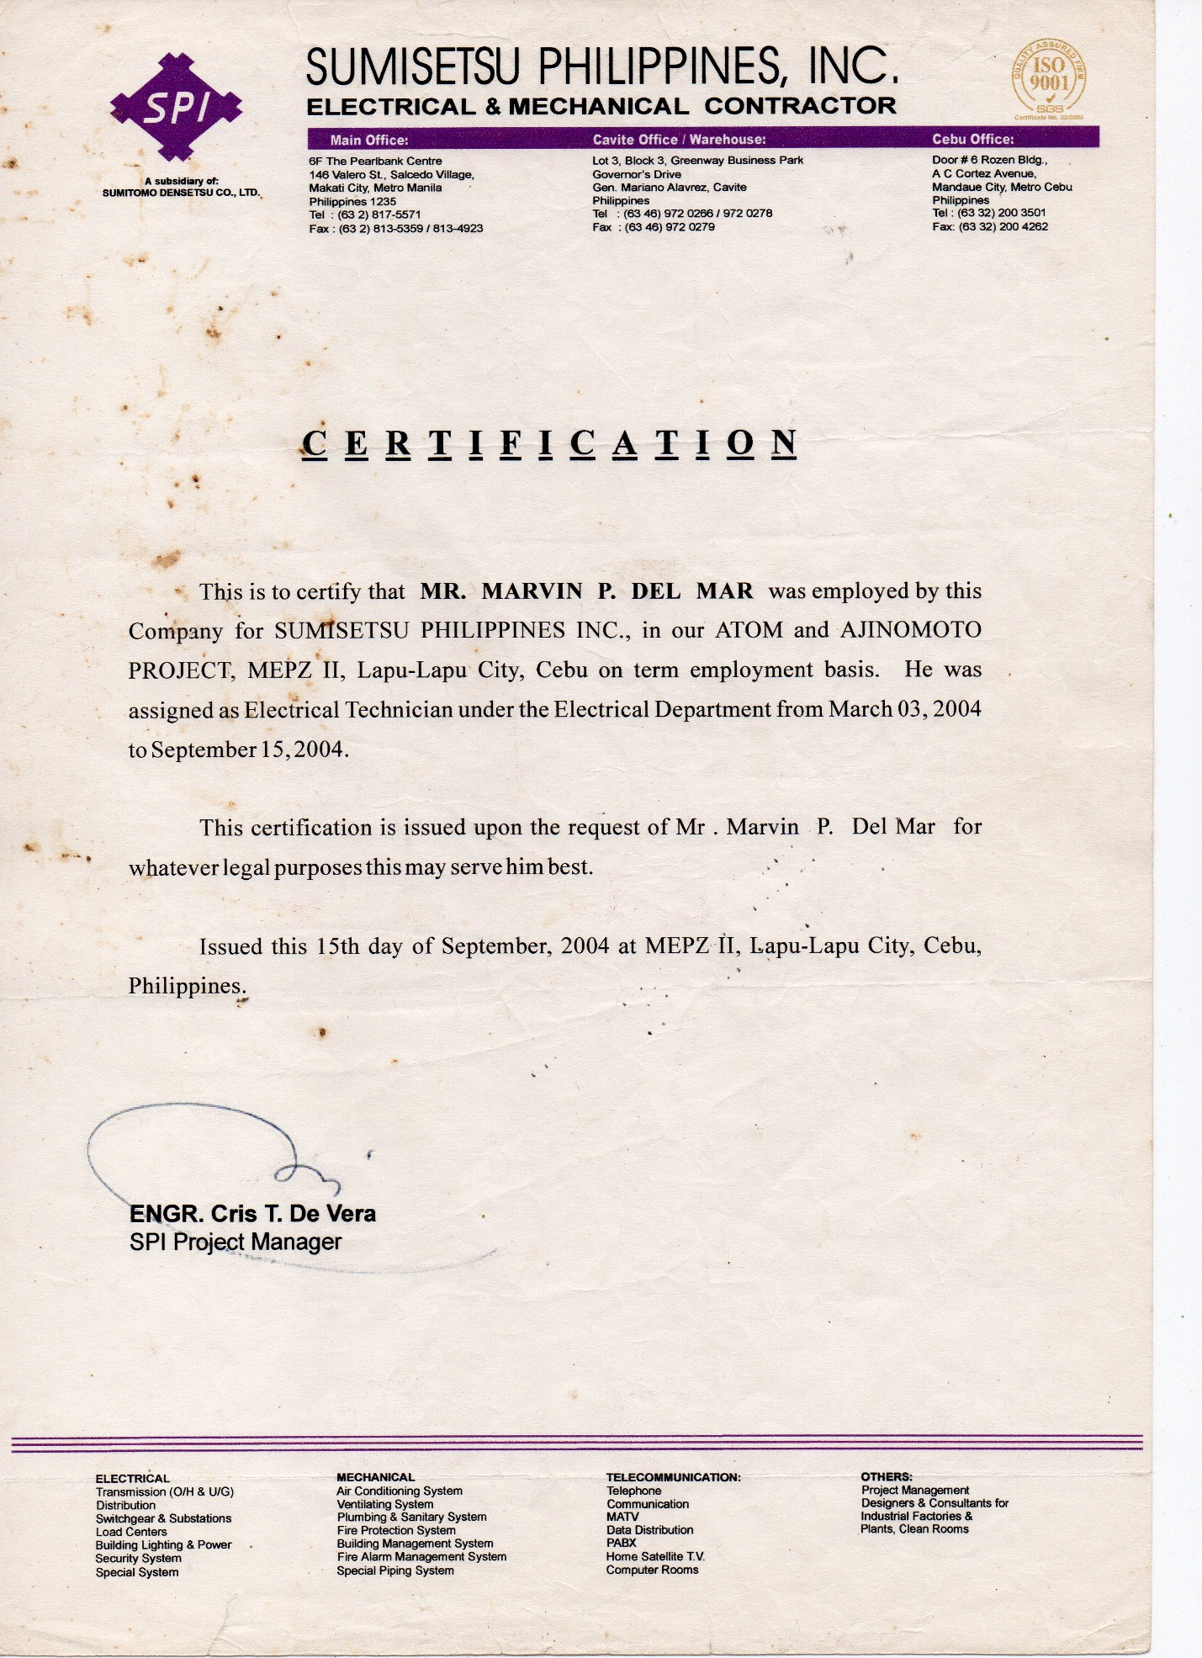

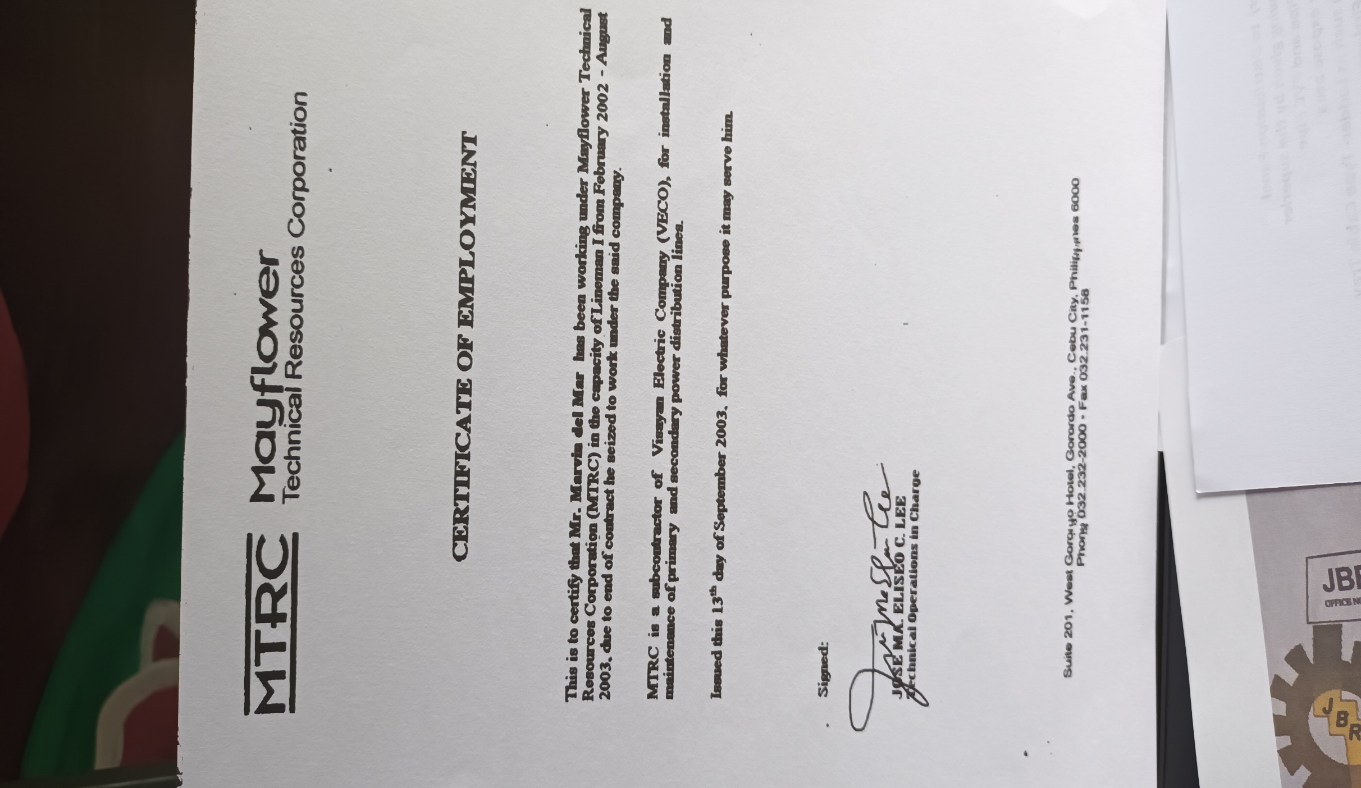

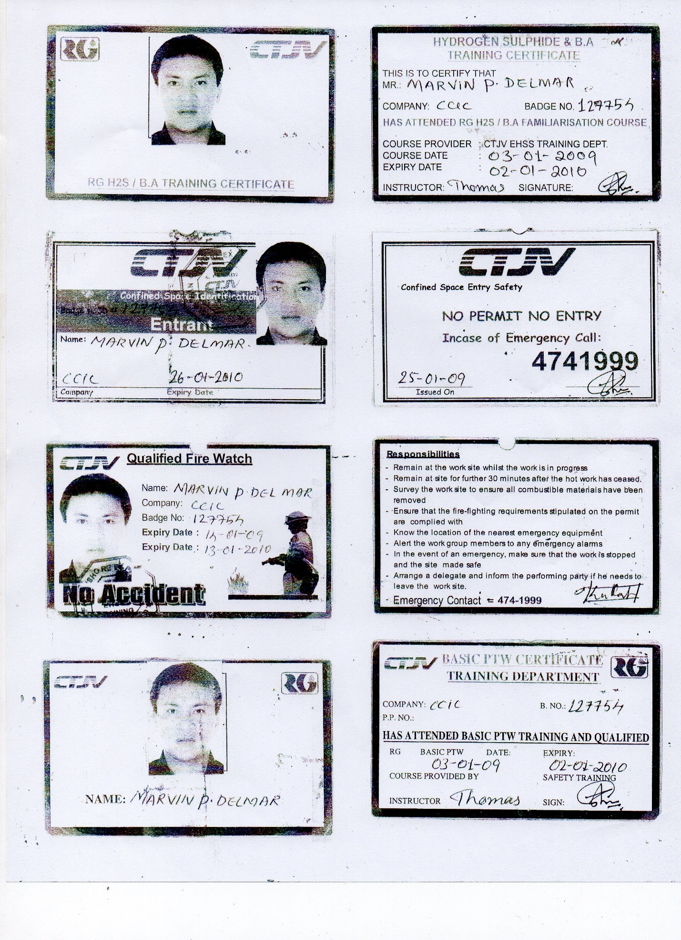

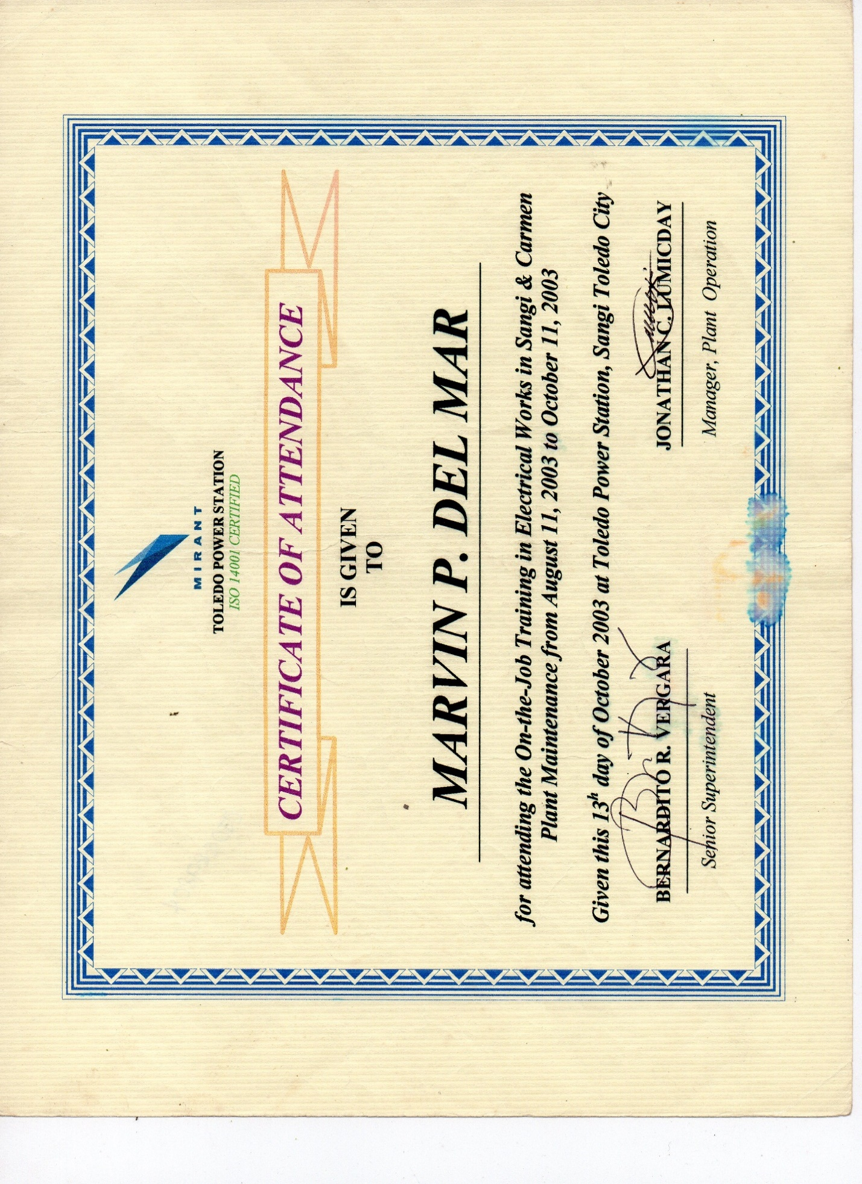

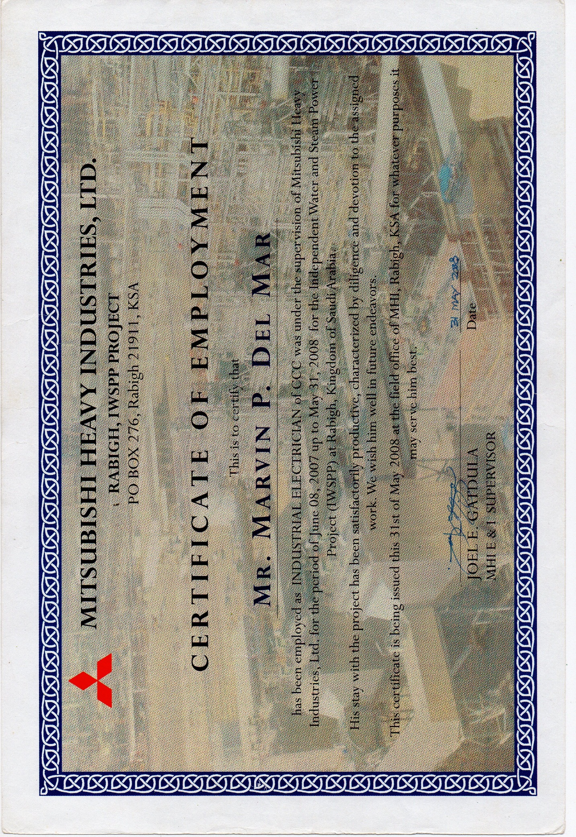

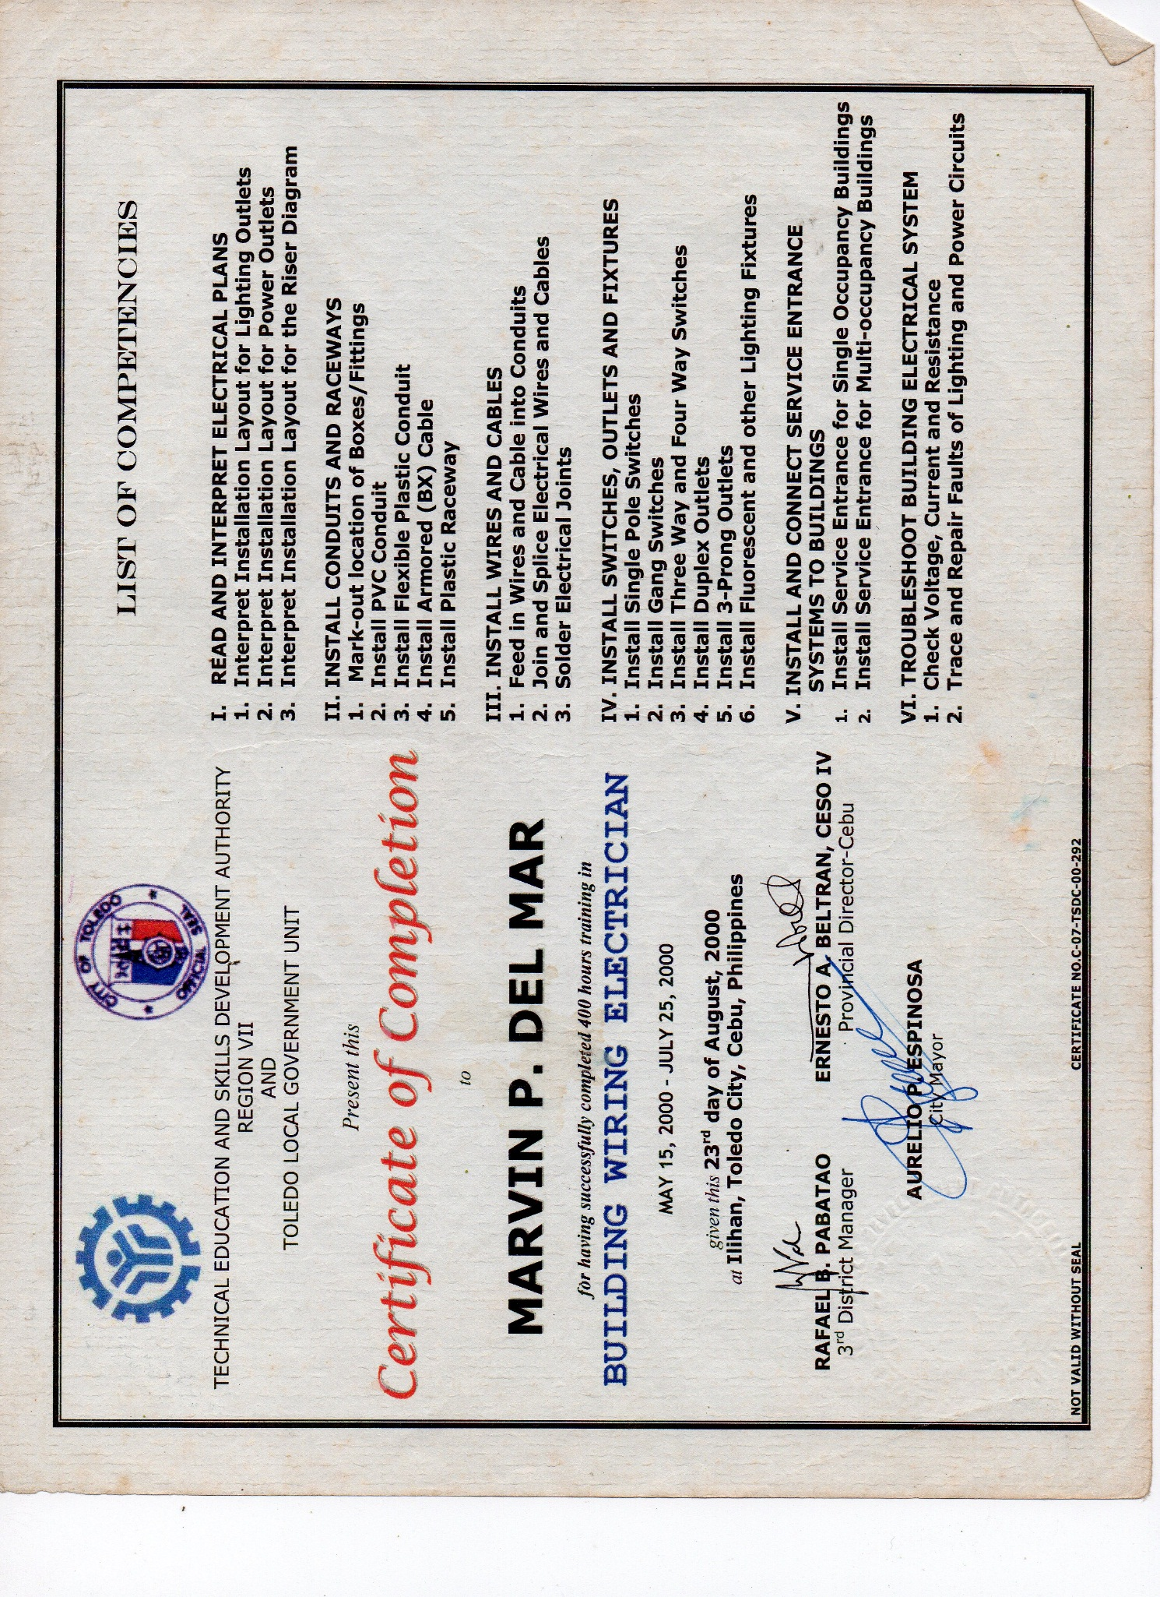

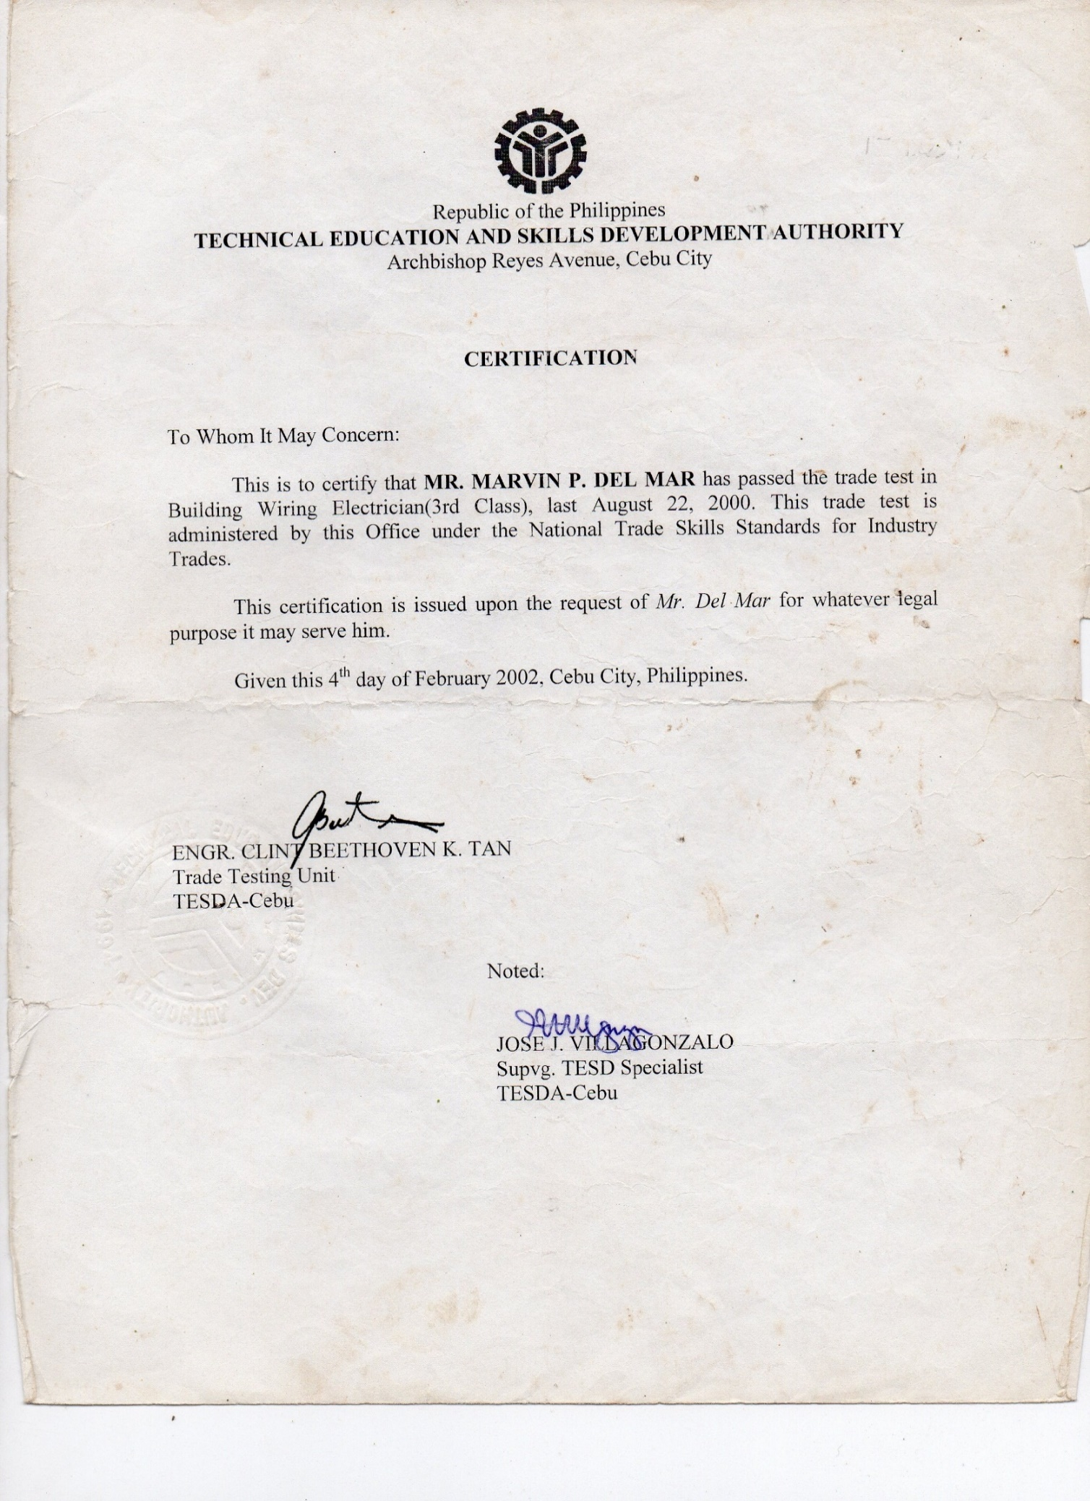

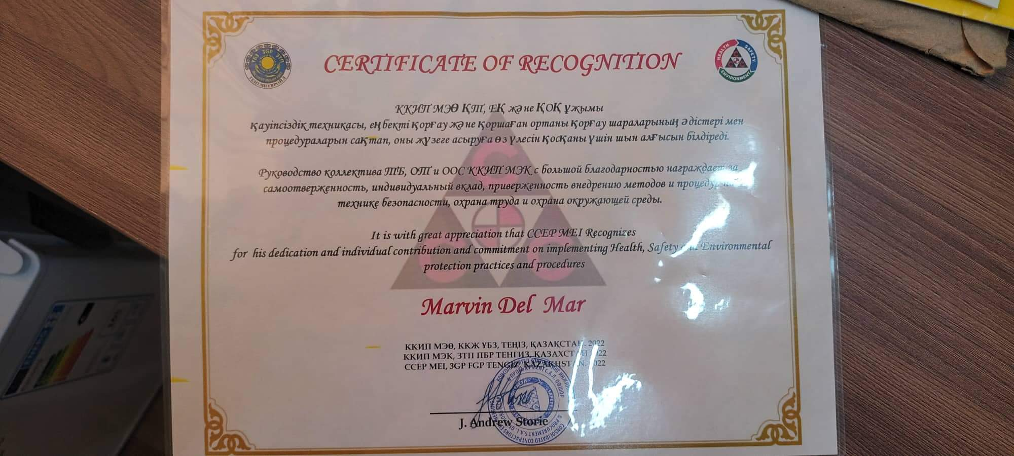

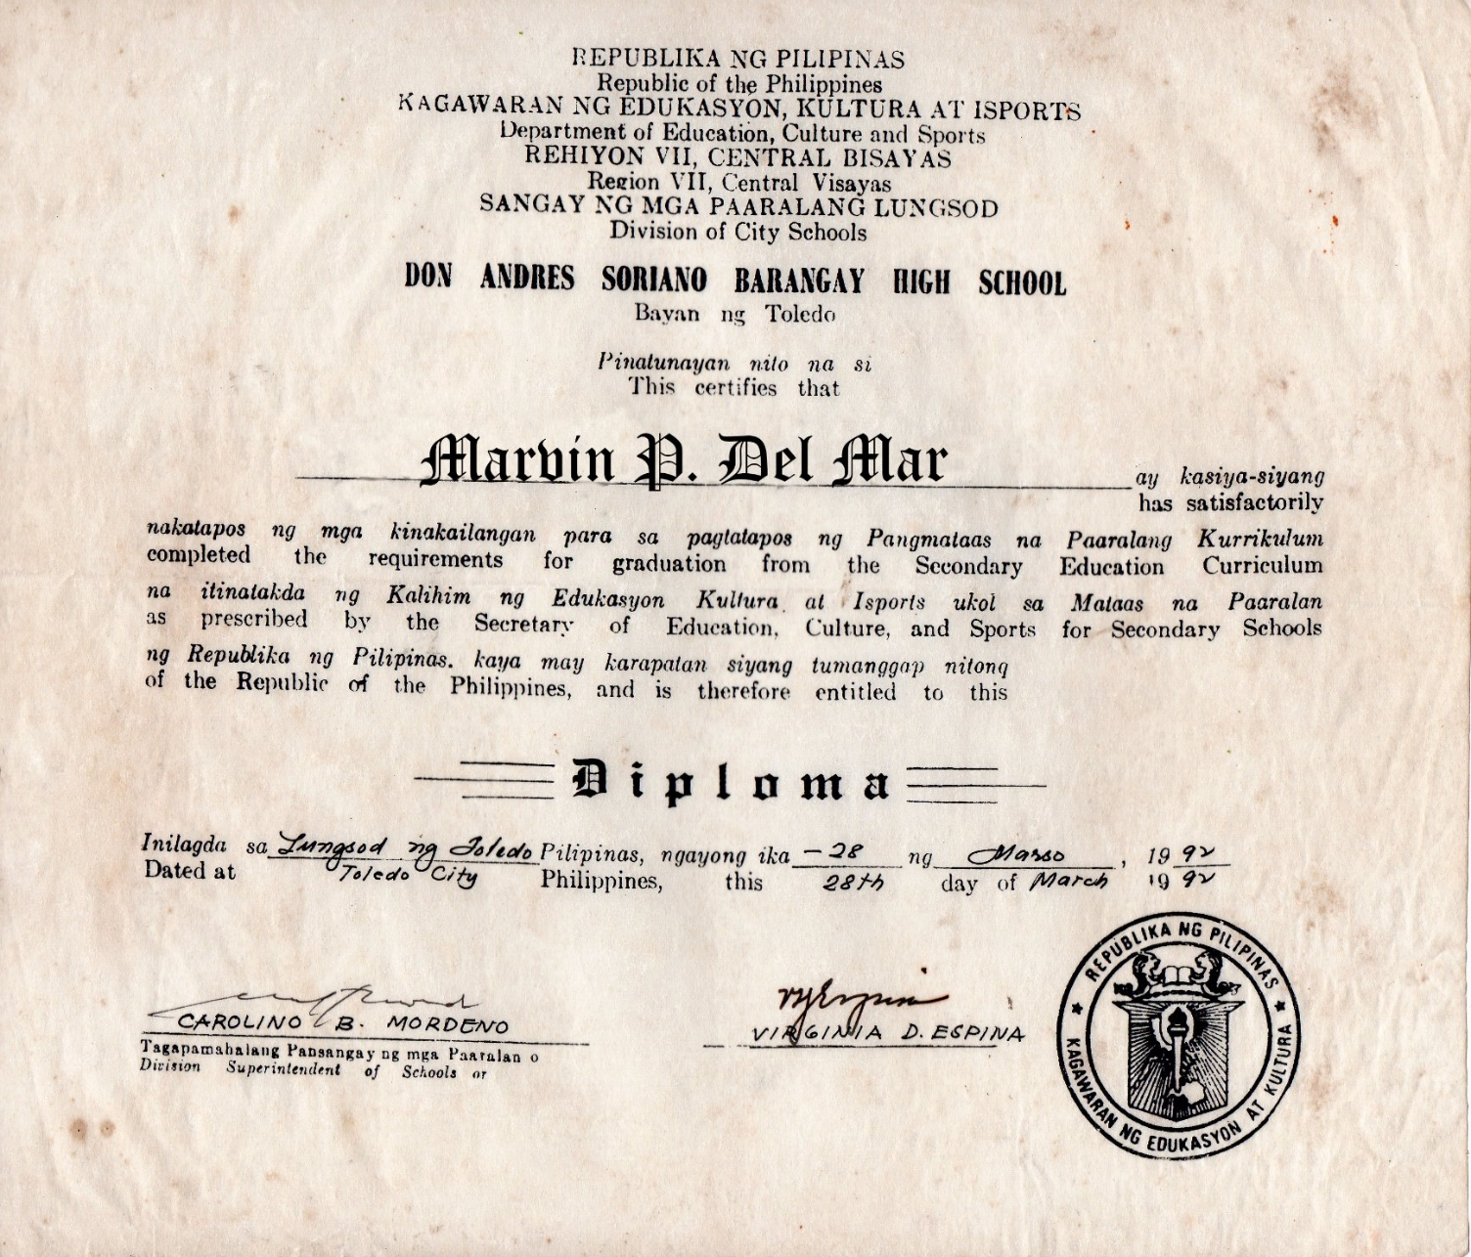

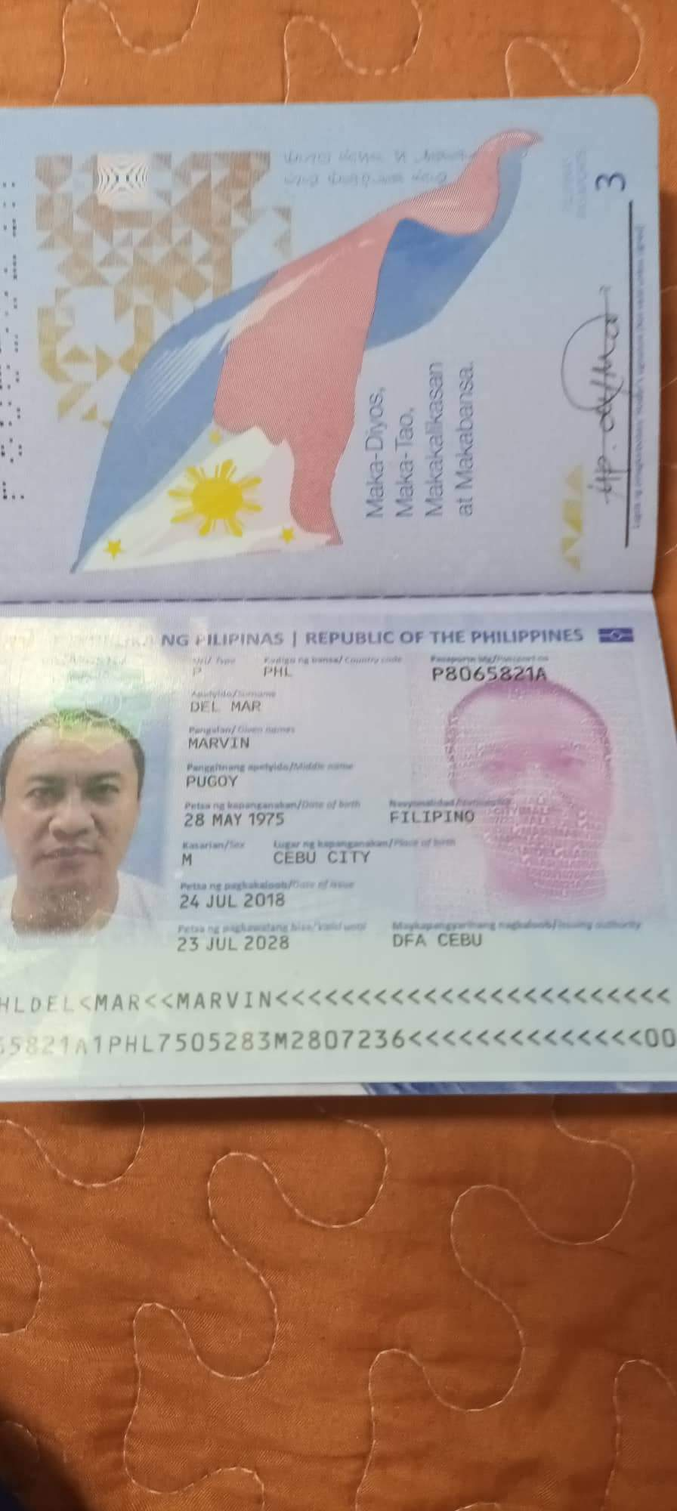

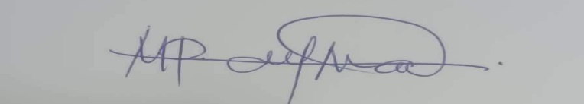
MARVIN P. DEL MAR
Passport No. P8065821A
Expiry: 23 July 2028

