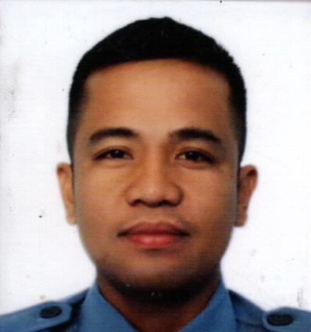
MARK ANTHONY C. ILAGA
Crisostomo St. Brgy. 11 Ben- Agan Batac City
Ilocos Norte, Philippines 2906
Mobile: 09668201681
ilagamarkanthony@gmail.com

OBJECTIVES:

To obtain a position in a company that enables my professionalism and development needed for an effective contribution to the company. A position that could give me an opportunity to integrate valuable management and to experience positive work attitudes. To strive through self-esteem and to enhance my skills and knowledge.

PERSONAL INFORMATION:
Age: 37 years old
Date of Birth: February 26, 1985
Place of Birth: Batac City, Ilocos Norte
Civil Status: Married
Religion: Roman Catholic
Nationality: Filipino

EDUCATIONAL BACKGROUND:

Tertiary: Data Center College of the Philippines
Laoag City, Ilocos Norte
Bachelor of Science in Criminology
S.Y. 2005 – 2009

Secondary: Batac Junior College
Batac City, Ilocos Norte
S.Y. 1998 – 2001

Elementary: Benigno Macadaeg Memorial Elementary School
Batac City, Ilocos Norte
S.Y. 1992 – 1997

WORK EXPERIENCES:

- Bureau of Jail Management and Penology
Position: Jail Officer I
July 12, 2010 – October 15, 2020
Position: Jail Officer II
October 16, 2020 – Present

TRAINING EXPERIENCES:

- BJMP Ilocos Norte Firearm Proficiency Training
(1st PJA Challenge Cup)
Bureau of Jail Management and Penology
Ilocos Norte
December 23, 2019

- “Disaster and Preparedness, Basic Emergency Medical Operation, Fire Prevention, Detection and Suppression Information Campaign”
City Disaster Risk Reduction Management Office and Bureau of Fire Protection
Batac City, Ilocos Norte
August 14, 2019

- Therapeutic Community Modality Program Seminar Workshop
Bureau of Jail Management and Penology
Regional Office I
February 11 – 15, 2019

- Basic Cooperative Course
Bureau of Jail Management and Penology
Regional Office I
November 17, 2015

- Intelligence and Investigation Seminar Workshop
Bureau of Jail Management and Penology
Regional Office I
November 31, 2014 – December 2, 2014

- Gender Awareness and Development
Civil service Commission
May 17, 2012

- Jail Basic Recruit Course
National Jail Management and Penology Training Institute
August 27, 2010 – December 20, 2010
CHARACTER REFERENCES:

- Senior Jail Officer IV Francis D. Tabios
Unit Executive Senior Jail Officer
Laoag City Jail, Bureau of Jail, Management and Penology
Brgy. 1 San Lorenzo Laoag City, Ilocos Norte 2900
Philippines
Mobile Number: +63 915 434 6900

- Jail Chief Inspector Cremencio A. Alones Jr.
Officer In Charge
Batac District Jail, Bureau of Jail, Management and Penology
City of Batac, Ilocos Norte 2906
Philippines
Mobile Number: +63 917 166 1136

I hereby certify that all information above is true and correct to the best of my knowledge.

Mark Anthony C. Ilaga

Applicant

