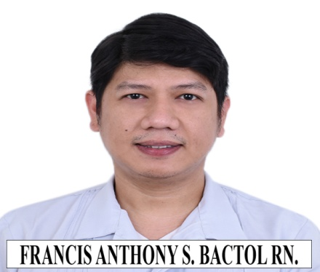
Francis Anthony S. Bactol
2531 Felix Huertas St. Sta.Cruz Manila Philippines Cellphone no.: +639458571469
E-mail: fasb1313@gmail.com

EMPLOYMENT OBJECTIVE:

To obtain a position in a Health Care Facility where I can utilize my skills, knowledge and experience to provide holistic care.

PERSONAL INFORMATION:

DATE OF BIRTH: September 13, 1984
AGE: 38
BIRTH PLACE: Manila
SEX: Male
CIVIL STATUS: Single
RELIGION: Catholic
LANGUAGE / DIALECT: Filipino, English
HEIGHT: 5’6 ½ feet
WEIGHT: 73 kgs.

EDUCATIONAL BACKGROUND:

COLLEGE: METROPOLITAN MEDICAL CENTER COLLEGE OF ARTS AND SCIENCES
Bachelor of Science in Nursing
2004-2010

HIGH SCHOOL: University of Santo Tomas High School
1997-2001

GRADE SCHOOL: Felipe G. Calderon Integrated School
1991-1997

EXAMINATION PASSED:
NURSING LICENSURE EXAM: 2017

WORK EXPERIENCE:

September 2019 – March 2020 : Dr. Jose R. Reyes Memorial Medical Center
PAYWARD 1 & 2 (MEDICAL/SURGICAL)

March 2020 – July 2020 : Dr. Jose R. Reyes Memorial Medical Center
COVID WARD

July 2020 – August 2021 : Dr. Jose R. Reyes Memorial Medical Center
ORTHOPEDIC WARD

August 2021 – May 2022 : Dr. Jose R. Reyes Memorial Medical Center
EMERGENCY SERVICE COMPLEX

May 2022 – present : Dr. Jose R. Reyes Memorial Medical Center
PAYWARD 1 (MEDICAL/SURGICAL)

CHARACTER REFERENCE:

ALICIA N. SALAMANCA RN., ET., MAN.
CHIEF NURSE
Dr. Jose R. Reyes Memorial Medical Center
87436918 local 212

TARCISIA F. RAGANIT RN.
NURSE MANAGER (ORTHOPEDIC WARD)
Dr. Jose R. Reyes Memorial Medical Center
87436918 local 277

ANNALIZA S. SAN ANTONIO RN.
NURSE MANAGER (PAYWARD 1)
Dr. Jose R. Reyes Memorial Medical Center
87436918 local 268

FRANCIS ANTHONY S. BACTOL RN.

