 | EMMANUEL CANETE  Project and System Design Engineer
  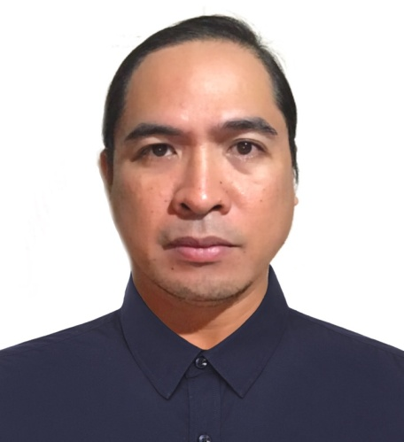
  PROFILE
  Project and System Design Engineer with 5+ years technical experience in system designs, project management and system integration. Possess a Bachelor’s Degree in Electrical Engineering and expertise in safety systems design and integration in the oil and gas industry. Looking to leverage my knowledge and experience to effectively fill the role that suits my qualification.
  PHONE
  (63) 905 491 3234
  EMAIL
  emmanuelccanete@gmail.com
  ADDRESS
  Purok Duranta Cogon Poblacion Lilo-an Cebu, Philippines 6002
  LINKEDIN
  linkedin.com/in/Emmanuel-canete-73488990
  PROFESSIONAL EXPERIENCE
  Project System and Design Engineer
  Omega Integration Pte Ltd, Singapore
  Jul 2021 – Oct 2021
  - Experienced in technical designs of Telecommunication systems for Oil and Gas industry such as Public Address and General Alarm Systems (PAGA), Page Party, and PABX system.
  - Detailed knowledge in Jotron PAGA system and Gai-tronics PAGA and Page Party systems technical designs, configuration and troubleshooting.
  - Experienced in Ericsson and AVAYA PABX Systems set- up and configuration to integrate with other systems.
  - Experienced in using EASE software for sound coverage study.
  - Experienced in on-site installation, hardware set-up, configuration, cable routing and troubleshooting or responds remotely to multiple international locations.
  - Assist manager in preparing technical proposals.
  - Managed and execute the projects to be cost effective, meet timely delivery, quality standards and client’s expectation.
  - Preparing technical proposals with good quality, competitive, complete and compliance to client’s requirements and on timely manner.
  - Assisting sales team in client’s meeting for technical clarification.
  System Engineer
  Vector Infotech Pte Ltd, Philippines
  Oct 2019 – Jan 2020
  - Experienced in telecommunication system design of BOSCH IP PAGA, Page Party & Intercom System, and Access Control System.
  - Technical and hands-on knowledge in design, installation, site-testing and commissioning and troubleshooting of telecommunication and security systems.
  - Provide engineering support including engineering drawings, documentation, etc. in accordance to contractual requirements within projected schedules and timelines.
  PROFESSIONAL EXPERIENCE
  Project System and Design Engineer
  Omega Integration Pte Ltd, Singapore
  Jun 2017 – Aug 2019
  - Experienced in technical designs of Telecommunication systems for Oil and Gas industry such as Public Address and General Alarm Systems (PAGA), Page Party, and PABX system.
  - Detailed knowledge in Jotron PAGA system and Gai-tronics PAGA and Page Party systems technical designs, configuration and troubleshooting.
  - Experienced in Ericsson and AVAYA PABX Systems set- up and configuration to integrate with other systems.
  - Experienced in using EASE software for sound coverage study.
  - Experienced in on-site installation, hardware set-up, configuration, cable routing and troubleshooting or responds remotely to multiple international locations.
  - Assist manager in preparing technical proposals.
  - Managed and execute the projects to be cost effective, meet timely delivery, quality standards and client’s expectation.
  - Preparing technical proposals with good quality, competitive, complete and compliance to client’s requirements and on timely manner.
  - Assisting sales team in client’s meeting for technical clarification.
  Sales Support Engineer
  Marshal Systems Pte Ltd, Singapore
  Apr 2008 – Apr 2012
  - Prepared competitive sales proposals, quotations and deviation list while ensuring the specification offered to customers are within company’s scope and fully satisfied the required specifications.
  - Prepared catalogue, brochure and presentation materials which include single line diagram for company’s range of products or system outline and present to the customer when necessary.
  - Conducted technical presentations to prospective customers and managed sales through new and existing one.
  - Negotiated sales contract and sales pricing while ensuring the continuation and enhancements of services.
  - Provided pre-sales consultation and after sales services and ensured that all works carried out were of highest quality standard to meet customer’s satisfaction.
  - Cold and warm calling of prospective clients to establish new business which resulted to the increase of sales revenue.
  Manufacturing Technician
  Lexmark International Phils. Inc., Philippines
  Apr 2004 – Apr 2008
  Thickfilm / Lexfilm process
  - Leading a team of new technicians to provide technical support, implementing the work in procedures and equipment preventive maintenance.
  - Supported R&D in developing new process and experienced in handling Karl Suss mask wafer aligner.
  - Monitored wafer probing failure and wafer map signatures including troubleshooting cases of non-conformance.
  - Experienced in statistical process control (SPC) for product quality and failure analysis and debugging to enhanced productivity.
  - Maintained good documentation and compliance to quality standards such as ISO9000.
  Tab Bond Process
  - Experienced in handling Kulicke and Soffa equipment including set-up and calibration.
  - Performed scheduled equipment preventive maintenance for equipment reliability and troubleshooting of machine breakdown.
  - Performed die to circuit reel flex bonding.
  Electrical Testing Process (E-Test)
  - Maintained and observed key-sight parametric testers / probers and performed calibration of measuring instrument.
  - Troubleshooting on prober / tester for testing reported issues.
  - Helped on reducing cost, yield or prober / tester performance by initiating and completing various Continuous Improvement Program projects.
  EDUCATION
  Graduated on Oct 2001
  Bachelor Of Science
  in Electrical Engineering
  Cebu Institute of Technology-University
  Cebu City, Philippines
  KEY SKILLS
  - Project Management
  - Troubleshooting
  - Customer Service
  - System Integration
  - Negotiation
  ADDITIONAL SKILLS
  English(Fluent)
  100%
  Microsoft Office
  90%
  Team Leadership
  90%
  PERSONAL DEVELOPMENT TRAININGS
  - Completed the AVAYA AIPS-SME credential training. (PABX SYSTEM).
  - Attended the PELCO Endura System and Network Planning (CCTV SYSTEM).
  - Work at Height Course Training
  - First Aid and Basic Fire Fighting
  - Crowcon Fire and Gas Explosion-proof Equipment

