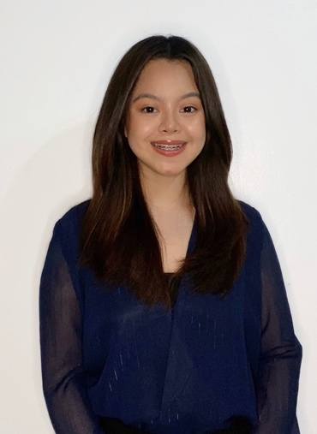
FAYE MARIE S. ALORA
211 A Purok 4 Biga 1, Silang, Cavite
0995 021 9175
fayaalora.work@gmail.com

OBJECTIVE
An applicant that aims to apply the knowledge learned as an Industrial Engineer. Seeking a career that will give me an opportunity to apply my technical skills and abilities in my future career.
EXPERIENCE
TOMS Manufacturing Corporation
Intern – Quality Assurance Department
March – May 2022
Analog Devices Inc.
Outsource Planner – External Manufacturing
September 2022 - Present

EDUCATIONAL BACKGROUND
TERTIARY De La Salle University – Dasmariñas
Bachelor of Science in Industrial Engineering with Specialization in Organization and Decision System
2018 – 2022
SECONDARY Philippines Christian University – Dasmariñas
Science, Technology, Engineering, and Mathematics
2016 – 2018
SKILLS
- Computer Literacy
- Microsoft Office
- Knowledge in SAP software
- Time Management
- Adaptability
- Flexibility
- Teamwork
- Communication Skills

____________________________________________________________________________________
AWARDS AND RECOGNITION
2021 Dean’s Honor List
A.Y. 2020-2021, 2nd Semester
Top Performing 3rd Year IE Students of the Year
A.Y. 2020-2021, 2nd Semester
Dean’s Honor List
A.Y. 2020-2021, 1st Semester
2020 Top 10 Performing 2nd Year IE Student of the Year
A.Y. 2019-2020, 1st Semester
_____________________________________________________________________________________________
TRAININGS AND SEMINARS
STIES XII – Recalibrate: Configuring Industries, Programming the Future Towards Advanced Engineering
Zoom Webinar, May 15, 2021
Joint Congress of the Asian Council of Ergonomics and Design (ACED) and the Southeast Asian Network of Ergonomics Societies (SEANES) 2020: Convergence, Partnerships, and Breakthroughs
Zoom Webinar, December 4, 2020
How Lean Six Sigma Practitioners Think
Zoom Webinar, December 4, 2020
STIES XI – Cultivate: Transforming Industries Towards Sustainability and Green Engineering
University of the Philippines Los Baños, Laguna, October 12, 2019
16th PIIE Congress National Student Congress - Diverge: Skewing Lines Beyond the Realm of Industial Engineering
PICC, March 10, 2019
_____________________________________________________________________________
REFERENCE:
Engr. Jashell S. Garcia, CLYSSB
Associate Engineer, Project Management Office
Analog Devices
Phone: 0956 885 5371
Email: jashell.garcia@analog.com

