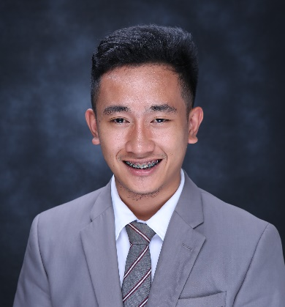
ALLEN CHRISTIAN J. CATACUTAN
AJ815 Soli St. Ajoya Subd. Gabi Cordova, Cebu
Contact No. 09065445860
Email Add: allenchristiancatacutan@gmail.com

OBJECTIVE

To apply in a progressive company which can help me expand my knowledge and provide me with opportunities to utilize my skills and qualifications to produce adept results.

ELEGIBILITY
CAAP ( Airframe and Powerplant ) – License # 150070

WORKING EXPERIENCE

On-the-Job Trainee- Mactan Aviation Technology Center, INC
General Aviation, Basak, Lapu-lapu City, Cebu

Helper Mechanic Trainee- OMNI AVIATION CORPORATION
Manuel A. Roxas Highway, Clark Freeport Zone
Clark Field, Angeles City Pampanga

Cargo Agent- PHILIPPINE AIRPORT GROUND SUPPORT SOLUTION (PAGSS)
Lapu-Lapu Airport, Lapu-Lapu City

SEMINARS / TRAININGS ATTENDED

Line Maintenance ( Marshalling, Towing, Mooring, Refueling and Pre-flight Inspection)
OMNI AVIATION
July 6, 2019

Actual Safety Wiring
OMNI AVIATION
July 10, 2019

Introduction to Aircraft Painting and Corrosion Control
OMNI AVIATION
July 3, 2019

Basic Hand Tools
OMNI AVIATION
July 5, 2019

Aircraft Weight and Balance
OMNI AVIATION
June 22, 2019

Technical Publications
OMNI AVIATION
July 9, 2019

Philippine Civil Aviation Regulation ( Part1-Part9)
OMNI AVIATION
Jun 25,2019

Service Personality Briefing
OMNI AVIATION
July 16, 2019

Emergency Response Procedures
OMNI AVIATION
July 4, 2019

Introduction To Safety Management System And Crew Resource Management
OMNI AVIATION
June 21, 2019

Human Factor and Error Management
PHILSCA
February 27, 2019

Aviation Safety ( Dirty Dozen Things )
PhilSCA
September 11, 2015

SKILLS

Basic knowledge about Airframe and Powerplant
Basic Knowledge about safety wiring
Computer Literate (Basic knowledge about MS Offices)
Able to communicate well in English language

QUALIFICATIONS

- God-Fearing Person
- Can work under pressure
- Mechanically inclined in the field of aviation
- Dedicated and hardworking individual
- Team player
- Team leader
- Always ready to learn

EDUCATIONAL BACKGROUND

Tertiary: Philippine State College of Aeronautics
Mactan, Air Base, Lapu-lapu City, Cebu
BS in Aircraft Maintenance Technology
2019

Secondary: Sindangan National High School
Dapaon, Sindangan, Zamboanga del Norte
2014

Primary: Saint Jude College
Salawag Dasmariῆas Cavite
2010

PERSONAL INFORMATION

Date of Birth: December 9, 1997
Place of Birth: Sindangan, Zamboanga del Norte
Age: 22
Civil Status: Single
Citizenship: Filipino
Religion: Seventh Day Adventist
Height : 5’4”
Weight : 69 kgs
Spoken Language: English, Tagalog, Cebuano

CHARACTER REFERENCE

Mr. Amiel D. Trayvilla, MPA
Registrar, Philippine State College of Aeronautics
Mactan Airbase, Lapu-Lapu City, Cebu, Philippines
Mobile No. +639065968401

Mr. Veronico T. Garcia
Maintenance Manager
Mactan Aviation Technology Center, Inc.
Gen. Ave. Area Mactan-Cebu Int’l Airport, Lapu-lapu City, Cebu
Mobile No. 09566451521

Mr. John C. Viernas
Student Accounts
Maintenance Training Center
OMNI Aviation Corporation
Manuel A. Roxas Highway, Clark Freeport Zone Clark Field, Angeles City Pampanga
Mobile No. 09497390934

Thank you for your time in considering my application, if you need any additional information please don’t hesitate to contact me at 09065445860/ allenchristiancatacutan@gmail.com .Good day and God bless.

