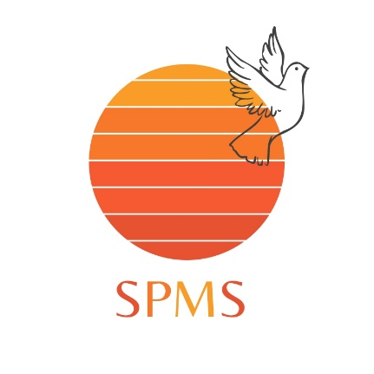

SMART POINT MIGRATION SERVICES
Office land building no 2 first floor

Interview and job offer steps and procedures

1-applicant need to share CV and bio page of the passport.
2-Smart Point will create the applicant profile and sent to our recruitment agency in Australia.
3-in a maximum time of 2 weeks applicant will receive a direct email from the
Australian employer with the date and time of the interview,
Usually interviews are done through Google meet app or zoom app.
4- 2 to 4 weeks maximum applicant will receive a direct email from the recruiter with the job offer letter (attested job offer) also an invitation letter will be sent from the recruiter to our visa processing team to support your application.
Note that all Australian employer information and details will be mentioned in the emails and provided from our side.
5-in case applicant is not successful on the video interview we will arrange a 2nd interview for the applicant with a different employer.
And also in case applicant is not successful in the 2nd interview a full refund of the first payment will paid back to the applicant within one week.

Visa processing

- After receiving invitation letter as well as the job offer, Smart Point processing team will start preparing for the visa application and list of document will be requested from the applicant.

Note: Smart Point processing team will assist the applicant to prepare the document.

- When all documents are ready visa application will be submitted online.
- If immigration requests for biometric or medical will be checked.
Smart Point team will make and assist you to do the booking.
- Wait for visa approval- 1-6months time frame.
- Smart Point will assist the applicant and arrange the post- landing services in Australia

Which includes the following:

  - Airport pick-up in Sydney and transfer to the accommodation.
  - Allocate the employer or assist applicant in legal procedure inside Australia in order to get the permanent residency.

Payment Procedure
One-time payment- 10,500 AED
Installment Basis
- Initial Payment- 3,000 AED
- After Job Offer- 3,500 AED
- On time of biometrics- 4,000 AED
- After Visa Approval- 2,000 AED

Total: 12,500 AED

Government application fees:
Visa application- 151AUD
Biometric fee- 200AED
Note: In case of visa refusal, Smart point processing team will check the refusal reason and will check on the applicant’s document and circumstances and will reapply the visa application for free. In case visa will be refused the second time, refund policy of 50% excluding government fee will be applied.
Applicant with partner or Kid- no additional fee applied except for government fee for each additional member.

DOCUMENTS NEEDED FOR VISA APPLICATION

- Photograph of each applicant- passport size
- Full pages of current passport
- All pages of expired passport
- Proof of employment such as:
  - Work contract
  - Salary certificate
  - Employment certificate
  - Bank statement or pay slip
- Proof of legal status in current country
- Travel history
- Family documents such as:
  - Birth Certificate
  - Marriage Certificate
- Proof of funds
  - 3 months bank statement or any proof of assets
- Valid government ID

Note: All documents must be professionally scanned before sending.

