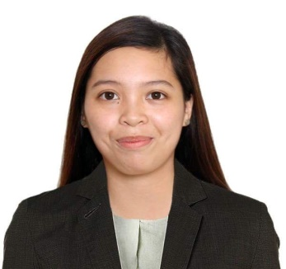

JOYCE M. CLAVO
Purok 6 San Jose City of San Fernando Pampanga
Mobile No.: 09974722950
Email: joyceclavo22@gmail.com

OBJECTIVE

Seeking an opportunity where I will be able to utilize my skills to contribute my knowledge to the growth of the company, and ability to work well with people, which allow me to grow personally and professionally.

PERSONAL INFORMATION

Date of Birth : February 22, 1997
Age : 25 years old
Place of Birth : San Fernando, Pampanga
Height : 5’6
Weight : 57 kgs

SPECIAL SKILLS

- Work well without supervision
- Possess good interpersonal and communication skills and manages multi-tasking effectively
- Has zest for learning and willing to be trained
- Proven team player, flexible, fast learner and alert
- Ability to work independently or as part of a team
- Computer literate in basic software application

EDUCATIONAL ATTAINMENT

Tertiary : Pampanga State Agricultural University
: San Agustin Magalang, Pampanga

Year Graduated : 2014-2018

Course : Bachelor of Science in Hotel and Restaurant Management

WORK EXPERIENCE
Food and Beverage Hostess (November, 2021- June, 2022)
Swissôtel Clark Philippines
Lot 2A, Lot 2B 2E1 Manuel A. Roxas Highway, Corner Claro M. Recto Highway, Clark Freeport, Zone, 2023 Pampanga

On-call Slot Attendant (February 2021- August 2021)
Widus Hotel and Casino Clark 5400 Manuel A. Roxas Highway, Clark Freeport Zone, Pampanga, Philippines

Food and Beverage Attendant (May, 2018 – January, 2020)
Widus Hotel and Casino Clark
5400 Manuel A. Roxas Highway, Clark Freeport Zone, Pampanga, Philippines

Penthouse Hotel On-the-Job-Training - (April 12, 2017)
4-3 A.Santos St., Balibago, Angeles City, Pampanga, Philippines

SEMINARS AND WORKSHOPS ATTENDED

Front Office Seminar with Property Management System Feb 24, 2016
Astoria Culinary and Hospitality Institute
PSAU, Farmer’s Training Center

Housekeeping Seminar with Bed making Procedures Feb 23, 2016
Astoria Culinary and Hospitality Institute
PSAU, Farmer’s Training Center

Front Office Procedures
Farmer’s Training Center Hostel Nov 10, 2016 Magalang, Pampanga

CHARACTER REFERENCE

Mr. Eduardo Tenioso Ms. Rachelle Canete Mr. Sean Mathew Solis
Outlet Manager Assistant Outlet Manager Supervisor
+639171900270 +639265475707 +639206428225

I hereby certify that the above information given are true and correct as to the best of my knowledged

Joyce M. Clavo
Applicant

