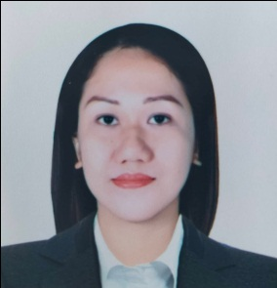
Rochelle Madrid Castro
EM Lacsamana Street, Catbangen
City of San Fernando, La Union, Philippines
castrochelle14@gmail.com
0998 358 1804

Career Objective:
To build a career that offer challenge and growth with opportunities to enrich my knowledge and skill while contributing my best to the organization I work for.

Working Experience:
Cashier
Paz Money Changer
December 2011-February 2021

Sales Associate
Mart One, La Union
January 2010-Janaury 2011

Seasonal Cashier
Mart One, La Union
December 1-31, 2009

Cashier
CSI, La Union
November 2008-May 2009

Service Crew
Greenwich, La Union
May 2007-September 2007

Personal Profile:
Birthdate : January 14, 1990
Age : 32 yrs. old
Birth Place : Paniqui, Tarlac City
Civil Status : Single
Religion : Roman Catholic
Citizenship : Filipino

Educational Attainment:
Tertiary : Bachelor of Science in Computer Engineering
National College of Science and Technology
College level
2006-2008

Secondary : La Union National High School
San Fernando City, La Union
2005-2006

Primary : Paringao Elementary School
Paringao, Bauang, La Union
2001-2002

Professional Profile:
- Time management
- Full of Patience to work
- Teamwork and collaboration
- Communication Skills

Character Reference:

Wilhelmino Araojo
Business Owner
Paz Money Changer
San Fernando City, La Union

Amorlina Racadio
Store Manager, Mart One, La Union
San Fernando City, La Union

Marian Gale Go
Store Manager, Greenwich, La Union

I hereby certify that the above information is true and correct to the best of my knowledge and belief.

Rochelle M. Castro
Applicant

