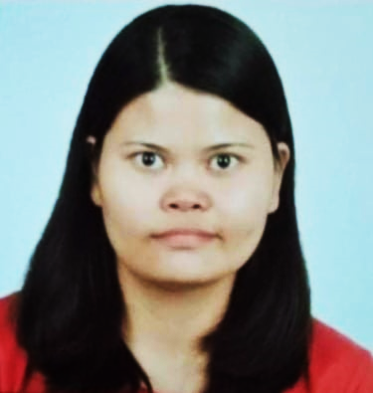
GLORIA REYES
474 Sitio Ibaba Maguyam
Silang, Cavite Philippines 4118
09452765692
klawria23@gmail.com
____________________________________________________

Objective: To obtain a full-time position that would provide me opportunities to utilize my knowledge and skills while continuously striving to improve and reach my full potential in my chosen field of expertise.

Education : Personal Support Worker (PSW)
PinoyWish Training Center, Inc.
2/F Unit 210 AIC Burgundy Empire Tower
ADV Avenue Ortigas, Pasig City
February 01 – March 17, 2022

Vocational
Caregiving NC II (822 Hours)
Personal Health Support Worker (PHSW)
MJ Padua Caregiving School
General Trias, Cavite
S.Y. September 8, 2020 – March 22, 2021

College
Nursing Aide
AMA Computer College
Dasmariñas, Cavite
S.Y. 2006 – 2007

Secondary
Bulihan Sites and Services High School (DNHS Annex)
BulihanSilang, Cavite
S.Y. 1992 – 1996

Working Experiences : Operator
TaiPhilProtech Industrial, Inc.
Carmona, Cavite
September 17 – November 11, 2020

Inline Presser
Kojimairyo Philippines, Inc.
Silang, Cavite
March 24 – May 20, 2019

Production Helper
Corporate MACRO – Management
Resources, Inc.
Legaspi Village, Makati City
February 20, 2017 – December 31, 2018

Production Helper – Manual Gluing
United Graphic Expressions Corporation
Damariñas, Cavite
March 24, 2010 – February 17, 2017

Skills : Hardworking
Good communication skills
Able to work under pressure
Effective time management skills
Willing to undergo necessary trainings

​Personal Data : Age : 43
Date of Birth : December 23, 1978
Place of Birth : GMA, Cavite
Civil status : Single
Citizenship : Filipino
Religion : Roman Catholic
Height : 5’1”
Weight : 60 kg.

References : Ms. Mary Rose Posion
Production Helper/Operator
MK Slider Philippines Corporation
09565504316

Irene Pardiñas - Marucot
Accounting Staff
Zamperla Asia Pacific, Inc.
09771529301

Ms. Leticia Verdeflor
Hospital Housekeeper
Philippine Orthopedic Center – Quezon City
(02) 711-42-76 local 225

