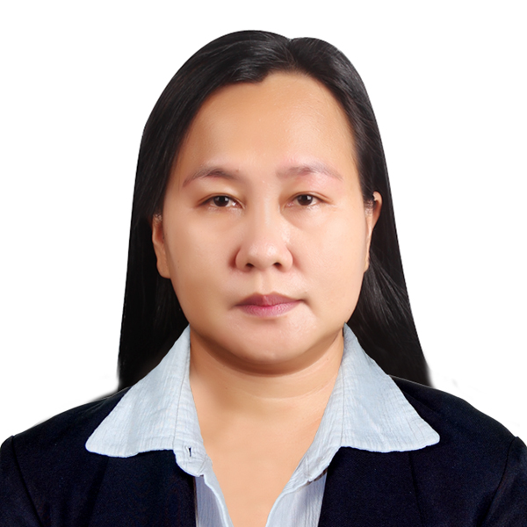

JOY BAUTISTA ANTONIO
#83 Cabalaoangan Norte, Rosales, Pangasinan
joygarnet110.ja@gmail.com
+639693189595

Basic Information
Age Birth Date Gender Civil Status 43 Jan 10, 1979 Female Married
Height (cm) Weight (kg) Nationality Religion
154 64 Filipino Catholic

Work Experience

May 2018 – September 2022 | Junior Quality Control Technician  King Yuan Electronics Co.,LTD  Electronics & Semiconductors  Taiwan  Quality Control of Incoming and Outgoing products following the Operation Instructions and Quality Standard of the company. These standards are : High Quality, Effective Cost, On time Delivery and Customer Satisfaction.
Dec 2014 - Dec 2017 | Junior Quality Control Technician  King Yuan Electronics Co.,LTD  Electronics & Semiconductors  Taiwan
Quality Control for Incoming and Outgoing products following the Operation Instructions and Quality Standard of the company. These standards are: High Quality, Effective Cost, On Time Delivery, and Customer Satisfaction

April 2012 -Oct 2012

May 2001 - Dec 2007

Domestic Helper

Hongkong

Do household chores and child minding.

Branch Operation Manager (Supervisory)
P.J. Lhuillier Incorporated Banking and Financial Services
Makati City, Philippines
Supervise all the transactions of the branch. Jewelry loans, personal insurance, remittance both foreign and domestic, cash flows, creating business opportunities and customer service.

Educational Attainment

Graduated : October 1999  Graduated: March 1995  Graduated: March 1991 | Tertiary:  University of Luzon / Luzon Colleges  Bachelor of Science in Accountancy  Dagupan City, Pangasinan  Secondary:  Saint Joseph College / St. Joseph Academy  Baggao, Cagayan  Elementary:  San Blas Elementary School  Villasis, Pangasinan

Certification And Trainings

Nov 27, 2021 | Taiwan Native Language Advanced Class  P6656048B
Dec 05, 2021  Graduated: June 4, 2011 | Chinese Mandarin Learning Course: Introductory Level  KD30031133
Caregiver
Fil-Canadian Training and Dev’t Center
Caregiving National Certificate II
11010402010709
Feb 2012 – March 2012
Household Services Training for NC II
PSAA international Academy

OTHER TRAININGS:
Team Building Workshop
Interaction Skills for Success Workshop
Basic Supervisory Skills Workshop

Skills Computer literate, Professionalism and Strong Work Ethics, Critical thinking and Leadership

Languages Tagalog, English and Basic Mandarin

