
John Philip S. Felices
Blk 6 Lot 52 ACM homes Anabu 2b Imus, Cavite
Mobile: 09613163828
Email: felicesmicco@gmail.com

Objective

I am looking for a job where I can utilize my skill and knowledge. I want to learn from the organization and growth with organization.

License

Airframe and Power plant license number: 133252- AMT
(Civil Aviation Authority of the Philippines)

Educational Attainment

College:
Bachelor of Science in Aircraft Maintenance Technology
Philippine State College of Aeronautics(2012-2014)
Piccio Garden, Villamor, Pasay City

Associate in Aircraft Maintenance Technology
Philippine State College of Aeronautics(2010-2012)
Piccio Garden, Villamor, Pasay City

High School:
Unida Christian Collages (2006-2010)
Imus, Cavite
Elementary:
M Imus Pilot Elementary School (2000-2006)
Imus, Cavite

Work Experience
- SINGAPORE AIRLINES ENGINEERING PHILIPPINES
Position: Aircraft Structural Mechanic B (Maintenance Release Certifying Staff)
From Oct.04, 2017 – Present
(Civil Aviation Complex Zone, Clarkfield 2023, Andres Bonifacio Avenue, Clark Freeport, Mabalacat, Pampanga)
Job Description and Responsibilities
- Drills, countersinks, dimples, reams and tap holes for bolting, screws, riveting and installation of fasteners.
- Assembles parts and components and sub-assemblies using special jigs and fixture.
- Preform re-skinning, doors doublers repair, removal and installation of rivets, patching and splicing repair, re-works and replaces components to rectify damage or malfunctioning components.
- Repair, replacement and installation of repairable and replaceable components such as flaps, ailerons, cowling, bulkhead, stringers, web, fuselage skin and other structural parts.
- Removes the threat corrosion, dents and scratches.
- Performed minor and major airframe structural repair such as re-skinning, flush patch repair, overlap repair, installation of rivets in various areas like bulkheads, stringers, spars and ribs in accordance of the Structural Repair Manual (SRM) and Service Bulletin (SB) of small and wide body type aircraft.
- Interpretation and perform of all kinds of repair in accordance with Structural Repair Manual (SRM), Service Bulletin (SB), Engineering Order (EO) and Blue Print as per local and International Aviation Standard.
- Performance of all those work is in accordance with Structural Repair Manual (SRM), Service Bulletin (SB), Engineering Order (EO) and Blue Print as per local and International Aviation Standard.
- Performs aircraft structural and sheetmetal repairs, modification and replacement of damaged parts in accordance with specific aircraft manuals and technical refferences ( SB, EI, EO).
- Assist in performing inspection and damage assessment of corroded structural parts, dent, scratch, gouge, lightning strike on the aircraft skin surfaces in accordance with the aircraft's Structural Repair Manual.
- Performs corrosion removal, control and treatment on aircraft sturctures and aircraft metallic parts in accordance with the aircraft manual and standard airframe general practices.
- Performs disassembly and assembly of airframe parts and components as called for in accordance with the work specification/ technical references of the aircraft undergoing maintenance schedule.
- Keep abreast with all work procedures, company policies, standards and manufacturer specification as applicable on the component, equipment and related accessories for complaince.
- Signing off work documentaions upon completion of any job/task.
- Maintain clean and neat working area at all times.
- Execute all work assigned in a safe, effecient and cost effective manner in order to help maximize the utilization of the company's manpower, materials, equipment and facilities.
- Performs other related duties as may be assigned from time to time.

Aircraft Handled
- Airbus A319, A320, A321, A330

- SINGAPORE AIRLINES ENGINEERING PHILIPPINES
Position: Aircraft Maintenance Trainee
(STRUCTURAL CATEGORY BATCH21)
From March 13,2017 – September 30, 2017

- On the job trainee in Lufthansa Technik Philippines, Inc. under AO Production – Line 1 Division from August 1, 2011 to December 31, 2011.

- On the job trainee in Philippine Air force, 15th strike wing Sangley Point, Cavite City 460th Maintenance and supply group from December 01, 2014 to May 29, 2015

CHARACTER REFERENCE:
Mr. Mark Andrew Dion
Sheet Metal Mechanic A
SIA Engineering (Philippines)
Clark Freeport Zone, Clark field Pampanga
Mobile Number: +639156769734
Mr. Gerald Mallavo
Sheet Metal Mechanic B
SIA Engineering (Philippines)
Clark Freeport Zone, Clark field Pampanga
CONTACT NUMBER: 09666740911

TRAININGS:
- AIRCRAFT MAINTINANCE TRAINING PROGRAM (SHEETMETAL TRAINING/STRUCTURAL TRAINING PROGRAM) BATCH 21
SINGAPORE AIRLINES ENGINEERING PHILIPPINES

- Airbus A318/A319/A320/A321 GENERAL FAMILIARIZATION LEVEL 1
SINGAPORE AIRLINES ENGINEERING PHILIPPINES

- AIRCRAFT ADVANCE STRUCTURAL COURSE
SINGAPORE AIRLINES ENGINEERING PHILIPPINES
- Cold Working
- Flap Peening
- Permaswage Repair
- Fuel Tank Safety
- Damage Mapping
- Electrical Wiring Interconnection System (EWIS)
- Philippines Civil Aviation Regulation (PCAR)
- Human Factors & Error Management
- Structural Repair Manual (SRM)
Personal Information
Age : 28 yrs old
Date of Birth : November 07, 1993
Place of Birth : Manila
Nationality : Filipino
Religion : Christian
Sex : Male
Height : 5’5”
Civil Status : Single

Seminars Attended
- Fleet Planning and Aircraft Selection
Vista Venice Resort, Morong, Bataan
January 31, 2014

- Human Factors and Aviation Safety
Vista Venice Resort, Morong, Bataan
January 31, 2014

- Aviation Career Path: A Key to Better Aeronautical Profession
Air Force Museum, Villamor Air Base, Pasay City
March 19, 2011

- Aircraft Electrical System: General Familiarization
Air Force Museum, Villamor Air Base, Pasay City
March 19, 2011

- Powerplant Technology: Advancement in Gas Turbine Propulsion
Air Force Museum, Villamor Air Base, Pasay City

Skills
- Knowledgeable and efficient in communication skills
- Coordination – adjusting actions in relation to other’s action
- Active learning- understanding the implications of new information for both current and future problem solving and decision making
- Equipment selection- determining the kind of tools and equipment needed to a job.
Strengths
- Work efficiency with diverse group of people
- Hungry for work
- Quick learner
- Has capacity to finish work with time is given

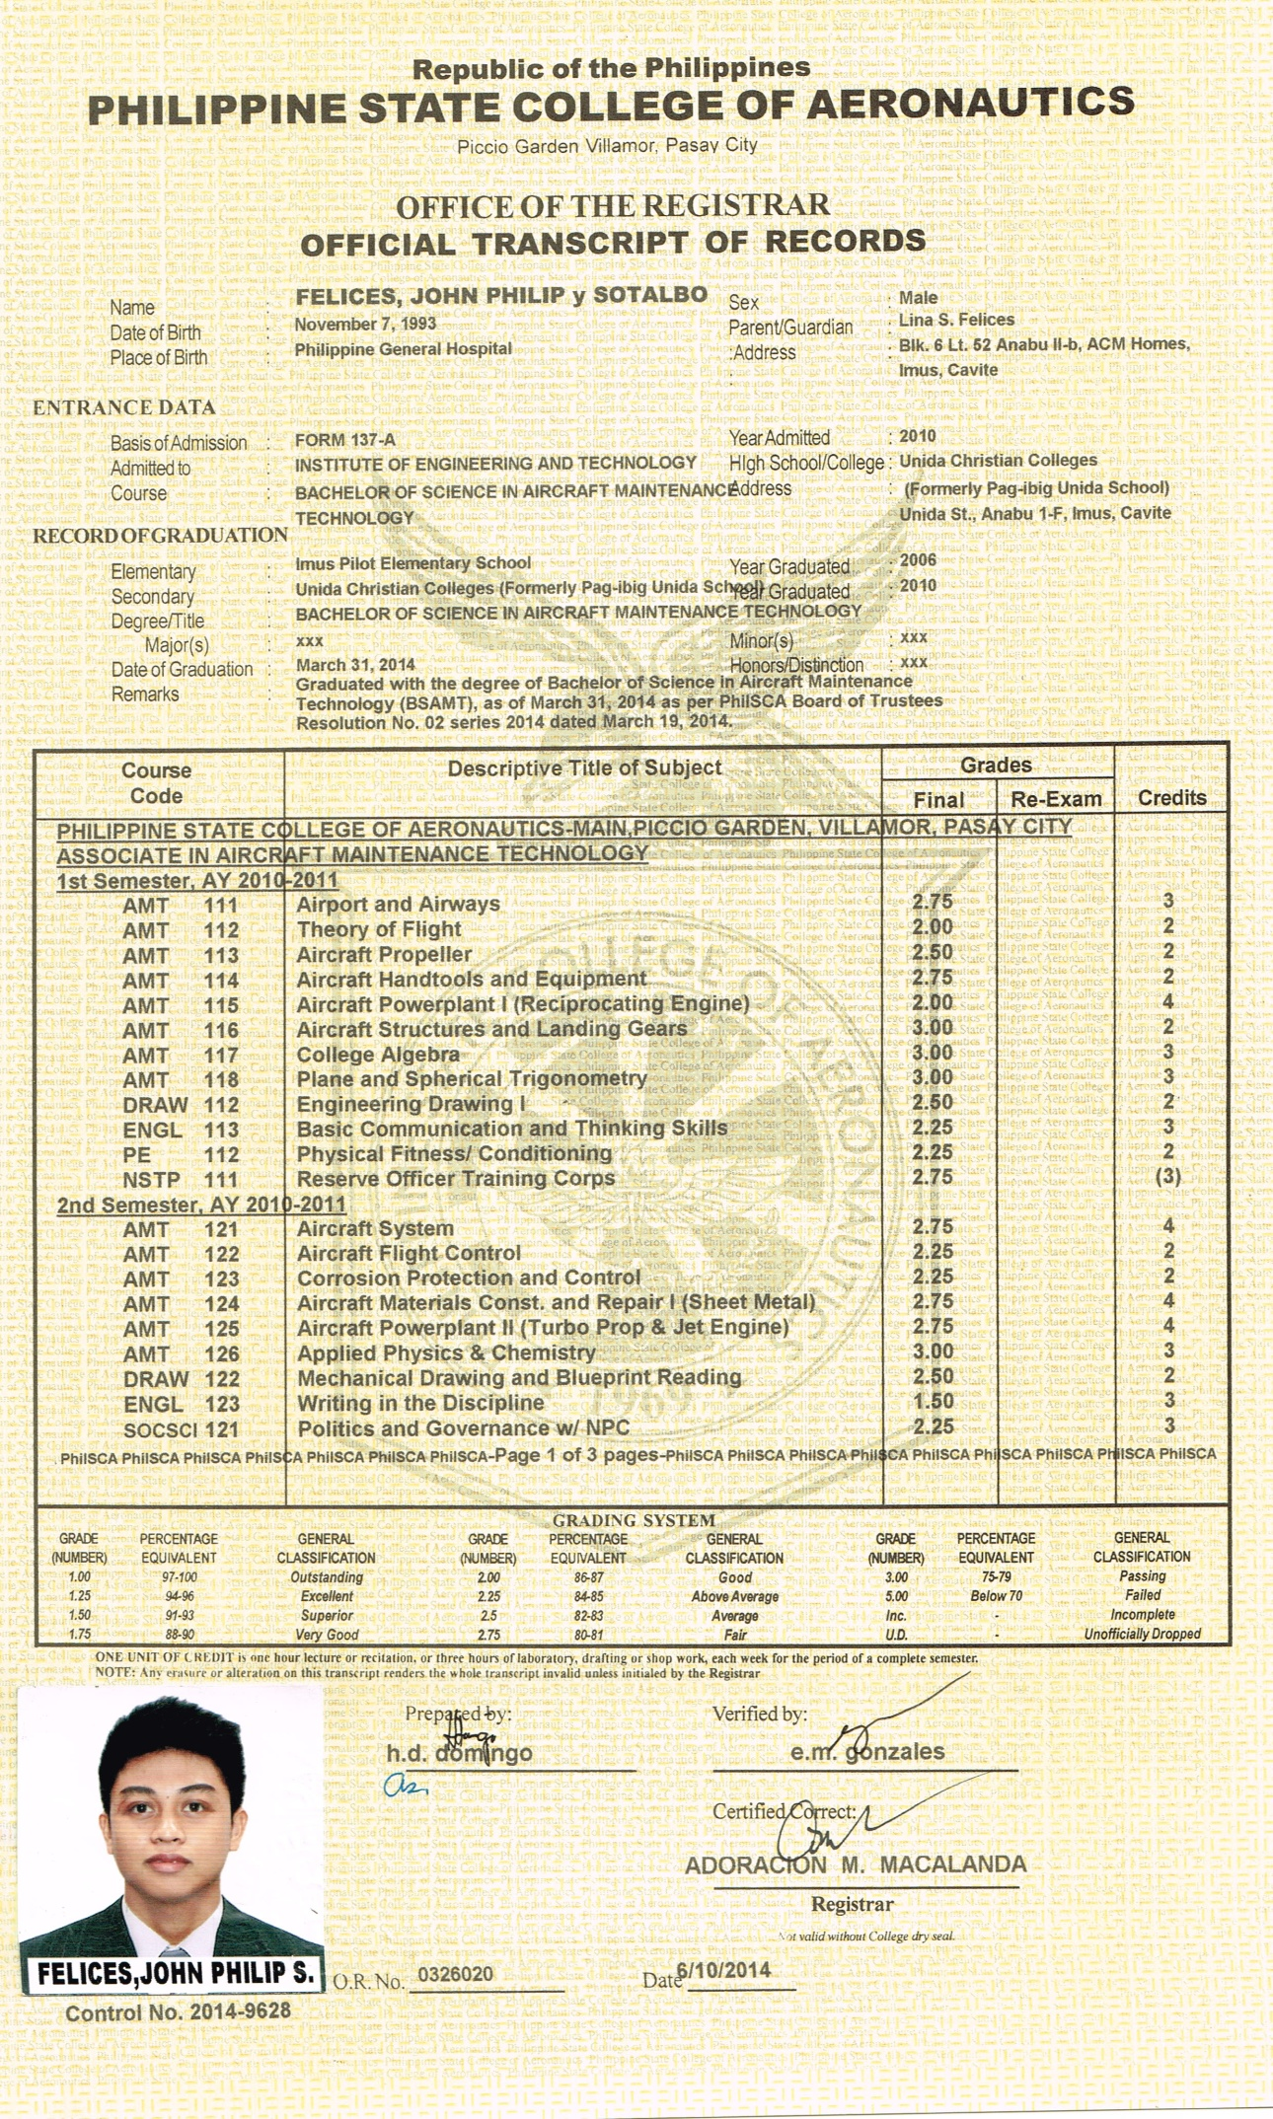
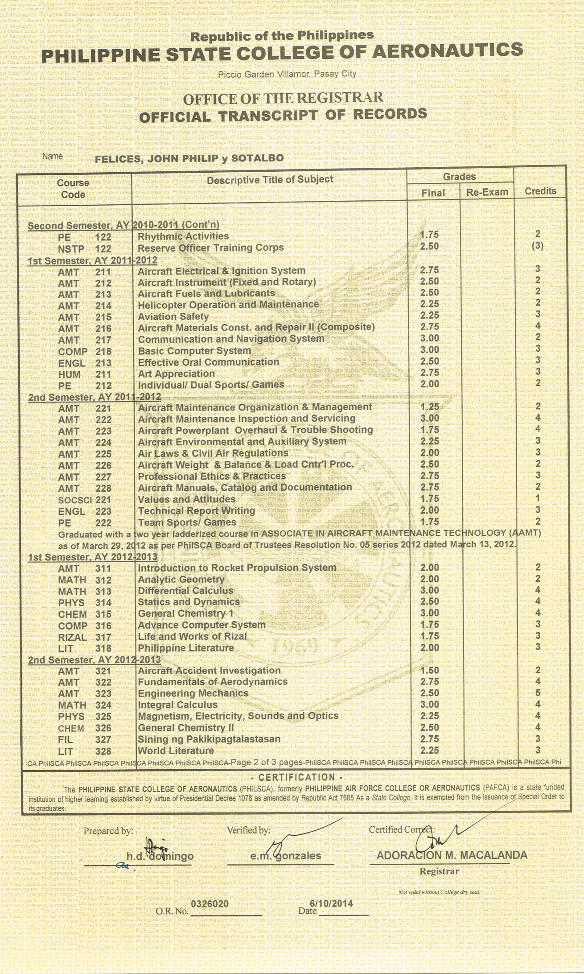
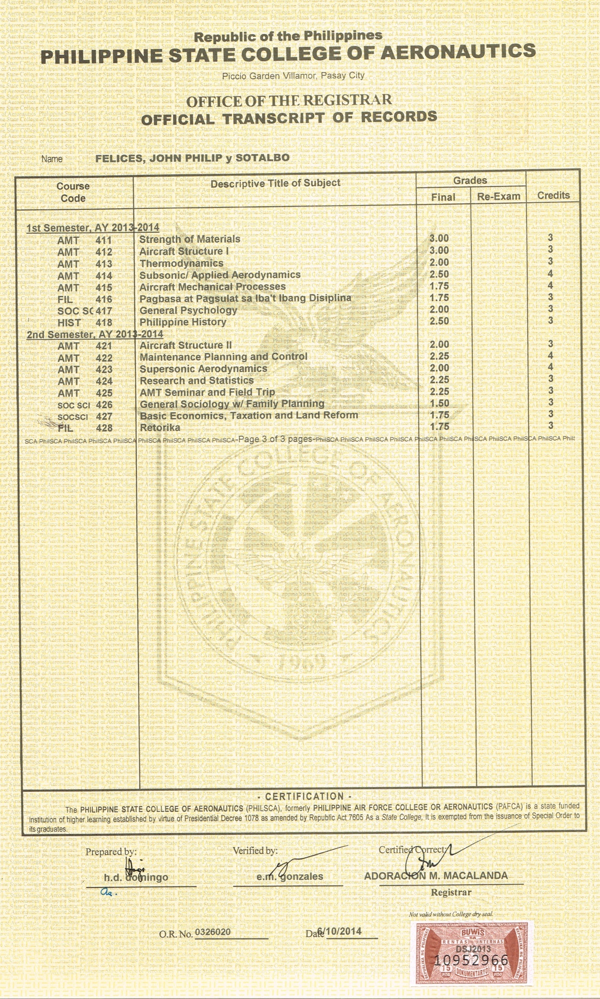
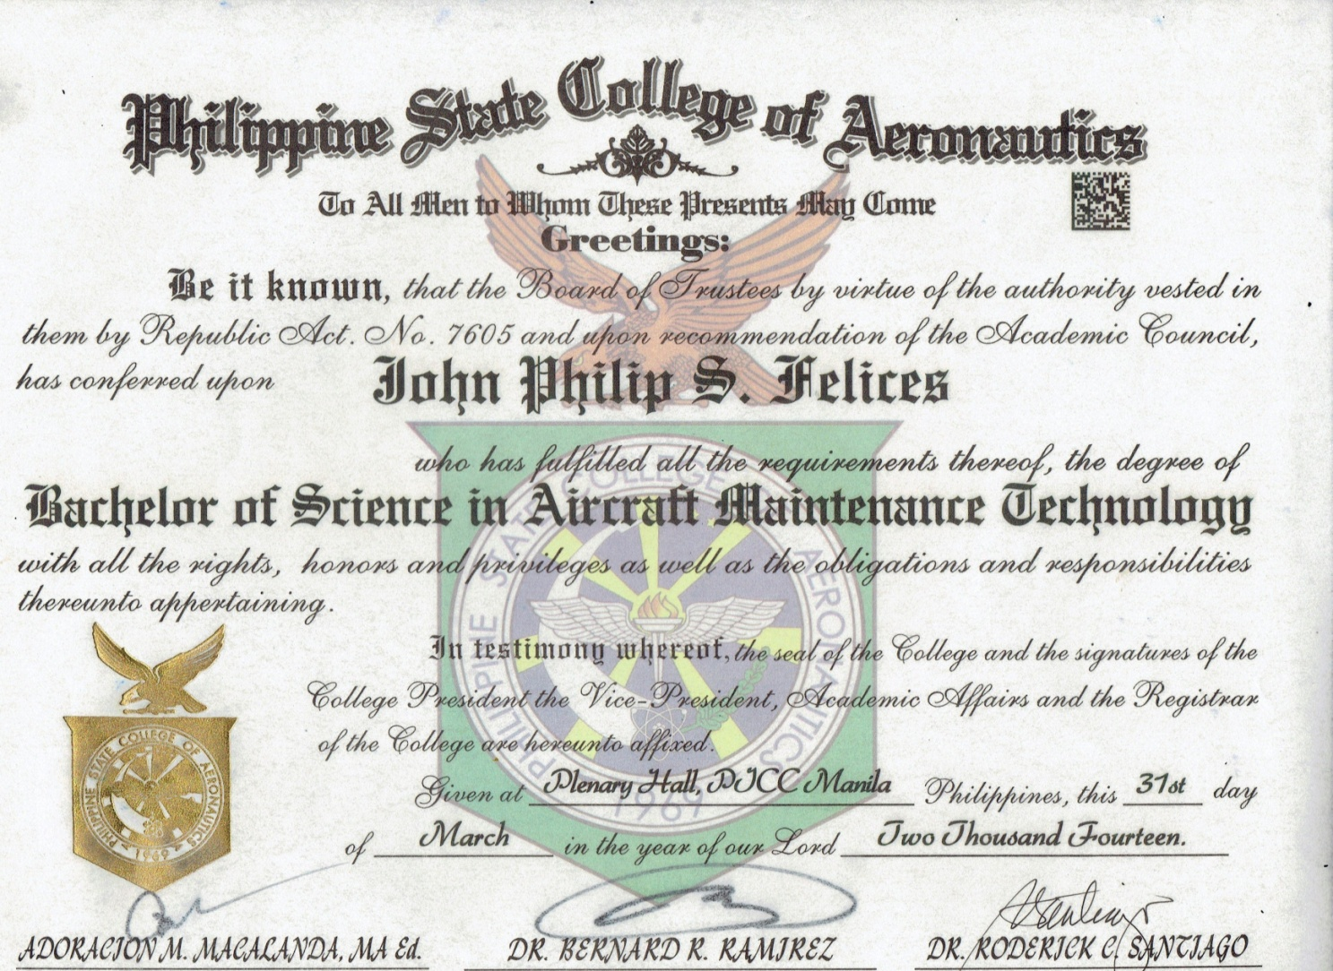

I hereby certify that the above information is true and correct to the best of my knowledge and belief.

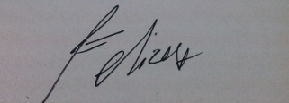
John Philip S. Felices
Applicant

