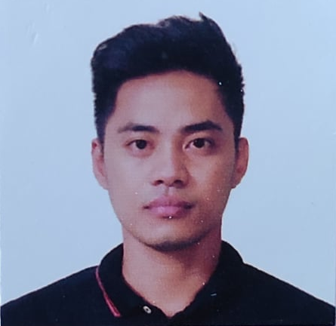
JEFFREY T. DE VERA
Lot 1 Block 2 Goldcrest Vilas San Agustin Trece Martires City,
09810316935
deverajeff5@gmail.com
To land a job where I can use my knowledge and render my dedicated service in return for excellent experience and opportunities for professional and personal growth.

Experience

january 2017 – december 2019

factory worker, min AIK CO LTD
Taoyuan, TAIWAN R.O.C
Oversees Machineries, Conducting Test and Inspect Finished Products, Maintain Safe Environment

March 4, 2016 – November 10, 2016

Lutong macao
Bel Air Village, Makati City
All around utility, (dishwasher, waiter, janitor)

Education

2009-2012

3 YEAR MARINE ASSOCIATE AND TRANSPORTATION,

PAN FACIFIC UNIVERSITY NORTH PHILIPPINES

URDANETA CITY

2003-2009

CABILAOAN AGRO INDUSTRIAL HIGH SCHOOL,

CABILAOAN, LAOAC PANGASINAN

SKILLS
- Have high sense of responsibilities  - Can work under pressure  - Hard working person  - Have good communication skills | - Enthusiastic, Committed and well-motivated  - Can work with others professionally  - Computer literate

ACTIVITIES
Can do job or responsibilities that given with courage and determination, can understand and speak Tagalog, English and Mandarin. Can finished task in given time, can handle pressure and stress at work.

I Hereby certify that the above information is true and correct upon the best of my knowledge and belief.

