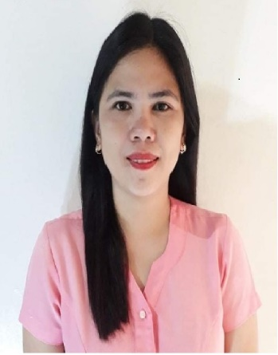

Mylen AMURAO Binondo
mylenbinondo1223@gmail.com
+639398852355
Present Address:
PUROK 7, SAN FELIPE, CUENCA 4222, Batangas, Philippines

Basic Information
Age  36 | Birth Date  Jan 06, 1986 | Gender  Female | Civil Status  Single
Height (cm)  151.13 | Weight (kg)  59 | Nationality  Filipino | Religion  Christianity - Catholic

Work Experience
I have been working for 10.24 years
Sep 2012 - PRESENT  (10 Years, 2 Months) | MASTER TEACHER I  DEPED ALITAGTAG NATIONAL HIGH SCHOOL  Education & Training Services  ALITAGTAG, BATANGAS, PHILIPPINES

Educational Attainment

June 2003-Mar 2007 ALITAGTAG COLLEGE, Inc.
Bachelor of Secondary Education
Jun 2014 - Mar 2016 | GOLDEN GATE COLLEGES  Post Graduate Diploma / Master's Degree  BACHELOR OF SECONDARY EDUCATION MAJOR IN ENGLISH/ MASTER IN EDUCATION NON-THESIS PROGRAM

Licenses / Certifications
Nov 25, 2009 | PRC  1038024

Requirements:
Do you have a valid passport? Not yet, but will process as soon as possible.
Do you have a valid NBI clearance? Not yet, but will process as soon as possible.
Do you have an evaluated transcript of records from a US credentialing company? None
Do you have your Philippine evaluated transcripts available and on hand? Yes

Questionnaire:
Are you currently teaching full-time in Elementary or High School, in a classroom setting and with pay? YES Name of School: DepEd Alitagtag National High School
Do you have relatives in the US? No
Do you have a pending immigrant visa application? No
Do you have experience teaching in the US? No
Have you ever been refused a US visa? No
Do you agree that you will apply for a visa without your dependents? YES
Are you willing to teach in Arizona, North Dakota and South Dakota? YES
In addition to Prime, have you submitted a teaching application or have a pending teaching
application with any US School District, US placement agency, US teacher company, Philippine
placement agency, Philippine teacher company? No

For SPED ONLY:
• Are you willing to teach any grade level—elementary, middle school, high school? YES
• What subject area are you capable to teach? English and basic Math and Science in elementary

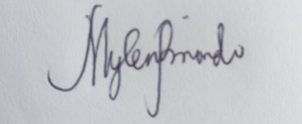

MYLEN A. BINONDO 12/01/2022
Name and Signature / Date

