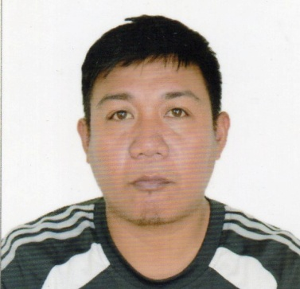
JAYSON T. ALVIAR
CENTRO NORTE GATTARAN, CAGAYAN
CONTACT NUMBER: 09278244369
E MAIL ADDRESS: jaysonalviar1984@gmail.com
_ _ _ _ _ _ _ _ _ _ _ _ _ _ _ _ _ _ _ _ _ _ _ _ _ _ _ _ _ _ __ _ _ _ _ _

JOB OBJECTIVE
Reliable that you can count on me to do my job to the best of my ability
I have a positive can do attitude that can make all the difference in how I do my job.

SUMMARY OF QUALIFICATIONS

Enough work experience in any job suited for me
Great physical endurance at assigned job undertakings
Clear and polite communicative skills
Flexible in terms of work assignments and shifting hours

PERSONAL INFORMATION

Date of Birth: 02-11-84
Place of Birth: Centro Norte Gattaran, Cagayan
Citizenship: Filipino
Religion: Roman Catholic
Known Languages: English, Tagalog and Ilocano

EDUCATIONAL BACKGROUND

Tertiary Cagayan State University Lal-lo Campus
Bachelor of Agricultural Technology
Sta. Maria Lal-lo, Cagayan
June 2011- April 2014

Secondary Northern Philippines Academy
Centro Norte Gattaran Cagayan
June 1196- March 2000

Primary Gattaran West central School
Centro Sur Gattaran Cagayan
June 1990- March 1996

SEMINARS ATTENDED
Trainer’s Training on Forage Management and Pasture Development
DA-Agricultural Pilot Center CVLMROS Minanga Norte Iguig, Cagayan
February 4-6 2014.

Construction Occupational and Safety And Health (COSH ) Training SO2
JGT Safety Training Center October 29,30 November 4 5 6, 2022.

ACHIEVEMENTS
Bachelor of Agricultural Technology Graduate
NC- II Animal Production
NC-1 Crop Production
NC-II Electrical Installation And Maintenance

WORK EXPERIENCE
Occupational Internship Program at Cagayan Breeding Station MaguirigSolana,Cagayan.
Animal Care Technician (swine production) GAD’S Feeds Supply Sta Cruz, Gonzaga Cagayan
JUNE 2014 –November 2018
Animal Care Technician (swine production) CMT Feed Supply Centro Amulung Cagayan
November 2018- October 2019
Private Security Guard R911 Security Agency under R81 Construction
January 2020-to present

REFERENCES

Mr. Cayetano B. Calagui (DVM) Alimannao Pena Blanca Cagayan
09662655176
Mrs. Filomena E. Pablo DOK JC Store Centro Iguig Cagayan
09560692192
Mr. Pedro Cornel Caritan Norte Tuegegarao City Cagayan
09169007372

I hereby certify that the above information has been accomplished in good faith and to the test of my knowledge and believe is true and correct.

______________________________
JAYSON T. ALVIAR

