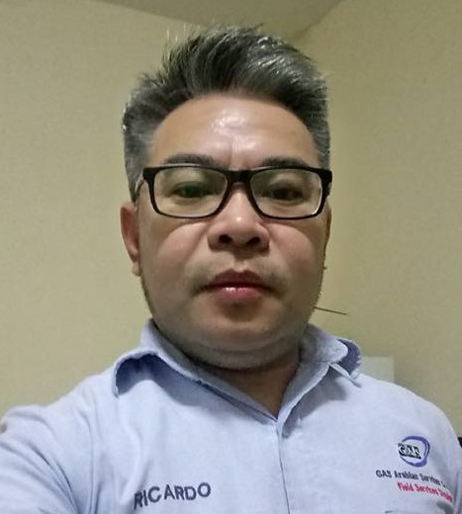

RIcardo P. Merencillo Jr.
HR & ADMIN COORDINATOR
121 Bala St. Luisiana, Laguna

Contact:
09618428898

Email:
Ricardo.merencillo@gmail.com

Jayr041978@yahoo.com

OBJECTIVES:

Passion to provide excellent customer service with excellent administrative skills, ability to face new challenge seeking an admin assistant position at your company

EMPLOYMENT HISTORY:

Municipal Government of Luisiana, Laguna
Revenue Collection
July 19, 2004 to October 23, 2009

Rezayat Company Ltd.
Admin Assistant
October 24, 2009 to October 24, 2011

GAS Arabian Services Company Ltd
HR & Admin Coordinator
September 09, 2012 to September 30, 2020

DUTIES AND RESPONSIBILITIES:

- Assist with day to day operation of HR function
- Conduct initial orientation to newly hired employee
- Assist our recruiters to source skills candidates
- Organize compile update personnel record ,documentation
- Able to work independently
- Handle visit visa to employee

EDUCATION:

Associate in Computer Programming
System Technology Institute (STI)

SKILLS:

TRAINING & CERTIFICATES:

CHARACTER REFERENCES:

  - Organization planning
  - Customer Service
  - Research Analysis
  - Prioritization, Problem Solving
  - Knowledge in SAP application

  - Student’s IT Expo 98 ( February 4 & 5, 1998)

  - Competency Assessment for Building Wiring Installation NC II (January 08, 2009)

  - Operations and Maintenance of Water System Seminar (April 24, 2009)

  - World Class Filipino Workforce / Computer Operator (Sept. 29, 2009)

  - Basic Life Support – HEARTSAVER AED (February 2010)

  - Quality Management System (October 31, 2017)

Mr. Larry De Assis
Principal/ Adviser
09614088481

