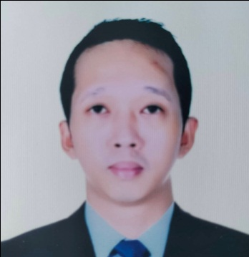
Jean Carlo Miller Difuntorum
88 Jucutan St. Parian, San Fernando City, La Union
Mobile No.: 0981 448 6275
Email Address: jeancarlodifuntorum3@gmail.com

Career Objective:
To obtain a position that will enable me to utilize my strong organizational skills, education background and ability to work well with people.

Work Experience:
Driver/Messenger
Paz Money Changer
November 2020-January 2022

Tourist Driver/Waiter
China Sea Beach Resort
February 2019-October 2019

Tourist Driver
Briggs-Kaith Travel & Tours
December 2016-December 2018

Personal Profile:
Birth Date : January 24, 1994
Age : 28 yrs. old
Birth Place : Catbangen, San Fernando City, La Union
Civil Status : Single
Religion : Roman Catholic
Citizenship : Filipino

Educational Attainment:
Vocational : Technical Education and Skills
Development Authority
National Certificate II (Driving)
June 28, 2018

Secondary : La Union National High School
San Fernando City, La Union
2013-2014

Primary : Christ the King College
San Fernando City, La Union
2006-2007

Professional Profile:
- Highly organized and dedicated with positive attitude
- Hardworking and energetic
- Time management

Character Reference:
Wilhelmo Araojo
Business Owner
Paz Money Changer
San Fernando City, La Union

Richie Marie Landrigan-Bermudez
General Manager
China Sea Beach Resort
Paringao, Bauang, La Union

Joey Maglaya
Owner/Manager
Briggs-Kaith Travel & Tours
San Fernando City, La Union

I hereby certify that the above information is true and correct to the best of my knowledge and belief.

Jean Carlo M. Difuntorum
Applicant

