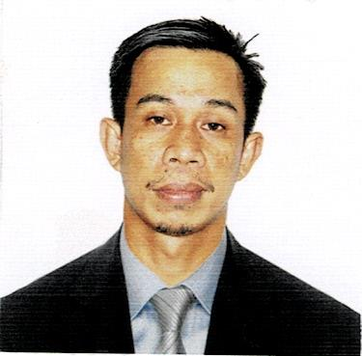
JAYPEE DELA CRUZ
050 Sapang Pahalang
San Rafael, Bulacan
Contact No. 0975-1229008
Email Address: delacruzjaypee12@yahoo.com

CAREER OBJECTIVE:

To seek employment that would allow me to continue to the growth and further development of the company or institution.

To develop my capabilities, to enhance my potential and to equip me with knowledge and skills needed for continuous career improvement.

PERSONAL INFORMATION:

Birth Date : January 16, 1984
Age : 38 years old
Gender : Male
Civil Status : Married

EDUCATIONAL ATTAINMENT:

Secondary Level : Binagbag National High School
Angat, Bulacan
SY. 1997 – 2001

Primary Level : Sapang Pahalang Elementary School
San Rafael, Bulacan
S.Y. 1991 – 1997

SPECIAL SKILLS:
- Able to work in a fact-pace environment.
- Tactful and customers – oriented.

WORK EXPERIENCE:

- SARIKA CONNOISSEUR CAFÉ PTE LTD.
SARIKA CONNOISSEUR CONCERTO is the leading chain of art boutique cafes boasting a comprehensive selection of gourmet food and creative beverages.

Position : Waiter, Barista, Cashier
Date Covered : May 29, 2011 – November 20, 2012
Location : Raffles Exchange, Singapore

Duties and Responsibilities:
- Prepare the place for operations.
- Greeting customers.
- Offering and serving beverages and food.
- Taking and serving meal orders.
- Continue service to look after the guest by providing everything they ask.
- Barista
- Cashier

- CREATIVE FOOD CONCEPT PTE LTD.
Creative Food Concept is a fresh and exciting catering company. Specializing in stimulating flavors, innovative presentation and high quality service.

Position : Waiter, Barista
Date Covered : January 3 – April 2, 2013
Location : Takashimaya, Singapore

Duties and Responsibilities:
- Prepare the place for operations.
- Greet and usher customers.
- Take and serving meal orders.
- Clear tables.
- Attend to customer’s needs and inquiries.
- Provide good professional customer service.

- FAMOUZ BURGER RESTAURANT

Position : Waiter, Kitchen Helper, Cashier and Barista
Date Covered : 2017 - 2019
Location : Jeddah, Saudi Arabia

Duties and Responsibilities:
- Prepare the place for the events.
- Greet and ushers guest.
- Serving food and beverages.
- Attend to guest’s needs.
- Clear tables.

TRAININGS:

- Basic Training, S.T.C.W.

I hereby certify that the above information is true and correct to the best of my knowledge and belief.

JAYPEE DELA CRUZ
Applicant

