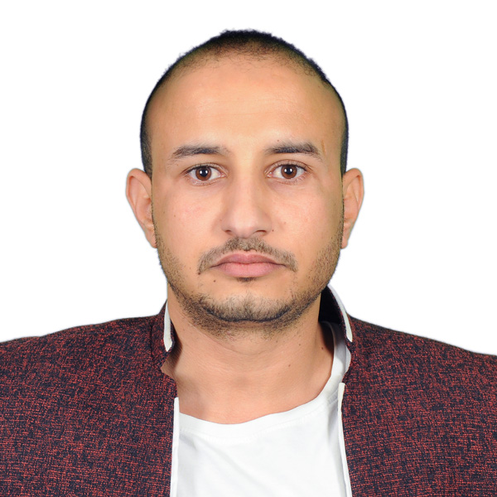

NAME : FAWAZ GAREED
DATE OF BIRTH : 01/01/1986
NATIONALTY : YEMEN
CURRENT RESIDENCE : CAIRO / EGYPT
MOBILE NUMBER : +201555118656
E-MAIL : FAWAZSALE44@GMAIL.COM
WORK EXPERIENCE
- FROM 02/2012 TO 12/2013 worked as a glazier and glass accessories sales representative
Full time job 6 days a week duties taking measurements, customize glass and aluminum , and install ( glass doors , partitions, automatic doors and stores front) at AL- HAMRA COMPNY for glass and accessories , RIYADH SAUDI ARABIA ( references are available upon request )

- From 01/ 2018 to 09/2019 glass , aluminum and stainless steel installation supervisor full time job 6 days a week duties ( marketing, visiting customers, taking measurements , coordinate with factories, purchases , leading the team and carrying out work at ALINSHA ALASHAL CONTRACTING ESTABLISH RIYAD CITY SAUDI ARABIA ( references are available upon request )
- From 10/2019 to 08/ 2022 worked as a manager ( glass, aluminum, roofing , automatic doors and cladding ) FAWAZ GAREED CONTRACTING establish, SANAA, YEMEN
- From 01/2014 to 12/ 2017 worked as sales executive at SAUDI TELECOM COMPANY STC
FULL TIME JOB 5 DAYS A WEEK RIYADH SAUDI ARABIA ( references are available upon request)

Education
- Two yeas diploma (foods industry)

Computer skills
- International computer driving license
- Good knowledge of computer use

Language ability
- English language fluent
- Arabic native speaker
Missions and roles I can fill professionally
1- looking for new clients and build trust with the existing ones.
2- Negotiating prices and concluding contracts
3- Estimating the materials needed to implement projects and communicate with suppliers
4- monitoring sites progress implementation and leading the work team
5-Training and qualifying the work team

6-Assisting the work team in complex tasks

most experience is in the following projects managing
- Glass doors and fronts installation
- Glass structure system assembling and installation
- Glass tampering and holing
- Double glass system
- Doors and windows installation and repairing
- Shower cabinets customizing and installation
- Cladding and roofing
- Automatic doors ( DORMA AND GEZE BRAND ONLY) installation.
- Stainless steel handrail

