NORMAN OMILIG
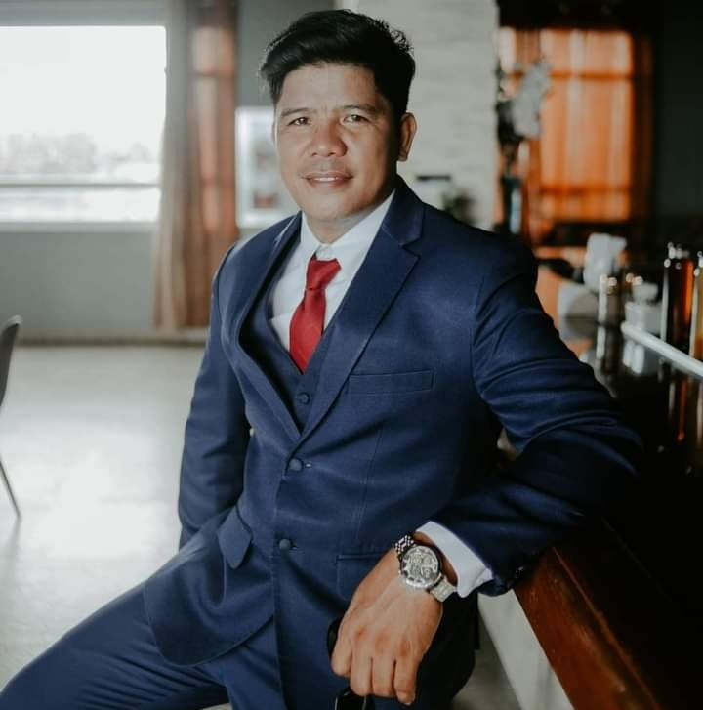
Tiltilon Jubay, Liloan6002, Cebu Philippines
normanomilig@yahoo.com
09286570018
Age: 42 years old
Birth Date: November 06, 1980
Birthplace: Sipalay, Negros Occidental
Gender: Male
Civil Status: Married
Weight: 75kgs
Height: 5’8
Religion: Christian (Born Again)

Objective
I'm looking for a full-time work or any available job in your company. As a Bachelor Degree and Diploma in Information Technology holder, I strongly believe that I will be a valuable asset to your company.

Personal Statement
I am a skilled worker. I firmly believe that I will be an effective employee to your company. My skills, expertise and experience in Metal/Engineering sector as a welder an Land Transportation Sector as a driver, and In-depth knowledge of construction procedures as a mason and as a carpenter. I am confident that I will be a potential asset to your company as well. I am looking for a role that complements my skill set and experience. I am available upon obtaining an essential skills or work visa.

Work history
JOED Wrought Iron Fabricators  Calero, Liloan Cebu Philippines  July 2017 - Present  Central Philippine Bible College, Disciples Ministries Inc.  Cebu, Philippines  Mar 2010 - June 2017  Industrial Education Learning Center and Technologies Inc.  Liloan, Cebu, Philippines  September 2020- Present  St. James Academy of Skills Technology, Inc.  Cebu, Philippines  Jan 2019 - Sep 2019 | SMAW, FCAW and GMAW Fabricator  Official Bus Driver, Welder, Carpenter, Property Construction foreman and Part-time College Teacher  Part-time Trainer/Assessor in Metal Arc Welding and NC2 Driving NC2  Part-time Trainer/Assessor in Driving NC2 and Shielded Metal Arc Welding NC2
TESDA Provincial Training Center - CARMEN  Cebu, Philippines  Jun 2017 - Dec 2017 | Part-time Trainer/Assessor in Driving NC2  Assessor in Welding NC2
ELE Technical Training& Assessment Center Corp.  Lapu-Lapu, Philippines  Sep 2015 - Sep 2016 | Trainer/Assessor in Shielded Metal Arc Welding (SMAW NC2)  Official Driver
Technical Education and Skills Development Authority (TESDA)  Cebu, Philippines  Dec 2014 - Aug 2015 | IT Support Staff, Competency Assessment & Certification (CAC) Unit and; Driver Support Staff, Procurement, Property, Supply and General Services (PPSGS) Unit
Pacific Rim Ministries  Iloilo, Philippines  Feb 2008 - Aug 2010 | Church Pastor/Evangelist
Disciples Ministries Inc., Central Philippine Bible College.  Cebu, Philippines  May 2005 - Nov 2008 | Official Driver, Welder, Dorm Dean and Property Custodian
Pacific Rim Ministries  Iloilo, Philippines  Apr 2003 - May 2005 | Church Pastor/Evangelist
QUALIFICATIONS
Cebu Graduate School of Theology  Cebu, Philippines  2012 - 2014 | Units in Master of Arts in Leadership
STI College  Cebu, Philippines  2006 - 2008 | Diploma in Information Technology
Central Philippine Bible College  Cebu City, Philippines  1997 - 2003 | AB-Theology

Technical skills
- Broad knowledge in Computer.  - Competent user of CorelDraw and Photoshop  - Develop, Organize and Complete Tasks and Projects using Office applications such as Word, Excel and PowerPoint  - Professional Driver with full restrictions. | - Excellent knowledge in Stick Welding (SMAW) and Knowledgeable in MIG welding.  - Knowledgeable in Oxy-Acetylene Welding  - Broad knowledge in Carpentry and Scaffolding.  - In-depth information on safety and security measures.

Personal skills
Communication Skills
Great communication skills, Good in both written and spoken English
Teamwork
Can work either in a team or as a free member.
Able to schedule and delegate work to the other coworkers.
Self-Management
Able to handle numerous tasks with ease.
Knowledge in maintaining and cleaning various construction machines.
High physical stamina to endure even the strenuous tasks.
Positive Attitude
Flexible, adaptable and respectful to authority.
Can comfortably work under pressure
Thinking Skills and Resilience
Decision making, critical thinking, organizing and planning oriented.High attention to detail, Flexible in Different Situations.

Interests
- Travel  - Sports  - Art | - Listening to Music  - Motorcycle Riding

Referees
Rebecco G. Leyson Joel D. Pilapil
Academic Dean Assessment Center Manager
Central Philippine Bible College Industrial Education Learning Center
Rebecco.leyson.cgst@gmail.com and Technologies Inc.
09093442235 Calero, Liloan, Cebu, Philippines
340-8457/ 09753752209

Luciana J. Barliso IE, DPA Nigel K. Pyle
Center Administrator TESDA PTC-Carmen Brother-In-law
ljbarliso@tesda.gov.ph 920 Kokopu Road, Kokopu 0170,
(032)429 9305/09268523790 Whangarei New Zealand nigelpyle@yahoo.com
0224762402

