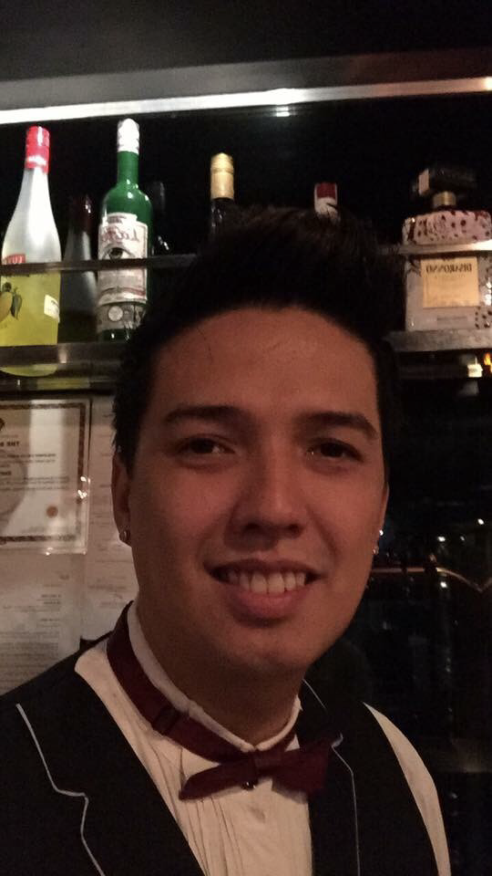
ALVARO P. BASILIDES.
2060 Aurora Silva St.,
Pasay City Metro Manila
Cellphone# 09695963186
e-mail@baby_ryu_basilides@yahoo.com

OBJECTIVE:

Obtain a position as a team-player in a people-oriented organization where I can maximize my customer-service experience in a challenging
environment to achieve the corporate goals.

EXPIRIENCE AND ACHIEVEMENTS:

West 32
Head Bartender
Kalayaan Ave. Poblacion
Makati City
March 16 2022 up to present

Draft Gastropub
Bartender
2nd Floor, Powerplant Mall
Rockwell, Makati City
February 2018 to Feb 2022

THE BREWERY AT THE PALACE
Bartender
Uptown Place, Bonifacio Global City, Taguig
October 2015 to Present

Draft Gastropub
Bartender
BGC Activity Center
The Fort Strip,5th Avenue,Taguig City
May 2015 to October 2015

Draft Gastropub
Bartender
Greenbelt 2,Makati City
June 2014 to May 2015

Imperial Ice Bar
Head Bartender
BGC Activity Center
The Fort Strip,5th Avenue,Taguig City
September 2012 to June 2014

Kabisera ng Dencio’s
Bartender
2303 G&A Building, Pasong Tamo
Ext. Makati City
July 2011 to July 2012

Pancake House Inc.
Front of the House
2259 Pasong Tamo Extension, Makati City
February 2009 to April 2011

Dencio's Bar and Grill
Front of the House
2259 Pasong Tamo Extension, Makati City
July 2007 to May 2008

Dads Saisaki and Kamayan Restaurant
Bartender and Server
First foods Inc. #251-253 Shaw Boulevard, Mandaluyong City
August 2005 to August 2006

Don Henrico's
Front of the House
Level 2, Glorietta 4, Ayala Center Makati City
November 2004 to April 2005

JOB DESCRIPTION:

BARTENDER
Imperial Ice Bar
Bartender
BGC Activity Center
The Fort Strip,5
th
Avenue,Taguig City
September 2012 to June 2014
Draft Gastropub
Bartender
Greenbelt 2,Makati City
June 2014 to May 2015
Draft Gastropub
Bartender
BGC Activity Center
The Fort Strip,5
th
Avenue,Taguig City
May 2015 to present
JOB DESCRIPTION:
Bartender
-Prepare alcohol or non-alcohol beverages
-Assess customers’ needs and preferences and make recommendations
-Mix ingredients to prepare cocktails
-Present bar menu
-Check customers’ identi:cation and con:rm it meets legal drinking age
-Restock and replenish bar inventory and supplies
-Stay guest focused and nurture an excellent guest experience
-Comply with all food and beverage regulations
Imperial Ice Bar
Bartender
BGC Activity Center
The Fort Strip,5
th
Avenue,Taguig City
September 2012 to June 2014
Draft Gastropub
Bartender
Greenbelt 2,Makati City
June 2014 to May 2015
Draft Gastropub
Bartender
BGC Activity Center
The Fort Strip,5
th
Avenue,Taguig City
May 2015 to present
JOB DESCRIPTION:
Bartender
-Prepare alcohol or non-alcohol beverages
-Assess customers’ needs and preferences and make recommendations
-Mix ingredients to prepare cocktails
-Present bar menu
-Check customers’ identi:cation and con:rm it meets legal drinking age
-Restock and replenish bar inventory and supplies
-Stay guest focused and nurture an excellent guest experience
-Comply with all food and beverage regulations
-Prepare alcohol or non-alcohol beverages
-Assess customers’ needs and preferences and make recommendations
-Mix ingredients to prepare cocktails
-Present bar menu
-Check customers’ identification and confirm it meets legal drinking age
-Restock and replenish bar inventory and supplies
-Stay guest focused and nurture an excellent guest experience
-Comply with all food and beverage regulations

EDUCATION:

PRIMARY:
Lyceum Philippines University
Associate in Computer Technology
2000-2002

Pamantasan ng Lungsod ng Pasay
Bachelor of Science in Education
2002-2003

SECONDARY:
Sta. Clara Catholic School
1996-2000

ELEMENTARY
Padre Zamora Elementary School
1990 to 1996

PERSONAL INFORMATION:

BIRTHDAY: August 24, 1984
HEIGHT: 5'11 1/2
CITIZENSHIP: Filipino

CHARACTER REFERENCES:

Cristina Fornis
Restaurant Manager
09989322268

I hereby certify that the information is true and correct to the best of my knowledge. . I am looking forward to a personal interview to discuss over the facts to my background and how my experience would be mutually beneficial.

Signature

