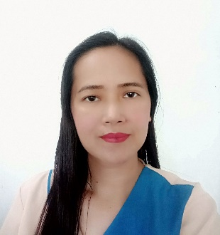
NILDA NUQUE TORRES
______________________________________________________________________________
OBJECTIVE: To be a part of a company that I can enhance my skills and potentials
Experience
2009-present Pre- School/Elementary Teacher
Responsibilities:
- Teach pupils on how to write, read, sing,
dance, draw, color pictures and engage
them in some school activities like reciting
poems, Math, Science and Art contest
August 2007- November 2008- Substitute Teacher
August 2005- March 2007- Contractual Teacher
June 2005- July 2005 – Substitute Teacher
August 2003-June 2005 - Pre-School Teacher
June 2005-August 2005 – Substitute Teacher
August 2001-January 2002 and
November 2002-July 2003- Sales Clerk
- Selling men’s shoes/ chocolates
- customer service
August 2000- May 2002- Bookkeeper
- Bookkeeping/encoding
April -May 1999- (Summer Job) Yongden Tech. Corp. Eletronic Assembler
EDUCATION:
2016-2017- Master of Arts in Education
Urdaneta College University (18 units)
2009-2011- Harvardian College (45 units)
1996-2 000- Bachelor in Elementary Education
Bulacan State University
Major in Work Education
Graduated as Private Scholar
RECOGNITION/AWARDS RECEIVED:
October 4,2022 1st placed District Storybook Writing Competition
September 17, 2017 -3rd Placed- District Level (Teacher’s Contest)
July 1, 2016- Resource Speaker
District Inset On Disaster Risk Reduction (DRR) on Comprehensive School Safety for Teachers Strategic Intervention Material in Math (SIM)
September 20, 2016- Coach/ Trainer of the Contestants won
1stplaced in GirlScout District Encampment

Personal Info
Address
679 Capalangan, Apalit, Pampanga; Philippines
Mobile: +639461235089/+639685053674
Whatsapp: +639461235089
E-mail: nilds4979@gmailcom
Skills:
- Computer skills (MS word, Excel, Power Point, Adobe Photo Shop)
- proven ability to relate to a variety of people of varying ages, background and cultures
- equally effective working alone as well as within a team environment
- excellent customer service focus
- an ability to learn new tasks and information quickly
- diplomatic and professional when dealing with challenging customers

SEMINAR/ TRAINING ATTENDED:
October 25-27, 2016 Mathematics, Science and History Seminar
F. Mendoza Memo. Elem. School

August 5, 12 & 19, 2016 District Roll-Out on Advance Training on the Content and Strategies for Select Elem. Mathematics Teachers
F. Mendoza Memo. Elem. School

May 19-21, 2016 Gender and Development Training
Polaris Beach Resort- Ilocos, Norte

PERSONAL DATA:
Birth Date: April 9, 1979
Birth Place: Gatbuca,Calumpit, Bulacan; Philippines
Citizenship: Filipino
Civil Status: Married
Religion: Iglesia Ni Cristo
Height : 150 cm
Weight : 48 kgs.

REFERENCES:

Nina R. Sumalabe
Arsenio Santos Memorial Elementary School
Principal

Ms. Gina Vallejo
Personnel Manager- SM City Pampanga

Edmund Lim
Manager- Ivann Metal Industrial Inc.

I hereby certify that the above information is true and latest to prior



NILDA N. TORRES
Applicant

