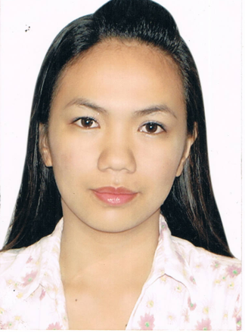

Princess Di O. Ramos, RN
License Number: 0624123
09555285247
princessdioasan2720@gmail.com
OBJECTIVES:
To join an organization where I can apply my skills and expertise in the field of nursing and attain a level of performance to any department I could be assigned in.
PERSONAL DATA:
- Date of Birth: January 27, 1988
- Age: 33 years old
- Place of Birth: Brgy.4 Nueva Era, Ilocos Norte
- Father’s Name: Cresencio V. Oasan
- Mother’s Name: Estrellita C. Oasan
- Civil Status: Married
- Spouse Name: Luisito P. Ramos
- Height: 155cm
- Weight: 55 kgs.
- Nationality: Filipino
- Religion: Iglesia Ni Cristo

EDUCATIONAL BACKGROUND:
- Cabittauran Elementary School 1995-2000
Nueva Era, Ilocos Norte
- Caestebanan National High School 2000-2004
Banna, Ilocos Norte
- Northern Christian College 2004-2009
Laoag, Ilocos Norte

ELIGIBILITY:
- Nursing Licensure Examination
November 29-30,2009
Passed

WORKING EXPERIENCE:
- Nurse Deployment Project
Nurse II (January 2016- up to the present)
- Nueva Era RHU with Birthing Facility
LGU Nurse (October- December 2015)
- My Health Clinic Alabang
Cashier (November-March 2013)
- Paranaque Doctors Hospital
Volunteer Nurse (July-October 2012)
- Estrella Laboratory and Diagnostic Clinic
Staff Nurse (May-October 2012)
- The Generics Pharmacy
Pharmacy Assistant/ Cashier
February 2010- February 2012
RELATED LEARNING EXPERIENCE:
- Mariano Marcos Memorial Hospital and Medical Center
Batac, Ilocos Norte
July 2008-March 2009

- Gov. Roque B. AblanSr.Memorial Hospital
Laoag City Ilocos Norte
July 2008-March 2009

- San Nicolas Health Center
San Nicolas, Ilocos Norte
April 2008

- Pasuquin Health Center
Pasuquin, Ilocos Norte
January 2009-March 2009
AFFILIATED TO:
- National Center for Mental Health
Mandaluyong City, Metro Manila
May 2008
- San Lazaro Medical Hospital
June 2008
- National Orthopedic Center
July 2008
SEMINARS AND TRAINING ATTENDED:
- Basic Life Support
Cardiopulmonary Resuscitation for Healthcare Provider
Pasay City Red Cross Training Center
June 18-19, 2012

- First Aid Training Standard
Pasay City Red Cross Training Center
June 20-23, 2012
- Personality Awareness and Customer Service Seminar
Turning Point Competency Development Center Inc.
3rd/f Lemon Square Bldg., 1199 Edsa, Brgy.Katipunan, Quezon City
July 25, 2011
- HIV Awareness
Department of Laboratory Medicine
Paranaque Doctors Hospital Conference Room
Dona Soledad Avenue, Paranaque City
July 13, 2012
- Telegeriatric Nursing Seminar for Health Professionals
Asian Institute of Management Makati City
October 15-17, 2012
SKILLS:
- Good Communication Skills
- Easy to adopt to a new environment
- Computer literate(MS Word,Excel,Powerpoint)
- Honest, Responsible,God-Fearing
PERSONAL REFERENCES:
- HON.ALDRIN R. GARVIDA
Municipal Mayor
Nueva Era, Ilocos Norte

- DR. RICKSON R. BALALIO
Municipal Health Officer
Nueva Era, Ilocos Norte

- MRS. MARIANELA A. VALERA
Public Health Nurse
Nueva Era, Ilocos Norte

I hereby attest that all the information above is certified true and correct.
PRINCESS DI O. RAMOS
Applicant

