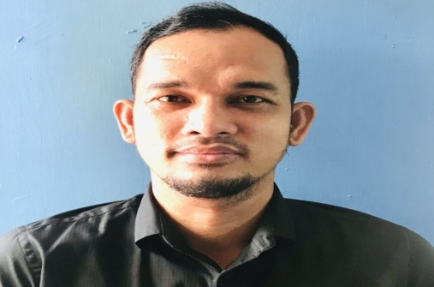
APOLINARIO G. VELORIA JR.
Hardworking and passionate job seeker with strong organizational skills eager to secure entry level CLEANER position. Ready to help team achieve company goals. To seek and maintain full-time position that offers professional challenge utilizing interpersonal skills, excellent time management and problem-solving skills.


Apokon, Tagum City, Philippines

+639195959854

Junbelle0905@gmail.com



EXPERIENCE
Gaisano South Citi-Mall - Stockman
Legaspi St. Davao City
Jun 2005 – Dec 2005

Gaisano South Citi-Mall - Sales Associate
Legaspi St. Davao City
Dec 2007 – May 2008

Jeco/Sheridan Marketing Inc. - Merchandiser
Davao City
Jun 2008 – Jun 2013

Sheridan Marketing Inc. - Concession Coordinator
Davao City
Jun 2013 – Jun 2018

Sheridan Marketing Inc. - Concession Supervisor
Davao City
Jun 2018 – Mar 2020
SKILLS

- MULTI-TASKING ABILITIES
- FLEXIBLE AND ADAPTABLE
- COMPUTER PROFICIENCY
Francisco Bangoy Natl High School - High School
Davao City Diploma
2002

University of South-Eastern Philippines - 1st year BSEE
Undergraduate
EDUCATION
ANALYN G. VELORIA
NACTV
423 Mountain Ave.,Neepawa
Manitoba, R0J1H0
Canada
+14317590886

Garry D. Lumanta
Hylife Foods,Ltd.
623 Main St E, Neepawa
Manitoba, R0J1H0
Canada
+12048413797

REFERENCES
- SPORTS
- READING
- CARPENTRY

HOBBIES
- ENGLISH
- FILIPINO
LANGUAGE

