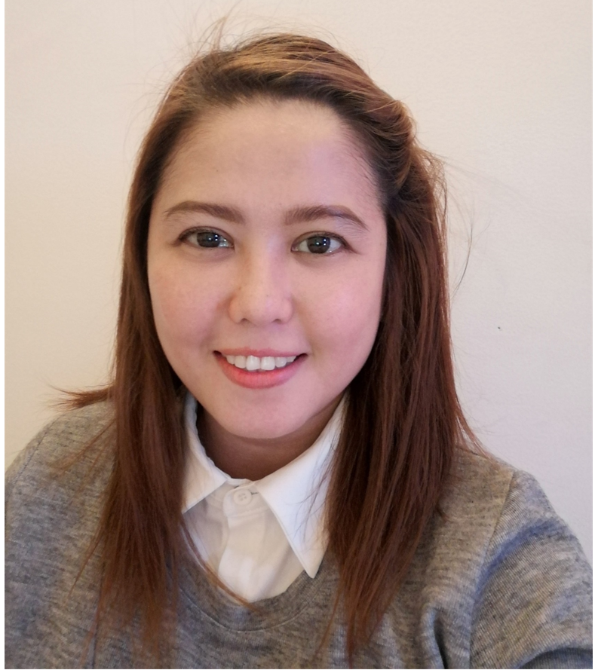

Marie Fay E. Jomilla
Lot 11, Block 15, Phase 2, Valley Ave., Valley View Executive Village, Antipolo, Rizal | 639927086896 | Marie.jomilla@gmail.com

Objective
Your company provides many services that I have had experience with, in a variety of capacities. I believe that my familiarity with the industry would make me a good fit for this position.

Experience

Oct 2017 – Present
Facilities Coordinator
CBRE GWS Business Support Services Philippines | Makati City
Industry: Call Center / IT-Enabled Services / BPO
Specialization: Building Maintenance

- Provide information in response to inquiries about products and services, handle and resolve complaints.
- Provide 24 x 7 services for the multiple portfolios including logging and management of requests received via phone, email, and online service portal. Generates and dispatches service request work orders for completion by vendors. Schedules conference rooms and audio-visual equipment.
- Create work orders in Si7 to record incidents that occur across the portfolio and issue incident notifications.
- Create work orders and assigns work orders to multiple technicians, subcontractors and vendors. Communicates work orders to technicians and assists management is resolving problems.
- Provides reports on open and close work orders and checks status with the appropriate technician or vendor.

- Responds to customer inquiries and concerns. Follows up with clients to ensure customer satisfaction.
- Updates computer maintenance management system, customer service database, and spreadsheets as needed with updated service information.
- Contacts customer for additional information and communicating the steps in the work order process.
- Runs, reviews, and distributes various customer service reports as necessary.
- May generate and dispatch service request work orders for completion by vendors.
- Currently handling 50+ accounts, 8 tools.

Nov 2015 – August 2017
Property Services Coordinator
Jones Lang LaSalle Shared Services Philippines, Inc. | Bonifacio Global City
Industry: Call Center / IT-Enabled Services / BPO
Specialization: Property/Real Estate

- Responsible for responding to all incoming facility and property related work orders from clients.
- Handle dispatching to vendors and track work order to completion.
- Accountable for approving invoices, arrange payment, interface with AP department and manage vendor payment queries.
- Ensure customer satisfaction by implementing the best strategy to respond in order to ensure superior customer satisfaction.
- Must be able to take ownership to resolve and discern between the symptoms of the problem and the root cause of cases being handled.
- Raise incident reports in a timely manner to address stockholders of specified accounts. Analyzes and resolves incidents and requests.

Apr 2015 - Sep 2015
Service Desk Analyst
Stefanini Philippines | Makati City
Industry: Call Center / IT-Enabled Services / BPO
Specialization: Technical & Helpdesk Support

- Provides support for basic incident resolution and requests reported to the division service desk.
- Responsibilities include initial assessment, triage, research, and resolution of basic incidents and requests regarding the use of application software products and/or infrastructure components.
- Responsible for collecting information through a customer conversation, accessing support tools, and additional support staff (service resources) if needed.
- Problems beyond the scope of my ability or responsibility are resolved by engaging in a timely manner other service resources from facilities, division or corporate groups, or the corporate service desk.
- Addresses and resolves basic incidents and requests; logs all incidents and requests; engages other service desk resources or appropriate service resources to resolve incidents that are beyond the scope of their ability or responsibility.
- Uses the appropriate categories for logging incidents and requests.
- Creates a positive End User experience and builds strong relationships through deep problem understanding, ensuring timely resolution or escalation, communicating promptly on progress, and handling customers with a consummately professional attitude.
- Ensures the end-to-end support experience and provides a single point-of-contact for the End User.
- Logs and tracks incidents and requests from identification through resolution. Follows up with other support staff (service resources) involved in resolution to ensure incidents are resolved, requests are filled, and the customer communication is complete. Documents resolutions and updates self-help and staff knowledge bases.

Apr 2014 - Nov 2014
Tier 1 Technical Support Specialist
RingCentral | Mandaluyong City
Industry: Call Center / IT-Enabled Services / BPO
Specialization: IT/Computer - Network/System/Database Admin

- Deliver service and support to end-users using and operating automated call distribution phone software, via remote connection or over the Internet.
- Interact with customers to provide and process information in response to inquiries, concerns, and requests about products and services.
- Gather customer’s information and determine the issue by evaluating and analyzing the symptoms; Diagnose and resolve technical hardware and software issues involving internet connectivity, email clients, VOIP and more.
- Research required information using available resources. Follow standard processes and procedures. Identify and escalate priority issues per Client specifications.
- Redirect problems to appropriate resource. Organize ideas and communicate oral messages appropriate to listeners and situations; Follow up and make scheduled call backs to customers where necessary; Stay current with system information, changes and updates.

Sep 2010 - Nov 2013
Process Associate
Interglobe Technologies (United Airlines) | Mckinley Hills, Taguig City
Industry: Call Center / IT-Enabled Services / BPO
Specialization: Customer Service

- Effectively managed a high-volume of inbound and outbound customer calls especially when there is Irregular Operations due to weather disruptions.
- Addressed and resolved customer product complaints empathetically and professionally. Gathered and verified all required customer information for tracking purposes.
- Defused volatile customer situations calmly and courteously. Accurately documented, researched and resolved customer service issues.
- Mastery of customer service management systems and databases. Communicate with passengers over the phone.
- Resolve disservice situations (e.g., determine alternate flight options for delayed, cancelled or missed flights, change/rebook reservations). Read passenger identification documents and flight status information.
- Perform simple calculations when needed. Ensure compliance with United and Federal Aviation Administration (FAA) regulations and policies. Determining fares and routing to assure passenger's travel needs are met.

Aug 2008 - Sep 2009
Quality Assurance Specialist
PLDT Ventus (now SPI Global)
Industry: Call Center / IT-Enabled Services / BPO
Specialization: Customer Service

- Responsible for performing training and quality activities within the account handled to ensure all agents are providing the same level of support.
- Must audit and analyze work performance and make recommendations as necessary to ensure maximum efficiency within the Customer Service Groups.
- Responsible for the overall management of the development and improvement of Training and Development, which includes but are not limited to the proper use of internal systems which includes, CRM, SAP and Captivate.
- Designing and developing training and development programs based on both the organizations and individual needs. Ensure the quality of CSR training including the review and modifications/improvements to the Customer Service CRM training materials, syllabus and certification program.
- Identify and develop refresher training to improve quality of service, efficiency and customer satisfaction.
- Establish training and quality goals, objectives and action plans. Identify process and procedure improvements that will increase efficiencies, increase customer satisfaction and reduce cost.

Sep 2007 - Aug 2008
1 year

Technical Support/ Customer Service Representative
PLDT- Ventus (now SPI Global) | National Capital Reg, Philippines
Industry: Call Center / IT-Enabled Services / BPO
Specialization: Customer Service

- Installed software, modified, and repaired hardware and resolved technical issues.
- Managed call flow and responded to technical support needs of customers.
- Identified and solved technical issues with a variety of diagnostic tools.
- Created cases and claims for damaged, lost, or displaced packages.
- Resolved problems with malfunctioning products.

Education
Xavier University - Ateneo de Cagayan
Bachelor's/College Degree in Commerce | Philippines
Major in Business Management

University of the East (U.E.)
Bachelor's/College Degree in Business Studies/Administration/Management | Philippines
Undergraduate

