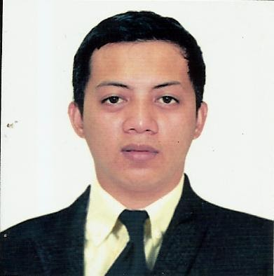

Acosta John Paul G.
Poblacion, Lagangilang, Abra 2802
Philippines
Mobile No.: +639975944590/+639065447129
E-mail: jhankenneth23@gmail.com

OBJECTIVE: To enhance and to apply my knowledge and skill in the production industry.

Personal Skills:
- Production and Processing
- Knowledge in stunning, sticking bleeding, gambrelling expose tendon and evisceration
- Expert in slaughtering operation
- Knowledge in sharpening knives
- Can work long hours

WORK EXPERIENCE:

Position: Slaughtering/Slaughter man
Name of Company: Urdaneta City Abattoir SH-663 “AA”
Address of Company: Urdaneta City, Pangasinan
Employer: Domingo S. Diego
Plant Operations Supervisor
Date of Employment: August 8, 2019 to October 8, 2021
Number of Days work: Monday to Sunday
Number of hours per week: Eight (8) hours a day or fifty six (56) hours per week

DUTIES AND RESPONSIBILITIES IN SWINE SLAUGHTERING OPERATION
- Stunning, Sticking and Bleeding, Immerse carcass to scalding vat, Open tendon, Remove sex organ, Evisceration, Singeing, Maintain personal equipment and cleaning the work area

Position: Quality Assurance Inspector/Machine Operator

Name of Company: ACCELL SERVICES CORP.
Contractor of San Miguel Yamamura Packaging Corp.
Address of Company: Brgy. San Agustin City of San Fernando Pampanga
(045) 963-3927
Date of Employment: June 24,2010-May 2013

DUTIES AND RESPONSIBILITIES
- Inspection of materials before the production starts
- Inspection of coder machine ( Inkjet Printer)
- Maintenance of Palletizer Machine before and after the production
- Recounting the volume produced after the production

EDUCATIONAL ATTAINMENT:

Vocational:
Diploma in Information Technology 2005 to 2006
Abra State Institute of Sciences and Technology (ASIST)
Main Campus, Lagangilang, Abra

Secondary
Abra Sate Institute of Sciences and Technology 2002 to 2003
Main Campus, Lagangilang, Abra

Elementary
Lagangilang Central School 1998 to 1999
Poblacion, Lagangilang, Abra

CERTIFICATIONS:
- Slaughtering Operations (Swine) NCII-TESDA
Validity: December 10, 2019-December 9, 2024
- IELTS General Training, Band Score of 5.0

CHARACTER REFFERECE:
Domingo S. Diego Plant Operations Supervisor
Meat Inspector 1
Deputized Meat Inspector Officer/NMIS
jiggssummer@gmail.com
Contact No. 09679816988

Filipino Labiste School Administrator
MMS/Baguio
Contact No. 09153243949

