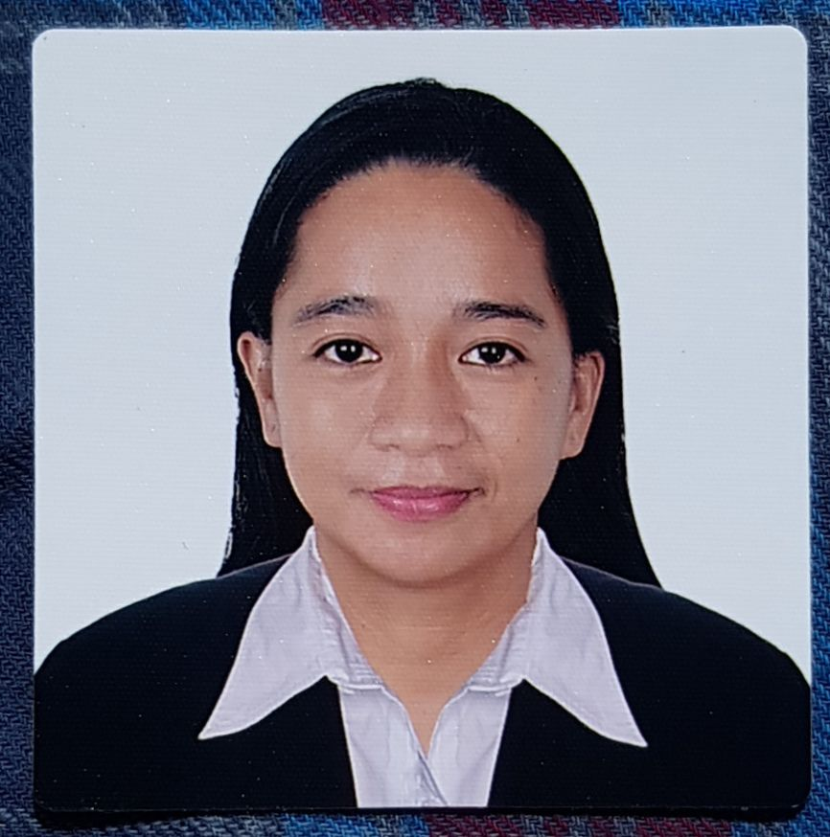
Anne Marielle M. Sausi
+639950730261
Email: annemariellesausi0208@gmail.com
Registered Nurse with 7+ years of experience in providing quality care to pediatric/newborn clients.

Neonatal Intensive Care Unit (NICU) & High Dependency Unit) - Staff Nurse
King Fahad Medical City, Riyadh Saudi Arabia (Tertiary Hospital)
October 23, 2022 - to present

Neonatal Intensive Care Unit (NICU) - Staff Nurse
Dr. Soliman Fakeeh Hospital, Jeddah Saudi Arabia (Tertiary Hospital)
December 1, 2018 - December 2, 2020

Neonatal Intensive Care Unit (NICU) and Nursery - Staff Nurse
Almostaqbal Hospital, Jeddah Saudi Arabia (Secondary Hospital)
July 21, 2016 - July 21, 2018

Job description:
• Assess, monitors, plans appropriate nursing care in collaboration with other health team members
regarding the status of sick babies (i.e ventilated preemies)
• Work closely with neonatologists and the nursing team, to provide holistic care to clients and their
families.
• Perform prescribed procedures (Assist in central line insertion, intubation, extubation and suctioning,
• Maintained compliance and regulations in medical care.

Cases handled:
Premature babies (600 grams), Post term babies with complications, neonates with respiratory distress syndrome/transient tachypnea, neonates with congenital anomalies such as omphalocele, gastroschisis, atresias, microscopically, etc), neonates with hyperbilirubinemia,

Equipment handled:
Incubators: Drager Caleo, Drager Air-Shields Isolette C200, Neo-Servo Incubator, GE Giraffe Omnibed, Air-Shields C-450QT, NeoGlider transport incubator.
Ventilators: Neoport (e360T), CPAP machines.
Phototherapy capsule (Bilispere 360), Neoblue.
Blanketrol III (Hyper-hypothermia)
Spacelabs (Ultraview SL)
Infusion Pumps: Plum A, Alaris
Pulse oximeters: Masimo RD set, Nellcor pulse oximeters, Welch Allyn's 73WT - McKesson
Welch Allyn Suretemp plus 690 thermometers

Pediatric Clinic Nurse
Dr.Victoria Basiao pediatric clinic
January 2013 - May 2016

Education

Elementary: Colegio San Agustin-Bacolod
June 1993 - May 1999

High School: Negros Occidental Science High School
June 1999 - May 2003

College: Colegio San Agustin-Bacolod
Bachelor of Science in Nursing
June 2004 - May 2008

Specialized Training & Competencies
• Basic Life support, First Aid Training for Healthcare
• Neonatal Resuscitation Program
• Breast feeding course

Licenses
Philippine Regulation Commission - Registered nurse
Saudi Council Registered nurse

References:
Ms. Marjurie Damasco, RN
Dr. Soliman Fakeeh Hospital, Jeddah KSA - Nurse Manager
+966 54 159 9627

Ms. Barbara Ulang, RN
Almostaqbal Hospital, Jeddah KSA - Head Nurse
+966 50 933 7437

