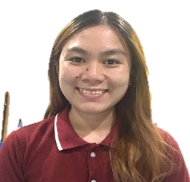

MAE ANTONETTE P BERSO, RMT, MLS ASCPi
Registered Medical Laboratory Scientist

Contacts: Profile:

Location: Sitio Felimon Brgy. San Jose, Banga, Competent Medical Laboratory Scientist
South Cotabato, 9511 Philippines with 3 years’ experience in laboratory
setting. Efficient in performing laboratory
Contact No: +639103094497 task & quality control. In-depth knowledge
in biosafety, risk management & laboratory
EmailAddress:dtrlantonette.pbsp@gmail.com network.

EDUCATION

2017-2008 Primary Level
Graduated Class Valedictorian
Lamba Central Elementary School

2008-2013 Secondary Level
Graduated Class Valedictorian
Notre Dame of Lamba

2013-2017 Tertiary Level
Bachelor of Science in Medical Technology
Notre Dame of Marbel University

2018- Ongoing Graduate School
Master of Science in Medical Technology
Philippine Women’s University

Experience

2017-2019 Metro South Medical Center
Medical Technologist
Paliparan Road, Molino, Bacoor, Cavite, Philippines
- Collect specimens for processing in Clinical Chemistry, Microscopy, Haematology, Blood Banking and histopathologic techniques.
- Process samples on different sections in the laboratory and performing quality control as a standard of procedure in laboratory.

2019- Present Philippine Business for Social Progress
Davao TB Reference Laboratory
Medical Technologist Global Fund TB Access
- Handle infectious specimens such as Sputum and COVID-19 positive sputum for tuberculosis testing.
- Collecting blood samples to TB Multi Drug Resistance patients in the certified TB Centers.
- Perform Molecular testing specifically GeneXpert MTB/Rif Assay, GeneXpert Ultra Assay and GeneXpert XDR MTB Assay.
- Perform Solid TB Culture Test using modified Kudoh method and assisting in Drug Susceptibility Testing using L-J method.
- Reading of sputum smears using Ziehl-Neelsen method.
- Conducting Training for trainers in National Tuberculosis Infectious Control and Prevention Manual of procedure.
- Facilitating Health Center and fellow healthcare workers to be knowledgeable in biosafety, biosecurity, laboratory risk management and laboratory network.

Skills

- Laboratory skills
Performing with quality assurance in pre-analytic, analytic and post analytic. Knowledgeable in Immunoserology, clinical chemistry, clinical microscopy, blood bank, haematology, histological techniques, mycology, virology and micro bacteriology
Collecting specimens using venepuncture extraction efficiently with grace under pressure.
Handle specimens with a proper knowledge about infection control, biosafety, biosecurity and risk management.
Able to perform quality control automatically or manually.
- Clinical Management Skills
Wide knowledge in biosecurity, biosafety, risk mitigation management and laboratory networking.
Experience in assisting laboratory inspection their standard of procedure and protocol.
Efficient in administrative task in laboratory standard of procedure, logistic, laboratory monitoring sheets and preventive maintenance.
- Communication skills
Trained in basic customer service approach. Through this, I am able to communicate efficiently in clients, colleagues verbally and written. By then, it helps me to work independently or in a team.
Proficient in English Language.
- Management and organizational skills
Cooperate in delegation of task, decision making, problem solving and even motivating colleagues.
Charting of day to day task to work grace under pressure and achieve the goal of the team effectively.
Having initiative in cleaning and organizing laboratory necessities for work improvement.
- Research skills
Checking resources by evaluating information, it’s validity, literature context. Acknowledging authority and asking questions to the scholars.
Attending trainings international about the latest update in the laboratory setting through online platform.

Certification/Trainings
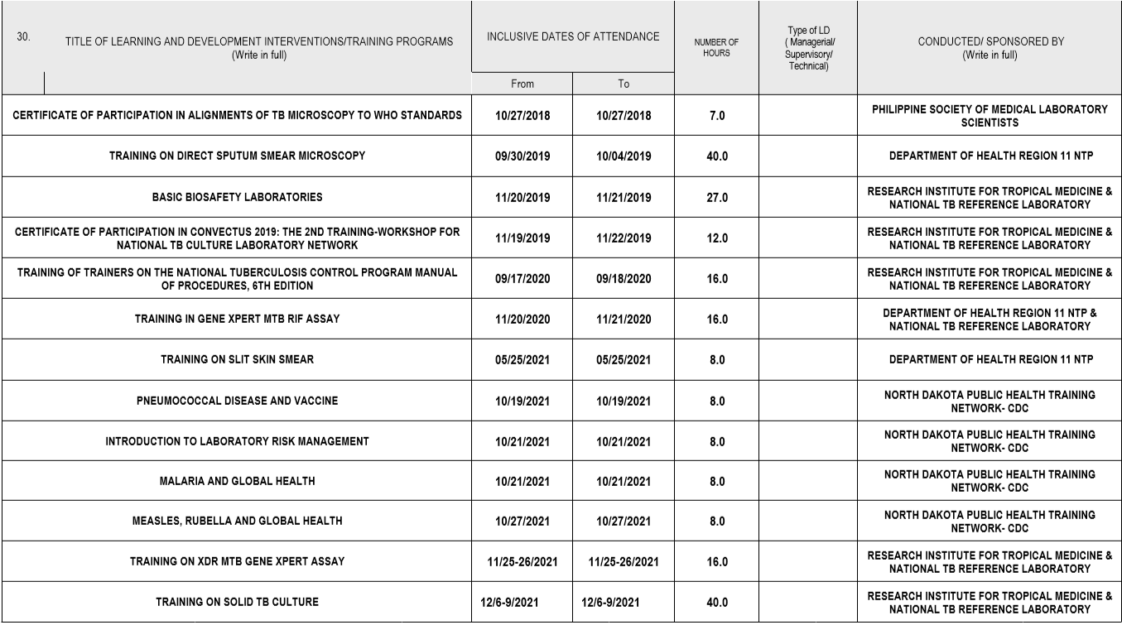

License/Examination

- August 26-27, 2017
-Medical Technology Licensure Examination
-PASSED
-License No. 0084106

- January 24, 2018
-American Society for Clinical Pathology International Examination
-PASSED
-ASCP ID: 25681463

