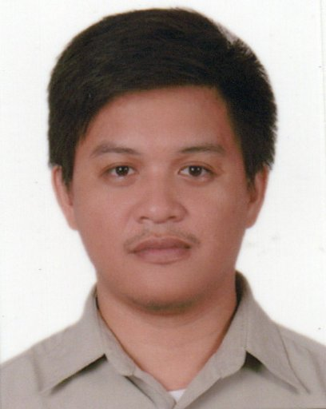
Name: JERALD F. TAMPIPI
Address: Purok 5, Sinaragan Matanao, Davao del Sur, 8003 Philippines.
E-mail: jeraldtampipi@yahoo.com/jeraldtampipi@gmail.com
Cellphone #: 639568405863
______________________________________________________________________________
PERSONAL INFORMATION

Date of birth: January 10, 1988
Place of birth: Sinaragan Matanao Davao del Sur
Age: 34
Status: Married
Gender: Male
______________________________________________________________________________

EDUCATIONAL ATTAINMENT
Elementary
School: Ramon Magsaysay Central Elem. School
Address: Lapu-lapu Ext. Digos City
Year: 1995-2000
Secondary
School: Digos City National High School
Address: Rizal Avenue Digos City
Year: 2000-2004

Tertiary
College: Polytechnic College of Davao del Sur
Address: Mc Arthur Highway Digos City
Course: Bachelor Science of Nursing (Undergraduate)
Year: 2004-2008

Tesda Program
Tesda School: Philippine International Technological School
Address: Aurora Extension Digos City
Short Course: Nursing Aide NC2
Year: 2019

______________________________________________________________________________

WORK EXPERIENCED
- Primary, Secondary, Tertiary hospitals
Address: within Davao City and Digos City, Davao del Sur
Position: On the Job Training (Nursing Student)
Year: 2007

- Company: DC INVEST INC.

Address: Digos City

Position: Distributor Sales Personnel

Year: 2017

- Company: JINZAI IKUSEI LANGUAGE AND BUSINESS SOLUTIONS
Address: Rizal Avenue Digos City
Position: Japanese Instructor, Marketing staff
Year: 2018- March 2020

- Company: PHILIPPINES INTERNATIONAL TECHNOLOGICAL SCHOOL
Address: Dona Aurora Extension Digos City
Position: Japanese Instructor

WORK EXPERIENCED ABROAD

- Company: Mitsubishi Motors (JAPAN)
Address: OKAZAKISHI AICHI KEN Nagoya Plant
Position: Door Assembler, Welder
Year: 2010-2013

