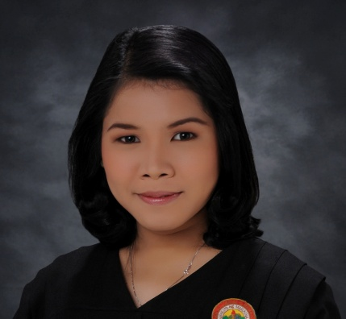

MARY ROSE COLASI AQUINO

 Blk. 31 Lot 5 Langka St. Libis
Bulelak Malanday, Marikina City
 09307381581
 maryroseaquino23@gmail.com
___________________________________________________________

Objective:

To be one of the great contributors of your company through the applications of my knowledge and skills, be competitive and enhance my abilities for my future fulfillment and satisfaction.
Education:
UNIVERSITY: Pamantasan ng Lungsod ng Marikina Brazil St., Greenheights Marikina City

DEGREE: Graduate of Certificate of Caregiving in Health Care Services
2008-2010

Bachelor of Science in Nursing
(2nd year level)
2009-2011

Special Skills:
- Computer Literate MS Word, Excel, Power Point Presentation
- Knowledge in Healthcare Services

Work Experience:

- Factory worker at Zenith Foot wear
( March 2020 – August 2020)

- Sales staff at Candy Corner Philippines Incorporated
(September 2014 – December 2014)

On the Job training:

St. Matteus Hospital (Banaba, San Mateo Rizal )
H.Vill Medical Hospital (Rodriguez Manggahan, Montalban Rizal)
Antipolo Medical Hospital (Antipolo City)
- I am the one who’s assisting the patient.
- Monitoring patients vital signs
- Caring the patients.
- Taking the data of the patients.

Seminars Attended:

- A Symposium on “Values and Personality Development”
PLMar Library, Concepcion 1 Marikina City
April 16, 2010

Personal Data:

Age: 31 y/o
Birth Day: November 09, 1991
Birth Place: Marikina City
Civil Status: Single
Gender: Female
Height: 5’0
Weight: 60 kg
Nationality: Filipino
Religion: Roman Catholic

References:
Mrs. Jeannette De Jesus RN.MAed
Professor, Pamantasan ng Lungsod ng Marikina
09178373745
Maribel T. Concepcion
Administrative Staff, TNS Global Market Research (Philippines)
09185597261

I hereby certify that the above information is true and correct upon the best of my knowledge and belief.

____________________________
Mary Rose C. Aquino

