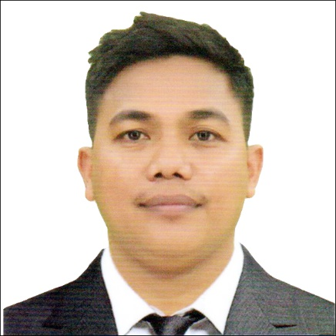

CAREER OBJECTIVE
Secure a responsible career opportunity to fully utilize my training and skills, while making a significant contribution to the succes of the company.

PERSONAL DETAILS
Applicant Name: Rodel Habolin Discalsote
Position Applied: Welder Fabricator

Birthday: June 09; 1986 Birth Place: Ragay Camarines Sur Age: 36yrs. old
Height: 157 cm Weight: 60 kls. Gender: Male
Civil Status: Married Religion: Born Again Christian

EDUCATIONAL INFORMATION

Education | Inclusive Year/s Attended | Name of School/College  & Address | Course
Vocational | May 10,2022 | TESDA MANILA | (Gmaw 6G ncll )
Vocational | April 23,2016 | Tesda Rosario Cavite | SMAW (1G,2G,5G,6G)
High School | SY 1998 – 2003 | Ragay National Agricultural and Fishiries School  Liboro;Ragay Camarines Sur | Secondary
Elementary | SY1993 – 1998 | F.Semion Ragay Camrines Sur | Primary

EMPLOYMENT INFORMATION

1.Company: HOUSE TECHNOLOGY INDUSTRIES PTE. LTD.
Address: Block 1 Cavite Economic Zone II, General Trias, Cavite
Position: Welder Fabricator - Forklift Operator
Date: July 21, 2019 to Present

2.Company: DAIWA SEIKO PHILS. CORP.
Address: L8 B5 Star Avenue Laguna International Industrial Park
Position: CNC Milling Machine Operator (Assistant)
Date: Jan. 02,2019 to April 15, 2019

3.PHILIPS WIRES AND CABLES COMPANY (PHILFLEX)
Address: B.o Sampaloc Pala pala Dasmariñas Cavite
Position: Facility Maintenance Welder (4years) Machine Operator (1year)
Date: March 18,2013 to April 17,2018

4.DYNASTY PALLETS SYSTEMS; INC.
Address: B.o Sala Cabuyao Laguna
Position: Warehouseman
Date: Sept. 11,2008 to March 15,2011

Duties and Responsibilities (Job Description)

- Performs welding and/or fabrication tasks visual inspection of welding/fittings are done in accordance with the work instructions.
- Performs daily maintenance of welding machines (GMAW/SMAW/GTAW) and ensures safe and proper use of the machinces
- Communicates with Leaders to insure priority materials are prepared or schedule for welding fabrication job based on work instruction.
- Coordinates with leaders and co employee to insure welding job to be undrtaken are within the specified quality requirment and standard.
- Handles documentations requirment of full welding activities such as filling up assembly drawing upon finishing fullwelding.
- Inspect/cheks the incoming processed parts to determine defective parts before start of fullwelding tasks.
- Performs daily preventive maintenance of welding machine to insure safe use /operation.
- Communicates with maintenance section to insure that preventive and corrective maintenance and repairs need are met in a timely manner so that the welding fabrication will be done efficiently within the target schedule.
- Complies with the established quality objectives and with all policies;procedures and standard set by company.
- Complies strictly to establish housekeeping and safety rules and regulations.
- Carry out operation in lifting materials using a Forklift and arrange them in a Steel Storage as well as loading and unloading finished fabricated machines and deliver to requestor department.

MACHINES / EQUIPMENT / APPLICATIONS USED & HANDLED

- Gmaw
- Smaw
- Gtaw
- Oxy Acetylene
- Plasma Cutting
- Radial Cutting
- Bench Drill
- Milling Machine
- Bar Cutter
- Bench Grinder
- Bandsaw Machine
- Hoist Crane
- Overhead Crane

TRAININGS & SEMINARS
Date | Training / Seminar Title | Presided By
March 8,2021 to March 20,2021 | SEMI-Automatic Welding Course (1F,2F,3F,4F) | Wu Kong Singapore PTE Ltd.
April 12,2021 to April 17,2021 | Heavy Equipment Operation (FORKLIFT) | House Technology Industries Pte, Ltd..
Oct 4,2021 | Machine Ownership Orientation (MILLING MACHINE) | House Technology Industries Pte. Ltd.

CHARACTER REFERENCES

Wilbert Mateo
Maintenance Staff (House Technology Industries Pte. Ltd.

Christian Mariano Alabado
Team in Charge (House Technology Industries Pte.Ltd.
Mobile no. 09271891508

CONTACT DETAILS

Mobile #: 639460455755
Email Address: rodelhabolindiscalsote1986@gmail.com
Present Address: B21 L34 Castillon Homes Phase 2, Pasong Kawayan 2, General Trias Cavite
Permanent Addres: F. Semion, Ragay ,Camarines Sur

