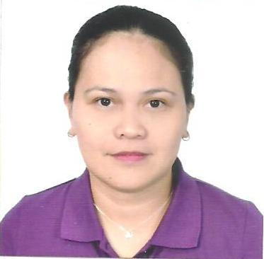
CESAR, JOCELYN SALGUERO
Blk9 Lot9 MACAWILI2 HOA Llano
Caloocan City, Metro Manila, Philippines
Mobile No: 09060965624
E-mail: ailynjhoe25@gmail.com

OBJECTIVE:
To work in a challenging and interactive environment that offers training that will optimize my professional and personal growth in preparation for future advancement to higher level of skills, and to contribute on the company’s goals and vision. Being Resourceful, Innovative and Flexible.

PERSONAL DETAILS:
Name : Cesar, Jocelyn Salguero
Age & DOB : 39 years, 29-June-1983
Sex : Female
Marital Status : Single
Nationality : Filipino
Permanent : Blk.9 Lot9 Macawili 2 HOA Llano,
Address Caloocan City, Metro Manila, Philippines
Fathers Name : Cesar, Tito Amoy
Mothers Name : Cesar, Josephine Salguero
Languages Known : English, Filipino, Cebuano
EDUCATION:
IMMACULATE CONCEPTION COLLEGE – LA SALLE
Bachelor of Science in Commerce
Major in Business Administration (Under Graduate)
ICC-La Salle Ozamiz City, Misamis Occidental, Philippines
March 2000

OZAMIZ CITY NATIONAL HIGH SCHOOL
Brgy. Tinago, Ozamiz City,
Misamis Occidental, Philippines
March 1999

CATADMAN ELEMENTARY SCHOOL
Ozamiz City, Misamis Occidental ,
Philippines
March 1995

WORK EXPERIENCE:

Republic Biscuit Corporation
#57 Gen. Luis St. Brgy. Nagkaisang Nayon,
Novaliches Quezon City, Metro Manila

April 2009 – December 2018
- Factory Worker ( Wrapping Dept.)
- Check quality of prepared product
- Clean plant processing area
- Check quality of various products before packing
- Make sure the quantity of the product is correct and no shortage inside
to avoid costumer complaint
- Check the biscuits sometimes if it is good not breakable
- Clean work areas

January 2018- Present
- Production SAP(System Application and Products in Data Processing) Encoder
- Execute Transfer Posting of Materials from Production Floor back to storage location/ Warehouse e.g. excess in Requested Material, unusable materials etc.
- Execute transfer posting in system when receiving requested materials from Warehouse based on approved Material Issue Slip.
- Execute Transfer Posting in System when returning unused materials to Warehouse Production basis of this is Material Return Slip approved by the Production Head/ Supervisor.

KREXIM PHIL. INCORPORATED
Brgy. Sta Monica, Novaliches Quezon City,
Metro Manila, Philippines
March 2006 – August 2007
- Quality Control
- Assure that all the goods produced by Production are all in good condition and quality passed.
- Make sure that the fish hook has no rust and the paint is in good quality
- Wipe the lead with a rag after inspect.

NIPPON PROMAC PHILS INC.
L&G Compound P.Dela Cruz,Novaliches Quezon City
September 2004-February 2005
Sorter
Categorize the item after production of chips.
Sorting the products efficiently,monitor and exclude the deform chips
Maintain a clean and organized production area..

ZAGU FOOD CORPORATION
#10 Brixton St. Pasig City,
July 2004 –January 2005
- Service Crew
- Cashier
- Preparing for Goods
- Approaching them with a smile as well as assisting them and Give them the best satisfaction of service I can give.

JBC FOOD CORPORATION
Llano Road,Caloocan City,
September 2000–January 2001
Packers
Checked the quality of the product if there is no hole or machine bites.
Make sure that the quantity is correct and not shortage before packing.
Packing finish product into bags and sealed.Then packed again bag into bundles.

STATELINE SNACK FOOD CORPORATION
Llano Road,Caloocan City
February 2000-July 2000
Machine Operator
Clean the parts of the machine and set up properly.
Checked the date of expiration if it inract properly
In the packaging.
Ensure that the machine runs smooth and works.
Every hour checked the products using water if there is no steam
Brush the sealer of the machine Everytime you change the roll.

CHARACTER REFFERENCE:
Emma Sangual
Operation Management Secretary
Republic Biscuit Corporation
Tel.#937-4434 (loc. 125)

Ross Almeniana
Supervisor
Krexim Phil.Inc

Declaration
I hereby declare that the above written particulars are true to the best of my knowledge and belief.
__________________ JOCELYN S. CESAR

