#13B, Matatag St.,Barangay Pinyahan
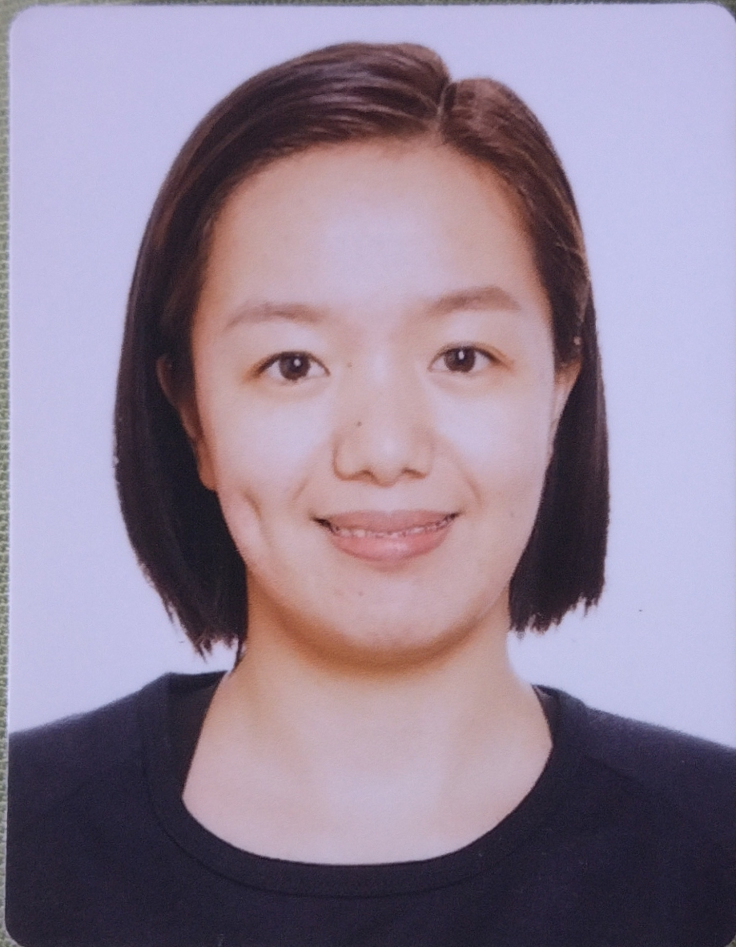
Quezon City, Philippines
09282142108
lokinoaivy@yahoo.com
aivy sapidew lokino
Objective |  | Contribute to the success of your institution by providing a high quality care to dialysis patients while adhering to its standard and policy.
personal profile |  | Age:29  Date of Birth: 14 August 1993  Civil Status: Single  Permanent Residence: Philippines
Experience |  | dialysis nurse, bbraun avitum philippines- national kidney and tranplant institute  22 June 2020 to 30 September 2022  5 June 2017 to 18 January 2020  - Performs routine dialysis treatment procedure\s.  - Providing nursing care and overseeing the dialysis treatment from start to finish  - Checking the patient’s vital signs and talking with them to assess their condition  - Perform venipuncture on arterio-venous fistula/graft  - Checking and recording patients’ vitals before, during, and after dialysis treatment.  - Ensuring that hemodialysis treatments are administered to patients correctly.  - Monitoring patients during dialysis treatment to identify any adverse reactions.  - Preparing and updating nursing care plans.  - Promptly notifying the appropriate medical practitioner of any problems that occur during dialysis treatments.  - Working with the dialysis technicians to ensure that dialysis machines and equipment are set up correctly.  - Educating patients on dialysis treatment options, kidney disease management, as well as suitable nutrition and exercise regimens.  volunteer dialysis nurse, bbraun avitum philippines-cya baguio  21 November 2016- 18 April 2017  - Performs routine dialysis treatment procedure\s.  - Providing nursing care and overseeing the dialysis treatment from start to finish.  - Checking the patient’s vital signs and talking with them to assess their condition  - Perform venipuncture on arterio-venous fistula/graft  - Perform initial evaluation visits and regularly reevaluate patient’s nursing needs.
skills & qualification |  | Exceptional Communication Skills  - Effective Interpersonal Skills  - Flexible  - Open for knowledge upgrade and learning.  - Good team player
training |  | Hemodialysis Training Program for Nurses  5 September 2016 to 7 October 2016  - Specialized Training Program which includes 32 hours of didactics and 168 hours of actual hands-on training.
Educational BAckground |  | TERTIARY  Easter College Inc.- Bachelor of Science in Nursing, Batch 2014  Easter School Rd., Guisad, Baguio City  SECONDARY  Lepanto National High School Batch 2010  Lepanto, Paco, Mankayan, Benguet  PRIMARY  Lepanto Elementary School, Batch 2006  Lepanto, Paco, Mankayan, Benguet
references |  | ONOFRE R. LAZARO  Regional Operations Manager  B.Braun Avitum Philippines Inc.  onofre.lazaro@bbraun.com  +63 1 515 2631  INDIRA RODULFO  HR Coordinator  BBraun Medical Supplies Inc.  B.Braun Avitum Philippines Inc.  indira.rodulfo@bbraun.com  +63 2 588 5637

