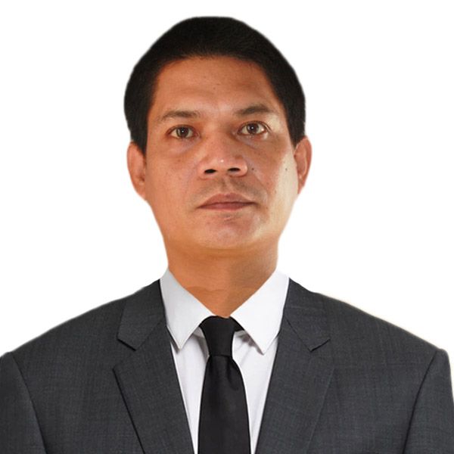
ROWELL JOHN PACOLOR SALVADOR
Ineangan, Dupax del Norte, Nueva Vizcaya,
Philippines, 3706
Phone No.: N/A
Mobile No.: (63939)325-7521
Email Add: salvadorrowelljohn306@gmail.com

PERSONAL INFORMATION

Permanent Address : Ineangan, Dupax del Norte, Nueva Vizcaya, Philippines, 3706
Birthdate : June 20, 1984
Birth Place : Dupax del Norte, Nueva Vizcaya
Height : 57 ft.
Weight : 149 lbs.
Sex : Male
Civil Status : Single
Religion : Roman Catholic
Nationality : Filipino

BENEFICIARY

Beneficiary Name : Salvador, Rosy Pacolor
Relationship : Mother
Permanent Address : Ineangan, Dupax del Norte, Nueva Vizcaya, Philippines, 3706
Tel. No. : (63915) 576 -9223

CHILDREN

N/A

DEPENDENTS:

Mother: Salvador, Rosy Pacolor Birthday: April 10,1952.
Birth Place: Dupax del Norte, Nueva Vizcaya
Occupation: Pharmacist

BROTHERS / SISTERS

Brother: Salvador, Rogelio Jr. Pacolor Birthday: April 25, 1981
Birth Place: Ineangan, Dupax del Norte, Nueva Vizcaya
Civil Status: Married
Occupation: Businessman

Sister: Salvador, Roselle Pacolor (Deceased) Birthday: May 21, 1979
Birth Place: Ineangan, Dupax del Norte, Nueva Vizcaya
Civil Status: Single
Occupation: N/A

EDUCATIONAL BACKGROUND

Elementary Year [From] - [To]
School: Ineangan Elementary School 1991 - 1997
Address: Ineangan, Dupax del Norte, Nueva Vizcaya, Philippines

Secondary
School: Lamo National High School 1997 - 2001
Address: Lamo, Dupax del Norte, Nueva Vizcaya, Philippines

College
Course: Bachelor of Science in Pharmacy (undergraduate) 2002 - 2008
School: Our Lady of Fatima University
Address: Valenzuela City, Metro Manila, Philippines

Course: Bachelor of Science in Pharmacy (graduated) 2008 - 2012
School: University of La Salette, Inc.
Address: Santiago City, Isabela, Philippines

EMPLOYMENT HISTORY

Position: Pharmacy Assistant
Company: RR and Rainne Pharmacy
Address: Malasin, Dupax del Norte, Nueva Vizcaya
Date: June 5, 2013  March 8, 2018
Reason for Leaving: Resigned

Job Description / Duties and Responsibilities:
- Responsible for preparing and dispensing drug to the patient.
- Responsible for daily inventory of all store stocks.
- Responsible for verifying the prescription are filled correctly in a timely manner.
- Responsible for receiving, recording and storing medications coming into the pharmacy.

Position: Pharmacist
Company: PRA Agency Manpower
Address: #7 Caruncho Ave. Brgy. Malinao, Pasig City
Date: February 4, 2019  June 30, 2019
Reason for Leaving: Resigned

Job Description / Duties and Responsibilities:
- Responsible for the quality of medicines supplied to patients.
- Responsible for ensuring that the supply of medicines is within the law.
- Responsible that the medicines prescribed to patients are suitable.
- Responsible for advising patients about medicines, including how to take them, what reactions may occur and answering patientsquestion

Position: Owner/Pharmacist
Company: RREPS Pharmacy
Address: Malasin, Dupax del Norte, Nueva Vizcaya
Date: July 28, 2020  Present

Job Description / Duties and Responsibilities:
- Responsible for the quality of medicines supplied to patients.
- Responsible for ensuring that the supply of medicines is within the law.
- Responsible that the medicines prescribed to patients are suitable.
- Responsible for advising patients about medicines, including how to take them, what reactions may occur and answering patients questions.

TRAININGS / SEMINARS ATTENDED

N/A

SPECIAL SKILLS / INTERESTS

- Practiced on giving medications with accuracy and efficiency
- Possess strong communications skills
- Computer literate
- Flexible and adaptive
- Knowledge in crop cultivation

CHARACTER REFERENCES

Mercelita P. De Vera
Retired Public Schools District Supervisor
Mobile No.: (63928) 356 -2567

Wendy Grace D. Castro
Chief Pharmacist
Dupax District Hospital
Mobile No.: (63966) 360-6873

Rhandel P. Barasi
Pharmacist
Azarias Pharmaceutical Laboratories, Inc.
Tel. No.: (63942) 647 -1658


_________________________
Applicants Signature

