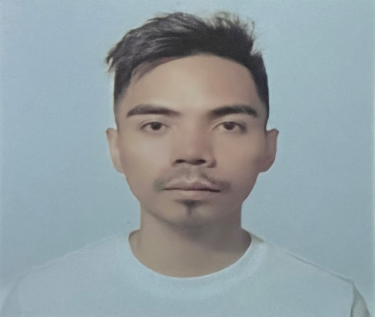
EDMAR R. OCAÑA
Cancawas, San Jose
Negros Oriental
dreambods@yahoo.com
+639651535189

OBJECTIVE

To seek opportunity to develop new skills as part of the team. Experienced in various industrial and manufacturing processes and is ready to take the new step in career. Looking for an opportunity with a growing company committed to dedicated employees.

PERSONAL INFORMATION
Date of Birth : April 6, 1992
Place of Birth : Valencia, Negros Oriental
Age : 30 years old
Civil Status : Single
Gender : Male
Height : 5’9”
Weight : 145lbs
Religion : Roman Catholic
Passport Number : P0800760B (Valid until: February 22,2029)
Language Spoken : English, Tagalog, Japanese

BENEFICIARIES:
Edward Vincent R. Ocaña
Brother
Rizzel Ann R. Ocaña
Sister

SKILLS / STRENGHT
- Monitored machinery in operation to identify concerns and make corrections or report complex problems.
- Support machine operations in setup and operation equipment resulting to efficient runs.
- Supported current production needs by moving items between equipment, conveyors and staging areas.
- Communications and Calculations.
WORK EXPERIENCES
Date of Employment: August 25, 2022 up to present
Company Name: Concentrix
Company Address: Glorietta 5, Ayala Center, Ayala Ave, Makati, 1200 Metro Manila
Employment Type: Local

Duties and Responsibilities:
Call Center Agent

FROM May 2022 – July 2022
Reason: I went to my province and take care of my chickens, cows and pigs in my father’s farm.

Date of Employment: February 2016 – April 2022
Company Name: Sekitei Co., Ltd.
Company Address: 767-27 Kanaya Toyama-Shi Toyama-Ken 930-0873, Japan
Employment Type: Overseas

Duties and Responsibilities:
Food Processor
- Work with food product in different stages such as cutting meat, mixing ingredients and packaging finish product.
- Ensuring all machines and workplace are clean before doing the assigned job.
- Sorting every package that comes in and out in the freezer.
- Cleaning machinery parts at the end of the shift.
FROM July 2015 – January 2016
Reason: I went Back to our province after my job in Fortune Packaging Corp. to help my father at the farm and went back to Manila to look for a job Overseas.

Date of Employment: February 2015 – June 2015
Company Name: Fortune Packaging Corp.
Company Address: #20 Main Avenue, Severina Industrial Subdivision, Km 16 South Superhighway Parañaque Bicutan, 1704 Metro Manila
Employment Type: Local

Duties and Responsibilities:
Machine Operator Trainee
- To maintain to have a sheet of paper for the printing job in the conveyor.
- Cleaning the rubber rollers of the machine in order to maintain the quality of the printing job.
- Make sure to always check the ink in every station of the machine printing.
- Check the finish product every 15 minutes to ensure the quality of its print.
FROM APRIL 2014-JANUARY 2015
Reason: Management in breeding of chickens in our farm, then raising them until they are ready to be sold.

EDUCATIONAL BACKGROUND

TERTIARY SILLIMAN UNIVERSITY
Bachelor of Science in Engineering
October 2012 – March 2014(Undergraduate)

ST. PAUL UNIVERSITY DUMAGUETE
Bachelor of Science in Information Technology
June 2008 – March 2012(Graduate)

SECONDARY TAMPI NATIONAL HIGH SCHOOL
San Jose, Negros Oriental
June 2004 – April 2008

ELEMENTARY SAN JOSE ELEMENTARY SCHOOL
San Jose Negros Oriental
June 1998 – April 2004

TRAININGS & SEMINAR
- National Trade Skill Test Level 3 / Professional Level
(Theoretical Subjects and Practical Exam Passer)
The Organization for Technical Skill Assessment of Foreign workers in Food Industry 355 Nishifutama Toyama-shi Toyama-Ken 939-0177, JAPAN
November 16, 2018

- Technical Intern Training Evaluation Test Level 2 / Advance Level
(Theoretical Subjects and Practical Exam Passer)
The Organization for Technical Skill Assessment of Foreign workers in Food Industry 355 Nishifutama Toyama-shi Toyama-Ken 939-0177, JAPAN
January 11, 2017
CHARACTER REFERENCE

Leidda Valenzuela – Ishikuro Sekitei Co., Ltd
Line Leader ishikuroleidda@gmail.com
CP# +819013139868

Kristy Francisco Cristobal Sekitei Co., Ltd
Co-Worker CP#+819037670621

Arjay De Chavez Funtilar Sekitei Co., Ltd
Co-Worker CP# +817020124042

I hereby certify that the above information is true and correct.

Edmar R. Ocaña
Applicant

