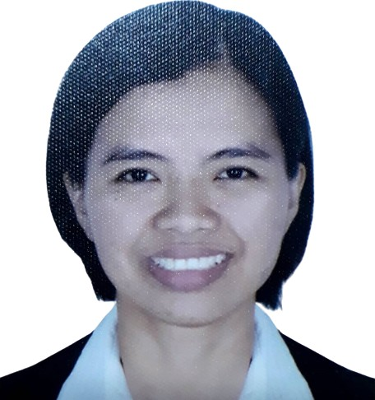
MARCELINA MARICEL A. SAN JOSE
C O N T A C T
(+63) 9086427972
marcelinamaricel sanjose@gmail.com/ ycel_262007@ yahoo.com
89 Monaco St. Ciudad Grande, Rosario, Pasig City
S K I L L S

Pharmaceutical operations Patient needs assessment Patient care & counselling Attention to detail
Ability to multitask
A C H I E V E M E N T S

Board Passer of Pharmacy Licensure Examination January 2012

E D U C A T I O N

BS Pharmacy
Centro Escolar University-Manila
2007-2011

P R O F E S S I O N A L S U M M A R Y

Compassionate & systematic professional with 10+ years of work experience in retail pharmaceutical industry. Highly proficient in carrying out doctor's prescription precisely to prevent drug errors and ascertain effective treatment. Seeking to leverage leadership and customer expertise.

W O R K E X P E R I E N C E

ASSISTANT BRANCH MANAGER-RPH

Mercury Drug Corporation | 2019 up to Present
Responsible in the management of the store.
Responsible for the planning, organizing & directing the operation of the rx section.
Performs the functions of the ABM on shifting basis and directs overhead services in retail operation.
Implements discipline for any violation of company rules, regulations & policies.
REGISTERED PHARMACIST II

Mercury Drug Corporation | 2014-2019

REGISTERED PHARMACIST I
Mercury Drug Corporation | 2012-2014 Under direct supervision of the ABMRPh. Compounds & dispenses prescriptions.
In-charge in the preparation of galenicals.
Assists in the purchase, dispensing & recording of dangerous drugs transactions & perform other related duties as may be assigned.

S E M I N A R S & T R A I N I N G S

Continuing Education for Pharmacists II "The Mercurian Pharmacists: Building Trust through Excellent Customer Service"
November 22, 2013

Continuing Education for Pharmacists III " Professionalizing Good Dispensing Practice through Adherence to New Pharmacy Regulations"
May 11, 2015

Licensing Seminar for Drugstores & Outlets
October 6, 2016

Continuing Education for Pharmacist IV "Optimizing Pharmacists' Knowledge on Disease and Medication Management"
March 28-29, 2019

