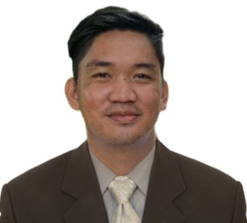
JOHN PAUL EVANGELISTA MANERA
WAITER
Barangay Sulquiano, Dingras
Ilocos Norte 2913
Mobile no. 09157871567 / 09454478738
Gmail: manerajohnpaul@gmail.com
OBJECTIVES
To join an organization were I can apply my knowledge and skills to complement those I have learn from school and from my job and I offer my skills about hospitality services with a challenging assignment which would enable me to exercise my skills in an effective manner and determination.

EDUCATION

June 2015 – May 2015 STI College of laoag
Diploma in Hospitality and
Restaurant Services
School Year 2008 - 2009 Dingras National High School –
Sulquiano Campus

School Year 2005 - 2006 Sulquiano Elementary School
Dingras Ilocos Norte

WORK EXPERIENCE

Febuary 2017 – april 2017 On-the-job-training
Astoria Current Boracay
Station 3 Boracay Island
Malay Aklan

January 2018 – present Rivermount Hotel and Resort
Sarrat, Ilocos Norte

June 2022 – Present The Red Stallion Catering
Waiter
Laoag City

PERSONAL BACKGROUND

Date of Birth January 29, 1993
Place of Birth Barangay Sulquiano Dingras Ilocos Norte
Age 29
Civil Status Single
Religion Catholic

REFERENCES

Mr. R-Jay Ramos (09950791804)
Food and Beverage Supervisor
Rivermount Hotel and Resort Inc.

Aldreds Lucero Edmalin
Manager
The Red Stallion Catering and Cuisine

I hereby certify that the above information are true and correct to the best of knowledge and belief.

JOHN PAUL EVANGELISTA MANERA
Applicant

