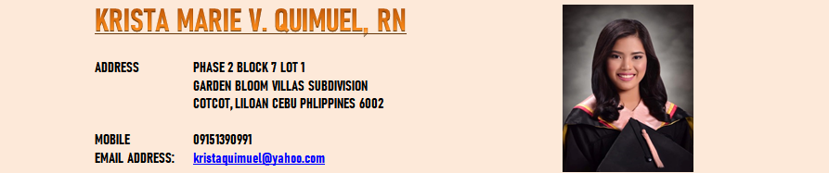
Graduated in Bachelor of Science in Nursing, Passed my Professional License Nursing Licensure Examination on November 16-17, 2019 with General Average Board Rating of 83.40 percent as a Registered Nurse (RN)

Objectives:
Seeking a Staff Nurse position which will give me an opportunity to gain experience at the same time as providing quality health care to residents, Dedicated, Compassionate, Motivated and Energetic with a great love for providing health care. I hope to start my career in this honorable profession with your Hospital Institutions.

Working Experience:

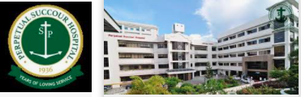
Perpetual Succour Hospital - PSH
- Gorordo Ave, Cebu City, 6000 Cebu, Philippines
- Position : Staff Nurse
- Date : January 04, 2021 – July 10, 2022
- Job Responsibilities:
Medical Surgical Nurse
- Provide direct and individualized nursing care to patients based on the application of scientific nursing principles.
- General nursing care.
- Consults and coordinates with health care team members to assess, plan, implement and evaluate patient care plans 
- Prepares and administers (orally, subcutaneously, through an IV) and records prescribed medications.
- Reports adverse reactions to medications or treatments in accordance with the policy regarding the administration of medications.
- Educates patients on surgical procedures, Records patients’ medical information and vital signs.
- Monitors and adjusts specialized equipment used on patients, and interprets and records electronic displays 
- Initiates corrective action whenever the patient displays adverse symptomatology 
- Provides bedside care for a wide variety of medical patients, including pre- and post-surgery patients 
- Initiates patient education plan, as prescribed by physician. Teaches patients and significant others how to manage their illness/injury, by explaining: post-treatment home care needs 
- Changes dressings, inserts catheters, starts IVs, Prepares equipment and aids physician during examination and treatment of patient 
- Responds to life-saving situations based upon nursing standards and protocol  Participates in discharge planning  Utilizes time management skills 
- Records all care information concisely, accurately and completely, in a timely manner, in the appropriate format and on the appropriate forms  Performs other position-related duties as assigned, depending on assignment setting

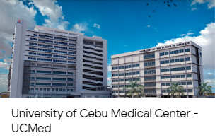
- A1 Ouano Avenue, North Reclamation Area, Mandaue City, 6014 Cebu, Philippines
- Position : Staff Nurse
- Date : Febraury 03, 2020 – August 31, 2020

- Job Responsibilities:
Labor and Delivery Nurse:
- Perform routine checkups on women in different pregnancy stages
- Runs diagnostics tests and interpret fetal heart monitors
- Makes health recommendations and administers medications
- Records patient information in an electrical medical record
- Identifies and managers preeclampsia, multiple fetuses, gestational diabetes and other high-risk obstetrical conditions
- Induces labor and provide care to patients during deliveries
- Assists physicians with caesarians and other difficult deliveries
- Provide postpartum care
- Educates new mothers about caring for their infants
- Examined patients in different pregnancy stages
- Maintained accurate patient health records
- Monitor patient’s temperature, pulse and blood pressure
- Assisted patients during the delivery process
- Identified and handled complications .

Others Responsibilities:

    - As a Nurse Staff, Responsible in providing comprehensive nursing care to patients in all walks of life, with variety of clinical conditions, Promotes and Restores patients’ health by completing the nursing process; collaborating with physicians and multidisciplinary team members; providing physical and psychological support to patients, friends, and families; supervising assigned team family members.
    - Provide care to patients and residents based on their care plan outlined by their doctor
    - Accurately monitor and record observations on patients' conditions
    - Maintain accurate records of residents care, financial procedures, and medication administration
    - Identify care planning needs
    - Carry out risk assessment
    - Record patients' vital signs and medical information
    - Reevaluate patient care plan as conditions change
    - Consult and coordinate with other healthcare team members
    - Direct or supervise less experienced nursing staff
    - Monitor patients' diet and exercise
    - Prepare patients and assist with treatments, surgery, or exams as needed
    - Manage stocks of supplies
    - Ensure storage and disposal of medication is carried out according to policy
    - Participate in clinical improvements and offer ideas on clinical and non-clinical policies

Certificate:

• Infusion Nurse Certification Training
on May 10-12,2021 valid until January 1,2025

Education:

Bachelor of Science in Nursing (BSN)
Cebu Doctor’s University
No. 1 Dr. P. V. Larrazabal Jr, Ave., North Reclamation, 6014 Mandaue City, Cebu, Philippines
Year Attended: 2015 – 2018
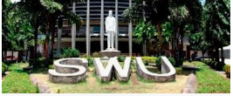
Bachelor of Science in Nursing (BSN)
Southwestern University - Phinma
Villa Aznar, Urgelio St., 6000 Cebu City, Philippines
Year Attended: 2018 – 2019
Graduated: May 25 2019

Personal Details:

Name: Krista Marie Villaceran Quimuel
Date of Birth: April 27, 1998
Place of Birth: Cebu City
Gender: Female
Height: 5’2”
Marital Status: Single
Religion: Roman Catholic
Father’s Name: Benjie A. Quimuel
Mother’s Name: Maria Maricon V. Quimuel
Sister’s Name: Athenna Katherine V. Quimuel
Kristina Jhona V. Quimuel
Brother’s Name: Alexander Zane V. Quimuel

Krista Marie V. Quimuel, RN

