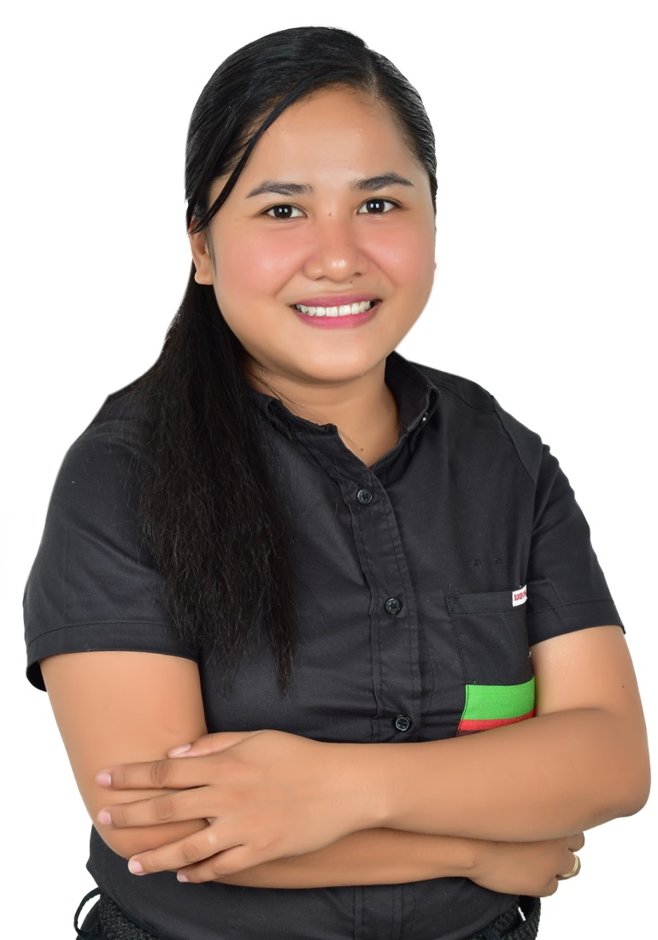

Attach Here
2x2
Colored Picture
NAME: RICHYL C. SELDA
Present Address: Brgy. Narauis Hinigaran Negros Occidental
Philippines,
Mobile No.: +639501600113
Email Add: richyl_selda@yahoo.com.ph

PERSONAL INFORMATION

Permanent Address : Brgy. Narauis, Hinigaran Negros Occidental
Birthdate : Feb. 11, 1995
Birth Place : Hinigaran, Negros Occidental
Height : 5’0
Weight : 52kg
Sex : Female
Civil Status : Single
Religion : Born Again Christian
Nationality : Filipino

BENEFICIARY

Beneficiary Name : Roque Selda
Relationship : Father
Permanent Address : Brgy. Narauis Hinigaran, Negros Occidental
Tel. No. : +639088627514

DEPENDENTS:

Father: Roque Selda Birthday: May 17, 1962
Birth Place: Hinigaran, Negros Occidental
Occupation: Government Employee

Mother: Loreto Selda Birthday: April 10, 1967
Birth Place: Hinigaran, Negros Occidental
Occupation: Government Employee

CHILDREN

Daughter: Birthday:
Birth Place:
Civil Status:
Occupation:

Daughter: Birthday:
Birth Place:
Civil Status:
Occupation:

BROTHERS / SISTERS

Brother: Rangelo Selda Birthday: July 6, 2002
Birth Place: Hinigaran, Negros Occidental
Civil Status: Single
Occupation: none

Sister : Raquel Selda Birthday: May 25, 1999
Birth Place: Hinigaran, Negros Occidental
Civil Status: Single
Occupation: None

EDUCATIONAL BACKGROUND

Elementary Year [From] - [To]
School: Hinigaran Elementary School-A 2001-2007
Address: Osmeña St,. Hinigaran, Negros Occidental

Secondary
School: Hinigaran National High School 2007-2011
Address: Rizal St. Hinigaran, Negros Occidental
College
Course: BSBA Major in Marketing Management and 2011-2015
Business Economics
School: University of St. La Salle
Address: La Salle Avenue, Bacolod 6100, Negros Occidental

EMPLOYMENT HISTORY

Position: Shift Manager
Company: Perf Restaurant Inc. / Burger King Philippines.
Address: 275, E. Rodriguez Sr. Avenue, Quezon City
Date: Nov. 8, 2017- Present
Reason for Leaving:

Job Description / Duties and Responsibilities:
- Delegating tasks to restaurant staff and supervising their performance
- Maintaining a fully-stocked inventory and ordering food supplies, as needed
- Managing dining reservations
- Assist customer complaints and/or concerns in a friendly manner while still enforcing company principles and maintain professionalism.
- Ensure everyone follows the company guidelines, policies and procedures.
- Responsible for delivering outstanding customer service, assigning duties, development of team members, labor and cash handling.
- Develop a work environment that encourages compliance with company, state and federal safety and employment guidelines
- Negotiated with suppliers for rebates, bill-back and price-off contracts based on buying amounts.
- Oversaw and led back-of-the-house and assisted in front-of-the-house training
- Couched, taught and developed other team member.
- Oversaw daily operations; opened and closed the restaurant.

Position: Administrative Assistant
Company: Board of Investment
Address: Industry and Investments Building 385 Senator Gil Puyat Avenue, Makati City 1200
Date: May 2, 2016- October 15, 2017
Reason for Leaving:

Job Description / Duties and Responsibilities:
- Perform clerical duties
- Managing and distributing information within an office. This includes answering phones, taking memos and maintaining files.
- In charge of sending and receiving correspondence, as well as greeting clients and customer.
- Maintain contact lists.
- Develop and maintain a filing system.
- Act as the point of contact for internal and external clients.

Position: Servicing Staff
Company: Manila Memorial Park Inc. –Dasmañas
Address: Governor Drive, Brgy. Piela, Dasmariñas Cavite.
Date: Nov. 2, 2015-April 30, 2016
Reason for Leaving:

Job Description / Duties and Responsibilities:

- Performs all clerical duties
- Communicate directly to Clients and encourage for trusting relationships.
- Performs filling and organizing documents.
- Answer and direct phone calls.
- Submit and reconcile expense reports.
- Provide general support to visitors.

SPECIAL SKILLS / INTERESTS

- interpersonal and verbal communication skills
- Leadership
- Strong Customer Service Attitude
- Assertive Decision-Making

CHARACTER REFERENCES

Joyce Dela Cruz
RGM Burger King
09273324390

Ronald Sangalang
RGM Burger King
09273488008

Leilani Briones
RGM Burger King
09959520617

