
GIRLIE DAHILIG ESTABILLO
Brgy. 13 PuzolPinili, Ilocos Norte
Email add: estabillogirlie8@gmail.com
Mobile Number:0915-8689458

CAREER OBJECTIVE

International Student Professional with exceptional written and oral communication skills. Well-trained and dedicated to continuous professional improvement. Thoroughly enjoy working independently in a problem-solving capacity, coupled with a willingness to multi-task. However, also able to work in a team and under pressure effectively; always taking a proactive approach.

EDUCATIONAL BACKGROUND
College : Mariano Marcos State University
Bachelor of Science in Nursing
Batac, Ilocos Norte
1999 – 2003
Secondary : Immaculate Conception Academy
Batac, Ilocos Norte

Elementary : St. Elizabeth Elementary School
Badoc, Ilocos Norte
1989 – 1995
WORK EXPERIENCES

Administrative Assistant 1
Pinili Municipal Police Station
Philippine National Police
2018 – Present

Barangay Secretary
Pinili, Ilocos Norte
Local Government Unit of Pinili
December 1, 2007 – August 30, 2017

Staff Nurse
Ranada General Hospital
Laoag City, Ilocos Norte
August 17, 2005 – February 19, 2006

Manager
AP21 GAS Station
Puzol, Pinili, Ilocos Norte
2021-Present

SPECIAL SKILLS

Flexible
Time Management
Effective Communication
Adaptability
Leadership
Teamwork
Patient and Student Advocate
Computer Literacy

I hereby swore and declare that all information stated above is true and correct to the best of my knowledge and belief.
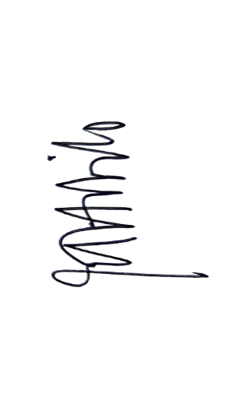

GIRLIE D. ESTABILLO

