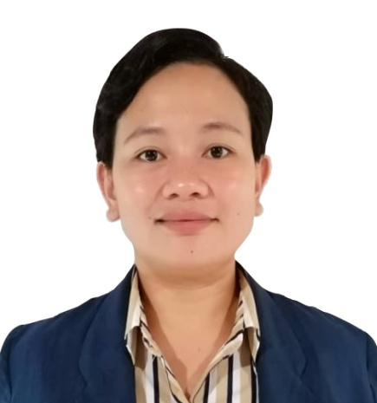
Catherine Vizcayno Sevilla
Block3 Lot6 Velino St.Altezza Grande Catalunan Grande Davao City Philippines.
09385522522/ 09364842887
Email: cathyriri09@gmail.com
Facebook account: Catherine VS
OBJECTIVE:

- To impart my skills, gain extra knowledge, wisdom, and experience for professional growth.
- To further improve my abilities and work with passion to achieve the goals set by the organization.
- To enhance my personal and interpersonal skills in dealing with diversities .
- To improve quality of life and secure the well being of my family.

EDUCATION:

Tertiary: Bachelor of Science in Nursing (Diploma)
Brokenshire College of Davao City
Madapo Hills, Davao City
(2016-2020)

Secondary: High School Diploma (With Honors)
Saint Mary’s Academy of Caraga
Caraga Davao Oriental
(2004-2008)

Elementary: San Jose Elementary School( With Honors)
San Jose, Caraga Dava Oriental
(2000-2004)

WORK EXPERIENCE:

- Cashier at Jollibee
Southern Bee Foods Corporation
July 2011- March 2013

- Nurse Assistant
Covid-19 General Ward
Brokenshire Integrated Health Ministries Inc.
Madapo Hills, Davao City
January 2021- August 2022
- Staff Nurse
Neonatal Intensive Care Unit
Brokenshire Medical Center
Madapo Hills, Davao City
August 2021- Present

SEMINARS / TRAINING

- Kidney Transplantation
AVR 1, Brokenshire College, Davao City
March 2018

- Trends for Oncologic Pediatric Nursing Care
AVR 1, Brokenshire College, Davao City
January 2018
- Nursing Employment Issues and Trends
AVR 2, Lora Dyer Building,
Brokenshire College, Davao City,
March 2018

- Neonatal Resuscitation Program
NICU Brokenshire Medical Hospital
May 2022

- Lactation Management Program
Neonatal Intensive Care Unit Brokenshire Medical Hospital
August 2022

SOCIO-CIVIC ACTIVITIES:

- Member
Philippine Nurses Association (PNA- Davao Chapter)
November 2020 to present

- Member
Rotaract- Brokenshire College of
Rotary Davao 2000
2017 to 2020

- Member
Philippine Nurses Student Nurses Association (PNSA- BC Chapter)
2016-2020

WORK RELATED SKILLS:

- Computer Literate: Oriented and uses Microsoft word, Power Point
- Communication Skills: Able to speak and write English, Tagalog
- Flexible/Adaptable: Willing to learn new skills and can work with diverse setting.
- Cultural Sensitivity: Can work with people of different culture either as a client or a co-worker.
REFERENCES:
Mr. Junhard J. Belonguil Visual Display Officer
The SM Store Davao and SM Lanang Premier
09369099268
Ms. Sheijan Lilang Staff Nurse
Brokenhire Integrated Health Ministries Inc.

