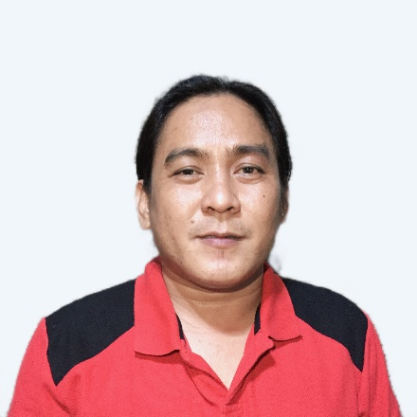
Robert C. Gotengco
Address: 297 Mamatid, Cabuyao City, Laguna
Contact no.: 09105998257
Email: robertgotengco0507@gmail.com

Objective: To achieve a challenging and responsible position that will enable my skills and abilities be fully utilized and improved.

PERSONAL DATA:
Provincial Address : 297 Purok 2 Brgy. Mamatid, Cabuyao City, Laguna
Age : 39 years old
Sex : Male
Place of Birth : Brgy. Mamatid, Cabuyao City, Laguna
Date of Birth : May 07, 1982
Height : 5’4”
Weight : 147 lbs
Religion : Roman Catholic
Civil Status : Married
Nationality : Filipino
Languages Spoken : Tagalog, English

Person to be contacted in case of emergency: Jay-an G. Gotengco
His/Her Address and Cellphone Number: 297 Mamatid, Cabuyao City, Laguna
09398646294

EDUCATIONAL BACKGROUND

Vocational Course : Philippines Science Technology Centers
Computer Technology
1999 – 2001

Secondary Education : Cabuyao Integrated National High School
Cabuyao City, Laguna
1995 – 1999

Primary Education : Mamatid Elementary School
Mamatid, Cabuyao City, Laguna
1989 – 1995

SKILLS
- Able to examine welds and ensure that they meet standards and/or specification.
- Has the ability in reading text, documents use, numeracy, writing and oral communication, working with others, problem solving, critical thinking, job task planning and organizing, and significant use of memory.
- Able to perform welding works using SMAW/GTAW process using carbon steel, stainless pipes, aluminum plates and different electrodes.
- Recognizes, sets up, and operates hand and power tools commonly used in the welding sector, such as shielded metal arc and gas metal arc welding equipment.
- Examines work pieces for defect and measures work pieces.
- Lay out, position, align, and secure parts and assemblies prior to assembly, using straightedges, combination squares, calipers, and rulers.
- Perform maintenance, welding work steel pipes, and stainless tubing pipes.
- driving code123
- Assembler, Fabricator, Fitter Welder
- Repair and assemble the Equipment &amp; Hydraulic System
- Plasma Cutting and Oxy Acetylene Cutting
WORK EXPERIENCE

Inclusive Date : January 30, 2008 to January 23, 2009
Position : Plate Welder
Company : SK – Engineering / Construction Co. Ltd
Address : Building 8 Street 13, Block 3
Job Description : Perform welding job assigned as SMAW of the project,
Company SK – Engineering Construction Co. Ltd Project of my company piping oil and gas, use of material carbon steel, consumable material use like electrode and 6010, 7018, and also follow-up safety rules and regulation of the project.

Inclusive Date : February 17, 2009 to July 19, 2010
Position : TIG Welder Fabricator
Company : SANVIL Industrial Supply
Address : #78 B San Antonio Village Paciano Rizal, Calamba City,
Laguna
Job Description : Perform full welding works on carbon steel pipes in
Fabrication shop with different diameter by using GTAW/SMAW process with 100% testing radiographic test.

Inclusive Date : August 10, 2010 to February 15, 2014
Position : TIG Welder Fabricator
Company : ADM Industrial Supply
Address : Brgy. IV Tanauan City, Batangas
Job Description:
- Perform full welding works on carbon steel pipes, stainless pipes, and aluminum plates like electrode 304, 316, 308, 4043, and also follow-up safety rules and regulation of the project.
- Recognizes, set up, and operates hand and power tools common to the welding trade, such as shielded metal arc and gas metal arc welding equipment.
- Monitors the fitting, burning, and welding processes to avoid overheating of the parts of warping, shrinking, and distortion or expansion of materials.
- Examines work pieces for defect and measures work pieces with straightedges or templates to ensure conformance with specifications.
- I will lay out, position, align, and secure parts and assemblies prior to assembly, using straightedges, combination squares, calipers, and rulers.
Inclusive Date : February 16, 2014 to present
Position : Preventive Maintenance
Company : Coca-Cola Femsa Sta. Rosa City, Laguna
Address : Pulong Sta. Cruz, Sta. Rosa City, Laguna
Job Description:
- Perform maintenance of Packer Machine and Labeler Machine.
- Perform welding works steel pipes and stainless tubing pipes.
SEMINAR AND TRAINING ATTENDED
- Completed the 8-hour training course on Technical Safety (Electrical Safety, Machine Safety, Working in Heights, Chemical Safety, and Safety in Confined Spaces), Coca-cola Plant Sta. Rosa, Laguna. (May 26, 2012)

- KHS (Filling and Packaging Worldwide) Comprehensive training on Innopack Padshrink Packer PSP 050B SN.89403121/1900, Coca-cola Femsa Sta. Rosa Plant. (December 8-13, 2014)

- CRO MAGNON CORPORATION (American Welding Society): 8-hour seminar on Maintenance, Repair, and Overhaul Solutions, Plant 1, Sta. Rosa, Laguna, Coca-cola Femsa Philippines Inc. (March 11, 2016)

- HEATS SCHOOL OF WELDING TECHNOLOGY, INC.: 32-hour program on Welding Inspector’s Course held at Laguna, CN. W1-16-0214, Coca-cola Femsa Sta. Rosa Plant (July 6-8, 2016)

- TESDA (Technical Education and Skills Development Authority) National Certificate in Shielded Metal Arc Welding (August 12, 2017 – August 11, 2022).

- Completed the 6-hour training on Motor Circuit Evaluation, Coca-cola Beverages Philippines Inc. Sta. Rosa 2 Plant. (June 02, 2020)

I hereby declare that the above information given is true and correct based on my knowledge and abilities.

Robert C. Gotengco
Applicant

