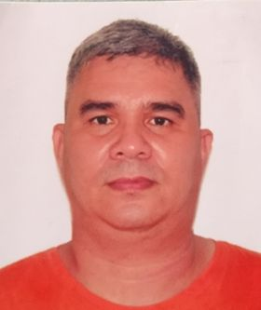  GEORGE JR. A. WARREN  133 Block 4 A. Bonifacio Avenue, West Rembo Makati City  Contact no. 09177049628  POSITION APPLIED  Welder  SKILLS  Welder with TESDA SMAW NC2  Forklift Operator TESDA FORKLIFT HEO NC2  Knowledge in Driving 123  PROFILE  Date of Birth: Feb 23, 1981  Place of Birth: Olongapo City, Zambales  Civil status: Married  Fathers Name: George Warren Sr. (Deceased)  Mothers Name: Evelyn Abayan  (Deceased)  REFERENCE  Myra Reyes  Admin Documentation Controller  Robert R. Respicio  Aistac Administrator  Engr. Benjamin M. Moronia Jr.  MTTC Administrator |  | EDUCATION  Balangiga Central Elementary School  Balangiga, Eastern Samar  School Year 1986 – 92  Balangiga National Agricultural School  Balangiga, Eastern Samar  School Year 1992 - 96  Jose Rizal University  80 Shaw Boulevard, Mandaluyong City  BCS - Management  School Year 2001 – 2006  WORK EXPERIENCE  March 22, 2022 up to August 10, 2022  Welder/Fabricator  Skynet Construction & Engineering Services  B1 L8 Belen St. Melendres Subdivision Barangay Dolores  Taytay Rizal  Operator / Driver  Utility Vehicle Express Service  2009 – march 2020  Transport passengers from point of origin (Terminal) to point of destination and perform preventive maintenance.  Backyard Piggery (Family Business)  2013 – 2016  Supervised in setting up the enterprise such the cost of the materials, feeds, number of piglets and cage maintenance.  Monitoring the operation of the business and coordinate with veterinary.

