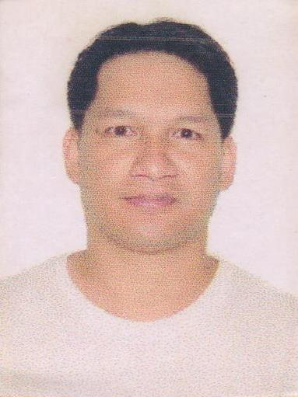
PATARAS, VENCIO DIONISIO
FD122D Tebteb, Balili, La Trinidad
Benguet, Philippines
E-MAIL : pataarasvencio@gmail.com
TEL : 09289216972
OBJECTIVE : Seeking for an opportunity to learn more to
enhance and to develop my working experience skills.
PERSONAL PARTICULARS
Date of birth : August 01 1984 Birth place : Kapangan, Benguet
Age : 37 Nickname : Ven
Gender : Male Nationality : Filipino
Marital status : Married Religion : Baptist Christian
Weight : 70 klgs. Height : 5’5”
Passport no. : EC8396792 Date issued : July 26 2016
Driver license : Restriction 2,3
EDUCATIONAL BACKGROUND
SCHOOL LEVELS SCHOOL YEAR SCHOOL NAME & ADDRESS COURSE
College : 2002-2005 : Saint Luis University Bonifacio : Bachelor of Science
Street Baguio City Philippines Electrical engineering
Vocational : 2007-2008 : AMA Computer College : Caregiving in Basic
Baguio City Philippines Life Support
High school : 1999-2002 : Saint Theresita’s High School
Labueg, Kapangan, Benguet, Phil.
Elementary : 1994-1999 : Taba-ao Elementary School
Kapangan, Benguet, Phil.

WORK EXPERIENCE
YEAR COMPANY ADDRESS FUNCTIONS
June 2019- present : Dionisio Farm : Kapangan Benguet : Farm worker
: Cultivating, planting
: Harvesting
May 2015 - Feb.2019 : International Tissue : Busan South Korea : Packaging Personnel
Company Ltd. Inc. : Tissue Machine
Rewinding operator
: Forklift operator
May 2010- Dec.2010 : Japan Agriculture : Iwate ken Japan : Farm Worker
International Program
SEMINARS TRAININGS ATTENDED
COURSE INSTITUTION
Korean Language Tutorial : Dream English Learning Center
Japanese Language Tutorial : Interskills Tutorial center
Caregiving NC II : Technical Education & Skills Development
Authority (TESDA)
Basic Life Support & Respondent Course : Baguio City Emergency Medical Service
RELATED SKILLS
*Driving
*Farming Agriculture
*Forklift Driver
LANGUGE/DIALECT Speak WRITE
Filipino Yes Yes
English Yes Yes
Korean Yes Yes
Japanese Yes Yes

