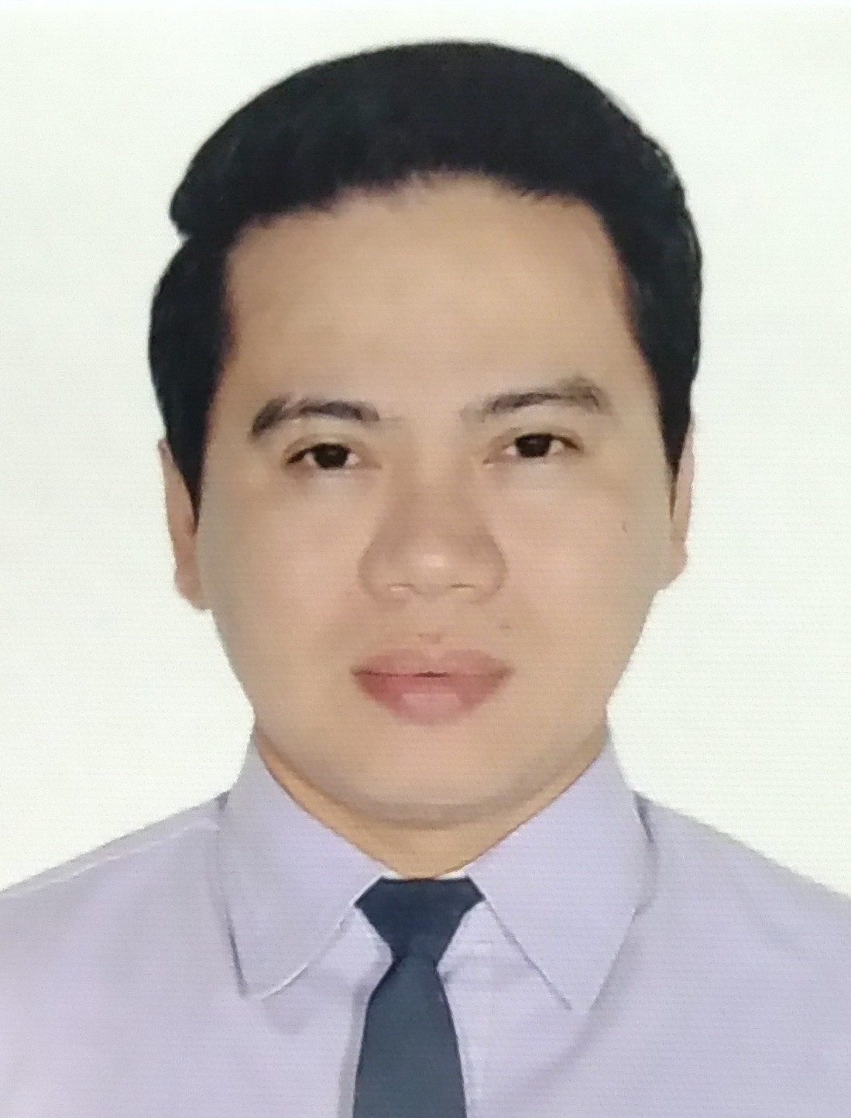
Jeffrey Alvero
+63939 337 2198
jeffreyalvero752@gmail.com
52 natividad st. brgy paltok, quezon city, Philippines

PROFESSIONAL SUMMARY

Experienced supervisor with expertise in prioritizing work, developing efficient workflow and managing 24 employees to achieve operational goals.

WORK EXPERIENCE

HOUSEKEEPING SUPERVISOR Jan 2018 - Present
SM AURA PREMIER FOOD HALL • TAGUIG CITY, Philippines

Supervising 24 staff and organizing and monitoring work processes.
Maintain staff by recruiting, selecting, orienting and training employees.
Devising work schedule and implementing deadlines.
Ensuring that quality standards are upheld.
Conducting performance reviews.

LEADMAN Oct 2016 - Dec 2017
SM AURA PREMIER FOOD HALL • TAGUIG CITY, Philippines

Educating staff on proper procedures and customer service.
Ensuring that established guidelines on hygiene, quality and safety are followed
Scheduling work shifts and approving or declining staff requests leave/time off.
Monitoring supplies and placing orders for new stocks are required.
Take care of paperwork / payroll.

MERCHANDISER Jul 2013 - Oct 2016
SM AURA PREMIER FOOD HALL • TAGUIG CITY, Philippines

Plan and develop merchandising strategies that balance customer’s expectation.
Analyse sales figures, customer reactions to anticipate product needs.
Plan product ranges / stock.
Monitor stock movement and consider price changes, clear outs etc.

BUSBOY / DISHWASHER Apr 2013 - Jul 2013
SM AURA PREMIER FOOD HALL • TAGUIG CITY, Philippines

Clear tables of dishware after meals and return to the kitchen.
Keep floors, tables and chairs clean by sweeping and mopping.
Clean, sanitize and reset tables after meals.
Assisting customer

WAREHOUSE ASSISTANT Sep 2012 - Mar 2013
FABTECH • MAKATI CITY, Philippines

Completes shipments by processing and loading orders.
Prepares orders by processing request and supply order, pulling materials.
Placing orders in delivery area.

ACCOUNTING CLERK Jul 2008 - Feb 2009
BSP & COMPANY INC • MANDALUYONG CITY, Philippines

Organizing and delivering documents and filing reports.
Updating records.

SALES ASSISTANT Oct 2003 - Nov 2007
WATCH N’ SEE, INC. / TIMEX • MAKATI CITY, Philippines

Serves customer by helping them select products.
Drives sales through engagement of customer, suggestive selling and sharing product knowledge.
Greets and receive customers in a welcoming manners.

WAREHOUSE ASSISTANT Oct 2002 - Feb 2003
MARETHE FRANCOIS GIRBAUD • PASIG CITY, Philippines

Process inventory for delivery.
Sort, organize and store inventory in the proper location.
Packages item and label correctly.
Scan delivered items and ensure quality.
Report damaged and missing inventory to supervisor.

SERVICE CREW May 2000 - Oct 2000
RED RIBBON BAKED SHOP • QUEZON CITY, Philippines

Greeting guests and taking orders.
Preparing food and drinks.
Assembling orders and packaging take-out and delivery.
Keeping all surfaces clean and sanitary to ensure the safety for our guest fellow crew member and ourself.

EDUCATION

DEAL WITH INTOXICATED GUESTS / NCII Jul 2022 - Jul 2022
TESDA • TAGUIG CITY, PHILIPPINES

Identify the responsibilities and obligations of housekeeping staff to guests;
Discover the benefits of responsible service of alcohol;
Apply appropriate procedures according to organizational policies;
Recognize what alcohol is and its types;
Recognize the effects of alcohol;
Identify what intoxication is and how alcohol affects the brain; and
Recognize the signs of intoxication.

PROVIDING GUEST ROOM SERVICES / NCII Jul 2022 - Jul 2022
TESDA • TAGUIG CITY, PHILIPPINES

Providing a friendly, welcoming and efficient service to all guests, in line with the Association’s vision and values on customer satisfaction.

AGRICULTURAL CROPS PRODUCTION / NCII Jun 2022 - Jun 2022
TESDA • TAGUIG CITY, PHILIPPINES

This course includes the knowledge, skills and attitude that you must have before working in the agricultural crops production sector.

PROVIDING HOUSEKEEPING SERVICES / NCII Jun 2022 - Jun 2022
TESDA • TAGUIG CITY, Philippines

deals with the skills and knowledge required to provide housekeeping services to guests within the tourism industry.
provides a glimpse on the duties qnd responsibilities of the different positions under the housekeeping department.

COMPUTER TECHNICIAN Jun 1997 - May 1999
SYSTEM TECHNOLOGY INSTITUTE • QUEZON CITY, Philippines

2years course with diploma and certificate.
Assembling hardware and Installing software.
Maintaining and repairing of computer

SKILLS

ASSEMBLING AND INSTALLING COMPUTER
COMPUTER LITERATE ( MS WORD / EXCEL )
PLUMBING
CARPENTRY

VOLUNTEER WORK

BLOOD DONOR 2013 - 2020
PHILIPPINE BLOOD BANK • QUEZON CITY, Philippines

Company blood donation program.
BLOOD DONOR 2021 - 2022
PHILIPPINE RED CROSS • MANDALUYONG CITY, Philippines

Company blood donation program.

WATCHER May 1996 - May 1996
PPCRV • QUEZON CITY, Philippines

Observe activities at a polling place to guard against illegal voting, fraudulent counting of ballots and other violations of election laws.

AWARDS AND HONOURS

TOP SELLER AWARD 2005

Top seller for the month of june

TRAININGS AND SEMINARS

Personal Safety and Social Responsibility 2015
Personal Survival Techniques 2015
Fire Prevention and Fire Fighting 2015
Elementary First Aid 2015
Basic Occupational Safety and Health ( BOSH ) 2021

I hereby certify that the information above are true and correct to the best of my knowledge.

Jeffrey Alvero
Applicant

