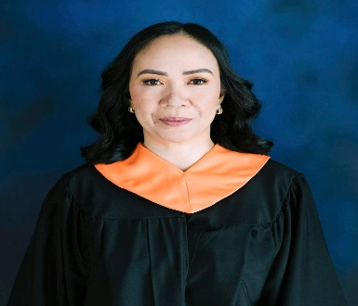
Charisma Joy Albaira – Molinyawe
Address: 219 Purok 4 Brgy. Majada Out Calamba City
Email: Charismajoymolinyawe@gmail.com
Contact number: 09271518098

Friendly Business Analyst/ Customer Service Representative for 13 years. Seeking proven skills in problem solving and communication to provide expert service in Business Research and Customer Service.

Work Experience
2009 – 2011 Customer Representative
Teletech Lipa
- Handling customer inquiry about their policy
(Dental and Vision coverage)
- Handling customer inquiry and complain about their billing
- Providing dental benefits and vision benefits

2011 – Present Business Analyst/ Complain
Concentrix Corporation
- Business Report Update
- Creating business report for large, medium, and small businesses
- Taking inbound and outbound calls
- Handling escalated cases from customers and SME’s
- Updating financial report for businesses
- Providing feedback to customers about current business rating
- Leveraged communication, problem solving and product knowledge skills

On -the Job Training

March – June 2022 Astoria Culinary and Hospitality Institute
Ortigas Business District Pasig City

June 21 – June 24 2022 American Hospitality and Lodging Educational Institute
Orlando Florida USA

Educational Attainment

March 2022 – August 17, 2022 University of Perpetual Help System Dalta
Bachelor of Science in Hotel and Restaurant Management
Calamba City, Laguna

Research Conference and Presentation Attended

June 2022 Simplified Title Methodology
University of Perpetual Help System- Dalta

Industry Certification

June 24, 2022 Certified Gold Service Professional: Golden Opportunities
University of Perpetual Help System- Dalta
Calamba City, Laguna

June 24, 2022 TripAdvisor: Reputation Management of Front-Line Stuff
University of Perpetual Help System - Dalta
Calamba City, Laguna

Seminars, Webinars and Training Attended

June 15, 2022
Tourism and Hospitality Post Covid-19 Pandemic Insight on Road to Recovery: The Case of Great Britain
University of Perpetual Help System - Dalta
Calamba City, Laguna

Personal Particulars:

Date of Birth: November 12, 1982
Gender: Female
Status: Married
Nationality: Filipino

Skills:
- Knowledgeable in MS words, MS Office, Excel
- Knowledgeable in DOS Based System
- Knowledgeable in Recipe costing, preparation
- Knowledgeable in small to large scale business
- Knowledgeable in using Sales Force (SFDC)
- Knowledgeable in using new software developed
- Fast learner
- Knowledgeable in cloud software

Interests:
- Cooking
- Watching movies
- Dancing
- Singing

_________________________
Charisma Joy Albaira - Molinyawe

