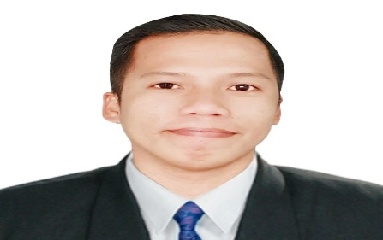
JAYVEE R. VIRAY
Address: Brgy. Esperanza Ibaba, Alfonso Cavite
Mobile No:09667317924
Email :Jebongviray25@gmail.com

I. CAREER OBJECTIVE
To obtain any position commensurate with any qualification that will enhance my skills and abilities contributed to the company as well as to my professional growth. To land in a challenging job for a position best suited for me.

II. EDUCATIONAL BACKGROUND
Tertiary City College of Tagaytay
Associate in Hotel And Restaurant Management
June 13, 2014 - April 5, 2016
Secondary Palocpoc Mendez National High School
June 14, 2010 - March 18, 2013
Primary Esperanza Ibaba Elementary School
June 5, 2000 - March 4, 2006

III. SKILLS AND CHARACTERISTICS
- Computer literate especially MS Office.
- Multi-task with Baking, Pastry, and Dining works
- Knowledgeable in Catering.
- Plan and direct food preparation.
- Estimate food requirements and labor cost.
- Work with minimal supervision
- Give prepared plates “final touch”
- Keep time and payroll honestly
- Maintain the positive and professional approach with co-workers and customer
IV. SEMINAR/TRAINING ATTENDED
Fruit Carving Seminar
College of Tagaytay Cavite City
March 10, 2015
Personality Development and Habit’s of Good Employee
Tagaytay Highlands International Golf Club Tagaytay, City
August 22,2016

V. PERSONAL INFORMATION
Age: 30 years old
Date of Birth: February 25, 1992
Place of Birth: Antipolo Rizal, City
Civil Status: Married
Citizenship: Filipino

VI.WORK EXPERIENCE
Commis I
Tsukemen & Bad bird Canopy
January 2022 Present

Commis I
Tavern by the lake hotel and restaurant
4120, Kaybagal South, Tagaytay Cavite City
September 18, 2019 - October 10, 2021

Commis II
Ambrocia’s By Isak Catering & Event Place
4120, Kaybagal South, Tagaytay Cavite City
October 17, 2018 – August 15, 2019

Commis II
Tagaytay Highlands Golf Club International and Country Club
June 2016 – August 13, 2017

F&B waiter
Dinners Bulalo Point
April 25 - July 30, 2016

On The job Training
Yellow Bricks Foods Service inc.
Bakeshop, Pastry, and Kitchen Department
November 2015 - February 2016
VII. CHARACTER REFERENCES

Jojo Rosano F&B Supervisor 09292666709/09272542574
Tagaytay Highlands

Vincent Pialago Nemenzo Kitchen Supervisor 09212168320
Tagaytay Highlands

Ms. Marilyn Cenizal Admin Officer 09175168427
Tagaytay Highlands

Alvin Daquio Kitchen Supervisor 09481701143
Ambrocia’s By Isaak

I hereby acknowledge that ever written statement is based upon my for knowledge and no one is influenced me in any form to make every statement as true accounts of my personal information. Hereby, I affix my signature thereon.

_________________
Applicant’s Signature

