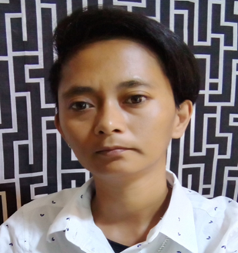  Profile  POBLACION I IGUALDAD STREET CALACA CITY BATANGAS  DECEMBER 29, I985  CALACA BATANGAS  36 YEARS OLD  SINGLE  FILIPINO  FEMALE  5’3” IN HEIGHT  50 KGS  ROMAN CATHOLIC  MIGUEL MARASIGAN  ROSALINA MARASIGAN  Contact  CELL PHONE:  0975726I748  EMAIL:  rosmilynmarasigan@gmail.com  rosmilynmarasigandfa@gmail.com  Hobbies  READING  DRIVING  SINGING  CONTACT PERSON IN CASE OF EMERGENCY:  LORETA A. SANTOS  09I63235369 |  | ROSMILYN MARASIGAN  EDUCATION  RIZAL COLLEGE OF TAAL  TAAL BATANGAS, PHILIPPINES  BACHELOR OF SCIENCE IN CRIMINOLOGY  JUNE 2004-APRIL 2008  UNITS IN PROFESSIONAL EDUCATION  MAJOR IN SOCIAL SCIENCE  JUNE 20I6 – NOVEMBER 20I6  VICTORIOUS KOREAN LANGUAGE INSTRUCTION SCHOOL  BATANGAS CITY BATANGAS PHILIPPINES  AUGUST 2022-SEPTEMBER 2022  WORK EXPERIENCE  IMS- INTEGRATED MANAGEMENT SERVICES INC.  CALAMBA CITY LAGUNA  POSITION: TEAM LEADER  LIFE INSURANCE AGENT FOR DEP ED TEACHERS  2009-20I0  CDO FOODSPHERE INC.  MALVAR BATANGAS  POSITION: PACKAGING CREW  HOTDOG PROCESSING AND PACKAGING  20II-20I2  EPSON PRECISSION INCORPORATED  LIPA CITY BATANGAS  POSITION: VIRTUAL PRODUCT QUALITY ASSURANCE INSPECTOR  INSPECTION OF PROJECTOR BEFORE BOXING AND DESPATCHED.  20I3-20I4  FORTUNE LIFE INSURANCE COMPANY  SHAW BOULEVARD PASIG CITY  POSITION: INSURANCE SPECIALIST  RESPONSIBLE FOR CHECKING INSURANCE DOCUMENTS FOR LIFE AND NON-LIFE.  20I5-20I6  UNITED MARZ PETRO CHEMICAL TRADING INC.  CALAMBA LAGUNA  POSITION: GAS STATION SUPERVISOR  LEMERY BRANCH  SUPERVISE MANPOWER AND HANDLING MACHINES AND ACT AS CASHIER.  MAY 20I9-AUGUST 202I  POSITION: FBAT AREA MANAGER  MANAGE 7 GASOLINE STATION UNDER MARZ MANAGEMENT AND COLLECTING SALES FOR BANK DEPOSIT.  AUGUST 27 TO OCTOBER 27,202I  PETRO LEMERY GAS STATION CORPORATION  LEMERY BATANGAS  POSITION: SUPERVISOR  SUPERVISE MANPOWER, SALES AND PRODUCT DELIVERIES AS WELL AS SALES PROFIT HANDLING.  JANUARY 2022-AUGUST 2022

