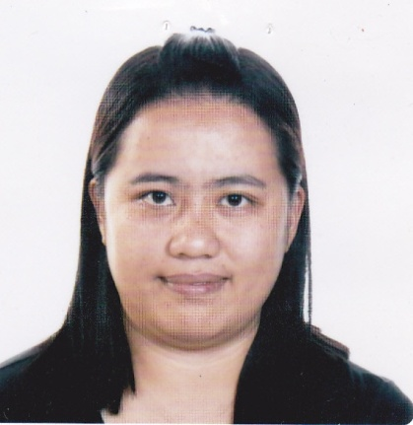
MARIANNE WILLY SAGADA
MA 157, Puguis, La Trinidad, Benguet
Mobile Number: +639171401249
Email Address: mariannelabbotwilly@gmail.com

PERSONAL DATA:
Provincial address : Taloy Sur, Tuba, Benguet
Date of birth : December 3, 1985
Place of Birth : La Trinidad, Benguet
Sex : Female
Citizenship : Filipino
Civil Status : Married
Religion : Christian
Height : 5”2’
Weight : 77 kg
Father’s name : Mario Mat-an Willy (deceased)
Occupation : N/A
Mother’s name : Rufina Labbot Paus
Occupation : Self-employed
Language/ Dialect Spoken : English, Filipino, Kankana-ey, Ibaloi, Ilocano
Person to contact in case
of emergency : Jenner D. Sagada
MA 157, Puguis, La Trinidad, Benguet
+639129174690

EDUCATION:
Tertiary : Benguet State University
2002 to 2006
Bachelor of Science in Nursing

Secondary : Tuba National High School-Taloy Sur Annex
1998 to 2002

Elementary : Salpang Elementray School
1992 to 1998

SEMINARS, TRAININGS AND CERTIFICATES:

National Certificate II -Medical Transcription
-Technical Education and Skills Development Authority
- Valid December 18, 2015 to December 19, 2019

Certificate of Training -Medical Transcription- Full Course
- Tech -Synergy Academy
- October 1 to December 18, 2015

Certificate of Attendance - Forensic Nursing Series I
-Forensic DNA Analysis, Death Examination and Autopsy, Wound Assessment and Examination
- December 5, 2010

Certificate of Participation - Hospital Customer Service Excellence
- One Relationship at a Time
- August 8, 2009

Certificate of Completion - Volunteer nurse
- General and Specialty Nursing
- PinesCity Doctor’s Hospital
- June 01, 2009 to August 31, 2009

Certificate of Attendance - 1st Post Graduate Course for Physicians, Nurses and Midwives
- “Back to Basics”
- September 28, 2008

WORK EXPERIENCE:

Realty property caretaker - Tayaotao Building
- FA 301, Balili, La Trinidad Benguet
- February 9, 2020 to February 21, 2022

Medical Transcriptionist - Company Confidential
- May 2019 to November 2020

General and Medical Transcriptionist: - Tech Synergy Academy
- #29 Cabinet Hill, Baguio City
- December 19, 2015 to April 2019

Domestic Helper - Midlevels, Hongkong
- October 20, 2014- December 17, 2014

Private Duty Nurse - Sharjah, United Arab Emirates
- Fatema Mohamed Al Zaabi
- October 29, 2011 to March 24, 2014

CHARACTER REFERENCES:
Jeantry A. Culpito
Baranggay Kagawad, Taloy Sur, Tuba, Benguet
Mobile Number: +639306837795

PMSg Elmer S. Lamsis
Investigator
Poblacion, Tuba, Benguet
Mobile Number: +630469645364

Lalaine T. Jordan
Retired Nurse, California, USA
Mobile number: +639171409721

I hereby certify that all information contained herein is true and correct to the best of my personal knowledge. I give consent to the verification of the above information.

MARIANNE W. SAGADA
Applicant

